

Labour Market Information & Wellbeing Events
November 2025

Ipswich Vacancies (and surrounding area)
432 jobs in Ipswich | Page 1 | Find a job

Ground Travel are looking for reliable drivers to transport SEN students and vulnerable individuals to and from school, college or day centres. You’ll be driving company vehicles (including 8-seaters and wheelchair-accessible vehicles), working termtime only with mornings and afternoons required. Full training, vehicle and fuel provided. Must hold a
UK driving licence and pass an enhanced DBS.
Assan Panel are looking for a Maintenance Technician and an Electrical Maintenance
Technician to work in their new UK division, using your experience in engineering.
If you think you have what it takes please speak to your work coach.
Fresh Fillaz – Catering Assistant. Permanent part-time role at 1 Coytes Gardens, IP1 1PS. 12–16 hours a week (Mon–Fri), working up to 4 hours a day. Join a small team preparing a variety of sandwiches and rolls, with some general food prep. You’ll follow food safety standards, keep workspaces clean, and support smooth kitchen operations. No experience needed – training provided. Ideal for someone reliable and organised.
Direct Table Foods in Bury St Edmunds is hiring Food Production Operatives and canteen staff. Pay is £12.36/hr plus overtime, with early or late weekday shifts. A £5 return bus runs from Ipswich. No experience needed—full training provided. Enjoy hot meals, free parking, and real chances to progress in a friendly team.
Anglian Home Improvements are looking for a Customer Care Door to Door and Advisor with good communication skills and confidence. If you think you have what it takes please speak to your work coach today for an interview.
Chassis Cab are looking for a Trainee Parts Sales Representative on £25-27k to work in
Great Blakenham. If you think you have what it takes please speak to your work coach.
Ground Travel – Passenger Assistant supporting SEN and vulnerable students on their
daily school journeys. You’ll help with boarding, safety equipment, and creating a calm, caring environment. Term-time only, with flexible part-time hours. Full training and DBS check required. You’ll be picked up and dropped off at home so no need for a driving licence to apply. If you're interested in applying for the role please ask your work coach.
Junior Assistant Producer Suffolk Libraries are offering an exciting chance to join their team as a Junior Assistant Producer. You’ll help curate six live music events at Ipswich County Library or Haverhill Library, gaining hands-on experience in event planning, sound engineering, artist liaison, marketing and media production. The commitment is for 12 days
between January and June 2026, with a fee of £150 per day (£1,800 total). The opportunity is ideal for anyone aged 18 to 25 who wants to gain experience in the creative industry. No formal qualifications are required,
The Insolvency Service – Ipswich are looking for Administrative Officers in Ipswich. Full time roles. For more information please contact your Work Coach.
Toolstation Ltd – Store assistant. Ipswich, Anglia, IP5 3RD. £12.37 per hour. Contract Part time. 16 hours per week 6 months Fixed Term Contract We are looking for candidates who live locally and can easily commute to our store. Our stores are open from 7 AM to 8 PM.
Care Home Support Worker Kingsley Healthcare - Ipswich, Suffolk, IP9 1AX
£12.6 per hour Permanent Full time. About the company Family-owned Kingsley Healthcare is a UK top 20 ranked care home group (carehome.co.uk) employing 2,000-plus staff and supporting 1,400 residents.

Lowestoft Vacancies (and surrounding area)
68 jobs in Lowestoft | Page 1 | Find a job

Civil Enforcement Officer – Lowestoft, 37 or 18 hours P/W, £28,598 - £31,022 P/Y (pro rata part time). Full driving licence essential. Excellent customer service. Proficient with smart tech & software, ability to learn new systems. Full details and apply via Suffolk Jobs Direct
Cleaner – N&S Police, Lowestoft, 5 hours P/W, Mon-Fri, £12.21P/H. Cleaning Offices, Vacuuming WC, Wiping, etc. Enthusiasm to cover holidays and sick and nearby sites. Police vetting is required. Training and Support provided. No experience required except positive enthusiasm. Speak to work coach for full details and to apply
Housekeeping Team Member – Gunton Hall Coastal Village, Lowestoft, NMW, part time. Full details and apply via Warner website
Laundry Assistant – Kingsley Healthcare, Lowestoft, £12.60 P/H, Weekdays with Alternative Weekends. Knowledge of cleaning and laundering procedures. An ability to work unsupervised and on own initiative. Full details and apply via Kingsley Healthcare website
Domestic Assistant – Kingsley Healthcare, Lowestoft, £12.60 P/H, weekdays with alternative weekends. Communication skills, confident to talk to residents and your colleagues. Awareness of general standards of cleanliness. Full details and apply via Kingsley Healthcare website
Bar Team Member – Gunton Hall Coastal Village, Lowestoft, NMW, part time. Full details and apply via Warner website
Barista – Starbucks, Lowestoft, NMW, full or part time. Customer service experience in a retail or restaurant environment. Full details and apply via Indeed
Bar Staff/Front of House - NEW** cafe bar & restaurant coming soon, Lowestoft, 1-25 hours P/W, £12.21 P/H. Experience in a restaurant or bar setting is preferred. Passion for hospitality, providing exceptional service, fast-paced environment. Apply via Indeed.
Mobile Catering Assistant – Edwards & Blake, Lowestoft, Mon-Fri, 9:30am-2:30pm, 22.5 Hours P/W (Term Time Only), £12.21P/H. Previous experience in a catering, hospitality, or customer service role is desirable. Full details and apply via Elior website
Kitchen Assistant - Harleston House (Greensleeves Care), Lowestoft, 16 hours P/W, up to £12.60P/H. Strong communication skills, Some experience of serving food, Some experience of working in a kitchen environment. Full details and apply via Indeed
Assistant Café Supervisor - Carlton Marshes Visitor Centre, Lowestoft, over 5 days Mon-Sun 9am-5pm, (April-Oct: 36 hours P/W, March-Nov: 35 hours P/W), £23,137.50 P/Y. Experience in a similar environment is essential, along with the ability to support and guide others in a busy setting. Full details and apply via Find a Job
General Assistant - Dell Primary School, Lowestoft, 11.30AM -13.30PM Mon-Fri, term time only, £12.21P/H. Simple food prep, Serving the Children and teachers, Allergy awareness. Full details and apply via Indeed
Customer Delivery Driver – Asda, Lowestoft, 16 hours P/W, £12.60P/H. Apply via Asda website.

Home Delivery Driver – Iceland, Lowestoft, 16 hours P/W, £13.27P/H. Full driving license (held for at least 3 years & have no more than 6 points). Positive, friendly. Punctual & can work well to deadlines. Strong awareness of road safety. Full details and apply via Iceland website
Store Service Colleague – Asda, Lowestoft, 8 hours P/W, £12.60P/H. Full details and apply via Asda website
Store Assistant – Aldi, Lowestoft, £13.02 - £13.95 P/H. Full details and apply via company website
Sales Assistant – Ryman, Lowestoft, 10 hours P/W (Thursdays & Saturdays). Full details and apply via Indeed
Seasonal Sales Assistant - Card Factory, Lowestoft. No retail experience required. Full details and apply via Indeed
Retail Assistant – Iceland, Lowestoft, 16 hours P/W, £11.20 - £12.27 P/H. Full details and apply via company website
Event staff - tinis fudge cakes and bakes, Lowestoft, £13 - £13.50 P/H, some weekends + extra hours during week in our bakery unit are available if wanted. Flexibility to work varied hours inc. evenings & weekends as required by event schedules. Apply via Indeed
Marketing & Content Assistant – Hales Group, Lowestoft, Mon-Fri, 8am–5pm, £33000 P/Y DOE. Solid understanding of social media and content trends. Proficiency with tools like Canva and Adobe Creative Suite. Full details and apply via Hales Group website
Administrator – Hales Group, Lowestoft, 4 hours P/D, Mon-Fri (flexible working hours), £12.21 P/H. Open incoming post, general admin support to HR & Facilities team. Assist in maintaining a clean, welcoming office environment. Full details and apply via Hales Group website
Optical Assistant/Receptionist - Primesight Opticians, Lowestoft, £12.21P/H, 14 hours P/W Mon-Sat. No experience required, training will be provided. Full details and apply via Indeed
Taxi Telephone Operator - Five one taxis, Lowestoft, £12.21P/H, 16-40P/W (min 16, include night shifts and weekends). Teamwork. Ability to use computer. Full training will be provided. Previous experience desirable. Full details and apply via Indeed
Food Production Operative – GI Group, Lowestoft, approx. Multiple vacancies, £12.21P/H (overtime at time and a half over 40 hours), average 30-40 hours P/W (some may exceed). Mix of shifts, additional overtime. Speak to work coach for full details.
Warehouse Operative - Nutriwolds Raw, Kessingland, 30–40+ hours P/W, Mon-Fri, fixed shift options: 6:30 am–2:30 pm, 7 am–3 pm, or 8 am–4:30 pm. Forklift licence preferred (or willingness to obtain). Full details and apply via Indeed
Warehouse Supervisor - Durham Animal Feeds, Lowestoft, £24,420.00 - £36,835.43 P/Y, full time. Mon-Fri (Occasional weekends with prior arrangement), 5am start, approx 40 hour P/W. Responsible for a small staff team. Full details and apply via Indeed
Seasonal Elves – QD Stores, Carlton Colville, 9.45am - 4.45pm, Sat & Sun. Enthusiastic, festive, and fun. Full details and apply via Find A Job
Teaching Assistant - Elm Tree Primary School, Lowestoft, part time, salary DOE. Full details and apply via mynewterm website
Cleaner - ecoSense Cleaning, £12.21P/H, Tue 9am-2pm, Wed, Sat & Sun 8am-2pm. Full training provided. Full details and apply via Indeed

Bury St Edmunds Vacancies (and surrounding area)
259 jobs in Bury St. Edmunds | Page 1 | Find a job

Suffolk Bright Futures
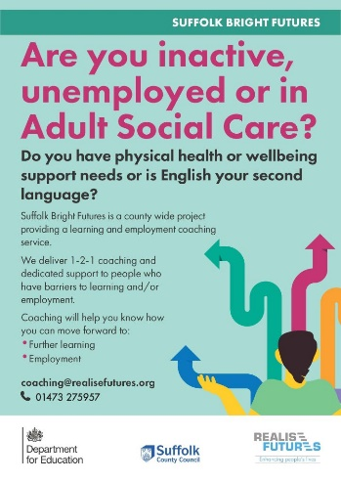


Click here for Autumn/Winter 25/26 timetable
Recovery College | Norfolk and Suffolk NHS

Our courses provide a safe, supportive, and compassionate approach to mental health recovery. We empower, educate, and offer tools to help individuals navigate their journey while learning from others with similar experiences. They are delivered with lived and learned experience of mental health and wellbeing.
Our sessions cover a range of topics, promoting:
- Self-awareness and acceptance
- Understanding recovery principles
- Learning new skills and strategies
- Leading a meaningful life, with or without symptoms



Get Everyday Activ in Suffolk | Motivating, supporting and inspiring healthier lifestyles
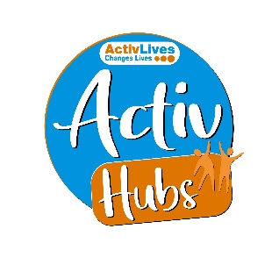
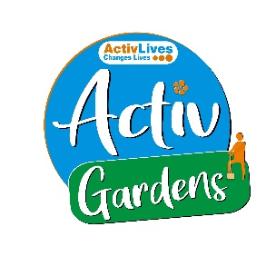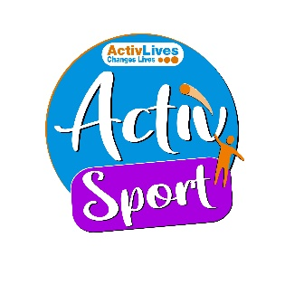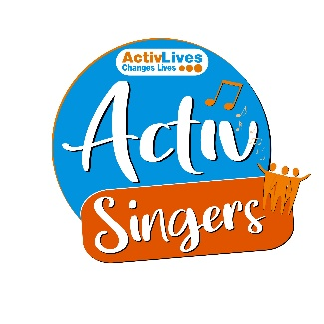
ActivHubs was set up to provide a fun and social way for people to keep fit and healthy, improve strength, balance andco-ordination, reduce stress and while doing all of that, make some new friends in the process!
ActivGardens are all about growing! Growing plants. Growing fresh healthy food. Growing yourself… your fitness, your health, your skills, your friends, your community. Get active with ActivGardens in Ipswich and Sudbury!
ActivSport - A community based sports and physical activity programme for adults. Particularly targeted at people who are not already taking part in regular sport or physical activity. New participants are always welcome!
ActivSingers meet in Ipswich and Woodbridge every couple of weeks to enjoy all of the benefits from the joy of singing. Everyone is welcome to join in with no previous experience of singing required.



The Suffolk Information Partnership manages a secure, online referral process to support vulnerable customers and clients and help them access services that they may not be able to on their own.
Please note that the referral form is only for use by organisations and is not for the public. If you wish to refer yourself or a family member to a service offered by the partners in the Scheme please contact the most appropriate organisation listed on the Partners' page.

Opportunities to Volunteer in Suffolk
Volunteer Roles - Volunteer Suffolk

Warm & relaxing space in the heart of Lowestoft

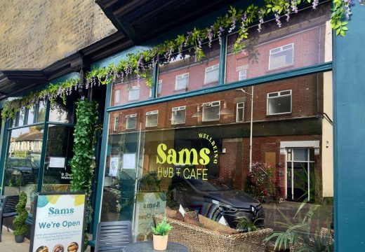

Sam’s Wellbeing Hub & Café is ready to welcome everyone, including your furry friends too (well-behaved & assistant dogs).
Nestled right in the heart of your community, we’ve created a warm, relaxing space that’s perfect for everyone to enjoy and escape to.
Whether you’re stopping by to explore our delicious food and drink menu or just looking for a cozy spot to unwind, we’re here Monday to Friday from 9:00 AM to 4:00 PM.
Come and say hello to our friendly team — they’re eager to show you around and share all the wonderful things our space has to offer.

Seasonal events in November



Nov 9 from 10:30am to 4:30pm

- Stonham Barns: Features a Christmas Craft Market.
- Bury St Edmunds: The St Edmundsbury Cathedral Christmas Market is planned for November 27, 2025, with over 60 stalls and live music.
- Trinity Park, Ipswich: A large Christmas makers' market is scheduled for November 29, 2025.
- Jimmy's Farm: The Christmas Fayre is a free-to-attend event.
- Lavenham: Expect a two-day Christmas market featuring local produce and crafts, along with a Lavenham Farmers Market on the Saturday.
- Stowmarket: The Christmas Fayre will include a light switch-on.

Other events
- Kentwell Hall: Hosts enchanting Christmas events.
- Kersey Mill: Features Santa's Workshop.
- Clare: Will have a Christmas fair.
- Easton Farm Park: Also has a Christmas market.



