***

|  |
| --- |
| **Labour Market Information & Wellbeing Events**  **October 2025** |

**Ipswich Vacancies (and surrounding area)**

**Seasonal Jobs Campaign**

**Starting now!**

Seasonal roles are beginning to go live – from Retail, Hospitality, Logistics and more you’ll begin to see more employers advertising for their festive roles. Please speak to your work coach today to find out more and see what’s available in your local area!

**A.C. Waste and Removals -Delivery Drivers Mate**

A.C. Waste and Removals are looking for Delivery Driver’s Mates in the Ipswich area.

Join their team delivering furniture and white goods for a major high street brand. This is a physical, customer-facing role supporting deliveries. 5–6 day rota, 9am–4pm shifts, including some weekends. Must be reliable, physically fit, and customer focused. DBS check required.

**McQueens-Canvasser**

McQueens are looking for canvassers and also drivers, to spread the word about their delivery service. Lots of walking involved and excellent salary, plus a company car if you want to lead a team too!

If you think you have what it takes please speak to your work coach today for an interview.

**Done With Dirt – Cleaning**

Done with Dirt are seeking a Cleaning Operative to work on a zero-hour contract in the Ipswich area. Applicants must have a valid driving licence and access to your own vehicle. If you're interested in the role and wish to apply, please ask your work coach today.

**Support Worker – Joe Healthcare**

Joe Healthcare is recruiting Support Workers for full and part-time permanent positions in the Ipswich area. These field-based roles offer flexible working patterns and full training. The role involves providing personal care, supporting daily living tasks, promoting independence, administering medication, offering emotional support, and facilitating social activities. No prior experience is required, as full training will be provided. Please speak to your work coach if you're interested in applying.

**Royal Mail**

Royal Mail have multiple vacancies in their locations around Ipswich.

If you are interested in any of the vacancies on offer please apply through their website

**Sizewell C**

Aspiring for a career in the nuclear sector? Explore numerous pathways to your desired profession, featuring current job openings, internships, apprenticeships and graduate schemes. Sizewell B, our operating power station on the Suffolk coast already provides long-term rewarding careers and we want Sizewell C to continue the legacy for years to come. Visit [www.sizewellc.com/jobs/current-vacancies](http://www.sizewellc.com/jobs/current-vacancies) for more details.

**4mySchools – Learning Support Assistant**   
A full-time (Temp) Learning Support Assistant role is available at a rural primary school just outside Ipswich. This is a term-time only position, supporting a child in Year 2 with social and communication development. driving licence and access to a car are essential. Hours: Monday to Friday, 8:30am to 3:30pm. Speak to your Work Coach to find out more.

**Cranswick – Production Operatives**

Cranswick Poultry are hosting an online Recruitment Drop-In session on Friday 10th October. Jobs are available across East Anglia. For more information, please speak to your work coach.

**Lowestoft Vacancies (and surrounding area)**

**Customer Service Advisor - East Suffolk Council**, Lowestoft, £26,403 - £28,142 P/Y FTE, 22.2 hours P/W (Mon, Wed, & Fri). Min four GCSEs at Grade A\*- C / 4 - 9 (inc. English & Maths), or equivalent. Experience in a busy office environment & dealing with customers at all levels in a friendly and courteous manner is essential. **Full details and apply via Suffolk Jobs DirectMarketing & Content Assistant – Hales Group**, Lowestoft, full time. Solid understanding of social media platforms and content trends, Proficient in Adobe Creative Suite (Photoshop, Illustrator, etc.). **Full details and apply via Hales Group**

**Support Worker (Housing) – Access Community Trust**, Lowestoft, £12.60 P/H, depending on location: 14 hours P/W, 21 hours P/W, or 37.5 hours P/W. Previous experience working within a supported accommodation or similar environment and supporting vulnerable people / families with issues relating to financial hardship, homelessness, mental health and substance misuse. **Speak to work coach for full details and to apply**

**Early Years Teaching Assistant - Carlton Colville Primary School**, Lowestoft, £23,657 - £24,404 P/Y, pro rata, 32.5 hours P/W, 39 weeks P/Y. A relevant Qualification, Level 3 or above is essential for this role. **Full details and apply via Suffolk Jobs Direct**

**Counter / Kitchen Assistant – Hales Group**, Lowestoft, 7am-2pm, 30 hrs P/W, Mon-Fri, £12.42 P/H. Previous experience in a similar role, Certificate in Food Hygiene is desirable, Enhanced DBS Check. **Full details and apply via Hales Group**

**Catering Assistant – Edwards & Blake**, Grove Park School Lowestoft, £12.21 P/H, Mon-Fri, 11am-1pm, term time only. Catering and Barista experience desirable but not essential. **Full details and apply via Elior website**

**Pizza chef – Stanford Arms**, Weds – Sat, £15 - £17 P/H. **Send a CV & cover letter to** **info@stanfordarmslowestoft.co.uk**

**Kitchen Assistant – Mitchells & Butler (Harvester)**, Lowestoft, NMW. Make sure the kitchen is stocked up, clean, tidy and ready for the shift ahead; supporting the chefs to serve food to be proud of. **Full details and apply via Find a Job**

**Evening Food Service Assistant – Sodexo**, Lowestoft, Mon – Fri, 15:30 - 21:30, £12.60 P/H. Assist with the preparation, presentation, and service of food and beverages, consistently maintaining the highest standards. **Full details and apply via Find a Job**

**Cafe Team Member – Tesco**, Lowestoft, must be 18+. Knowledge of Health and Safety standards. The ability to work efficiently and maintain a clean environment. **Full details and apply via company website**

**Casual Café Assistant Carlton Marshes - Suffolk Wildlife Trust**, Lowestoft, part time, £12.21 P/H (plus holiday pay). Prior experience in similar roles and proficiency in EPOS till systems are desirable, as are barista skills. **Full details and apply via Find a Job**

**Weekend Cafe Assistant - QD Stores Ltd**, Carlton Colville, 12 hours P/W, Sat/Sun. Responsible for a range of tasks that contribute to the smooth operation of the café. **Full details and apply via Find a Job**

**Bar Team Member - Corton Coastal Village**, full time, NMW. **Full details and apply via Warner website**

**Workshop Labourer – Hales Group**, Lowestoft, full time. Some engineering experience would be beneficial. MIG/TIG welding would be an advantage. **Full details and apply via Hales Group**

**HANDBALL OPERATIVE - The Best Connection Group Limited**, Lowestoft, £12.21 P/H, 6am - either 4 or 8 hour shifts, that vary throughout the week, depending on the client's need. No experience needed- but please note the role involves lifting, and the shift demands vary from week to week. **Full details and apply via Find a Job**

**Food Production Operative – GI Group**, Lowestoft, approx. 20 vacancies, £12.21P/H (overtime at time and a half over 40 hours), average 30-40 hours P/W (some may exceed). Mix of shifts, additional overtime. **Full details and apply via GI Group website or call 01502 56803**

**Digital Assistant – Clays Ltd**, Bungay, £11.44 P/H, Full-time. Previous factory experience required; strong work ethic and willingness to learn essential. Opportunity to develop skills on various machines. **Full details and apply via Indeed**

**Home to School Driver – Rainbow Transport**, Lowestoft, Mon – Fri regular hours to be discussed. Excellent driving skills, Good communication skills essential. A full driving license and a Private Hire License essential. Funding can be applied for, via work coach, to obtain the Private Hire Drivers License. **Speak to work coach for full details and to apply**

**Delivery Driver – Jojo’s Kitchen & Bar**, Lowestoft, good rates of pay, mixture of evenings available (must inc. weekends). **Direct message company for more information and to apply**

**Relief Premises and Security Officer – Access Community Trust**, Lowestoft, 0 hours contract, £12.60 P/H. Shifts are on a lone working basis, experience in a security / caretaker role is desirable. No SIA required. **Speak to work coach for full details and to apply**

**Housekeeping Team Member - Corton Coastal Village**, Lowestoft, NMW, part time. **Full details and apply via Warner Hotels website**

**Support Worker – Leading Lives**, John Turner short break unit, £12.60 P/H, 16 hours P/W. Prior experience with people in a care setting, including provision of intimate care, supporting complex needs and risk assessment. **Speak to work coach for full details and to apply**

**Store Team Member – Home Bargains**, Lowestoft, £12.21 - £12.50 P/H, Up to 16 hours P/W - must be available evenings and weekends. Demonstrate a good understanding of customer service. Experience of cash handling/ working in a retail environment, and of manual handling/ stock replenishment. **Full details and apply via company website**

**Seasonal Toy Merchandiser – Based in Tesco**, Lowestoft, 10 hours P/W, Mon/ Thur/ Sat, £12.21 P/H. Ensuring fixtures are set up effectively, products and promotions are displayed attractively, and the shelves are well-stocked. **Full details and apply via Find a Job**

**Customer Service Assistant - One Stop**, Westwood Avenue. Providing excellent customer service, stocking shelves, processing payments and helping maintain the store’s appearance. **Full details and apply via company website**

**Bridge Operator - Stafforce Recruitment**, Lowestoft, £16.21 P/H, 6am-6pm & 6pm-6am on a four-on-four off basis. Rotate between days & nights, full monthly rota will be supplied in advance. No experience in the specific role is required as full training will be provided. **Full details and apply via CV Library**

**Bury St Edmunds Vacancies (and surrounding area)**

[181 jobs in Bury St. Edmunds | Page 1 | Find a job](https://findajob.dwp.gov.uk/search?q=&w=Bury+St+Edmunds)

**Suffolk Bright Futures**

**Job Fairs**

**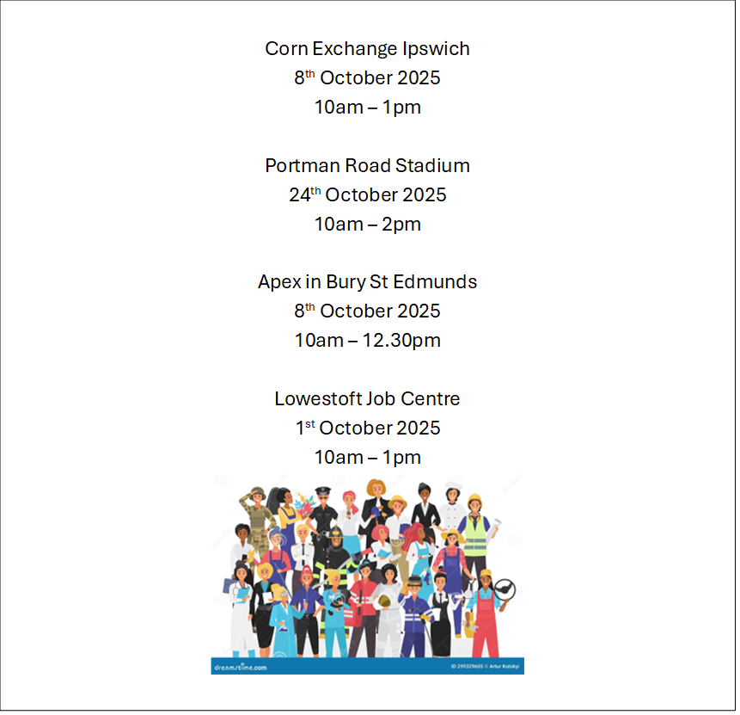**



Click here for Autumn/Winter 25/26 timetable

[Recovery College | Norfolk and Suffolk NHS](https://www.nsft.nhs.uk/recovery-college/)

Our courses provide a safe, supportive, and compassionate approach to mental health recovery. We empower, educate, and offer tools to help individuals navigate their journey while learning from others with similar experiences. They are delivered with lived and learned experience of mental health and wellbeing.

Our sessions cover a range of topics, promoting:

* Self-awareness and acceptance
* Understanding recovery principles
* Learning new skills and strategies
* Leading a meaningful life, with or without symptoms



[Get Everyday Activ in Suffolk | Motivating, supporting and inspiring healthier lifestyles](https://activlives.org.uk/)

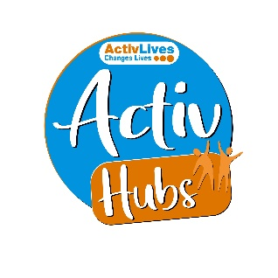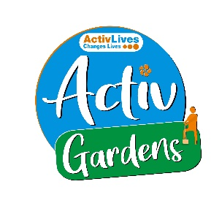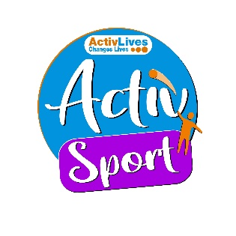  
**ActivHubs** was set up to provide a fun and social way for people to keep fit and healthy, improve strength, balance andco-ordination, reduce stress and while doing all of that, make some new friends in the process!

**ActivGardens** are all about growing! Growing plants. Growing fresh healthy food. Growing yourself… your fitness, your health, your skills, your friends, your community. Get active with ActivGardens in Ipswich and Sudbury!

**ActivSport** - A community based sports and physical activity programme for adults. Particularly targeted at people who are not already taking part in regular sport or physical activity. New participants are always welcome!

**ActivSingers** meet in Ipswich and Woodbridge every couple of weeks to enjoy all of the benefits from the joy of singing. Everyone is welcome to join in with no previous experience of singing required.



The Suffolk Information Partnership manages a secure, online referral process to support vulnerable customers and clients and help them access services that they may not be able to on their own.

Please note that the referral form is only for use by organisations and is not for the public. If you wish to refer yourself or a family member to a service offered by the partners in the Scheme please contact the most appropriate organisation listed on the [Partners' page](https://suffolkinformationpartnership.onesuffolk.net/partners/what-partners-do).

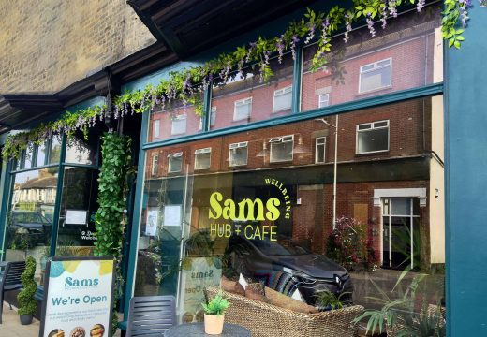

**Warm & relaxing space in the heart of Lowestoft**

Sam’s Wellbeing Hub & Café is ready to welcome everyone, including your furry friends too (well-behaved & assistant dogs).

Nestled right in the heart of your community, we’ve created a warm, relaxing space that’s perfect for everyone to enjoy and escape to.

Whether you’re stopping by to explore our delicious food and drink menu or just looking for a cozy spot to unwind, we’re here Monday to Friday from 9:00 AM to 4:00 PM.

Come and say hello to our friendly team — they’re eager to show you around and share all the wonderful things our space has to offer.

**Things to do in October & Half Term!**

Pumpkin picking in Suffolk for 2025 typically runs on weekends in October and then daily during the October half-term, ending on October 31st. Key locations include **[Rougham Estate](https://www.google.com/search?q=Rougham+Estate&sca_esv=8482df87b229566e&source=hp&ei=SADRaMnQG_GFhbIP3be26AM&iflsig=AOw8s4IAAAAAaNEOWI8397mGjm-_EcBZ9CmhISZNIHQn&ved=2ahUKEwi3uqTc8euPAxUNQUEAHScOHPoQgK4QegQIARAC&uact=5&oq=pumpkin+picking+suffolk+2025&gs_lp=&sclient=gws-wiz&mstk=AUtExfChaw1on-WPTGEM-waQ0reXDCmQJSlVOX17K98YfhzM-4XHhvn3vmKetWCb9OXsFyo1LSCqbfEQTMdEc_-NdsTVSFDSQm8iLDcq3beImXK6m3BDTq8n04TZvlf-whr24a8&csui=3" \t "_blank)** near Bury St Edmunds, [**Ruffins Farm**](https://www.google.com/search?q=Ruffins+Farm&sca_esv=8482df87b229566e&source=hp&ei=SADRaMnQG_GFhbIP3be26AM&iflsig=AOw8s4IAAAAAaNEOWI8397mGjm-_EcBZ9CmhISZNIHQn&ved=2ahUKEwi3uqTc8euPAxUNQUEAHScOHPoQgK4QegQIARAD&uact=5&oq=pumpkin+picking+suffolk+2025&gs_lp=&sclient=gws-wiz&mstk=AUtExfChaw1on-WPTGEM-waQ0reXDCmQJSlVOX17K98YfhzM-4XHhvn3vmKetWCb9OXsFyo1LSCqbfEQTMdEc_-NdsTVSFDSQm8iLDcq3beImXK6m3BDTq8n04TZvlf-whr24a8&csui=3) south of Bury St Edmunds, [**Siam Hall Spooky Pumpkins**](https://www.google.com/search?q=Siam+Hall+Spooky+Pumpkins&sca_esv=8482df87b229566e&source=hp&ei=SADRaMnQG_GFhbIP3be26AM&iflsig=AOw8s4IAAAAAaNEOWI8397mGjm-_EcBZ9CmhISZNIHQn&ved=2ahUKEwi3uqTc8euPAxUNQUEAHScOHPoQgK4QegQIARAE&uact=5&oq=pumpkin+picking+suffolk+2025&gs_lp=&sclient=gws-wiz&mstk=AUtExfChaw1on-WPTGEM-waQ0reXDCmQJSlVOX17K98YfhzM-4XHhvn3vmKetWCb9OXsFyo1LSCqbfEQTMdEc_-NdsTVSFDSQm8iLDcq3beImXK6m3BDTq8n04TZvlf-whr24a8&csui=3) on the Suffolk/Essex border, [**The Pumpkin Patch East Bergholt**](https://www.google.com/search?q=The+Pumpkin+Patch+East+Bergholt&sca_esv=8482df87b229566e&source=hp&ei=SADRaMnQG_GFhbIP3be26AM&iflsig=AOw8s4IAAAAAaNEOWI8397mGjm-_EcBZ9CmhISZNIHQn&ved=2ahUKEwi3uqTc8euPAxUNQUEAHScOHPoQgK4QegQIARAF&uact=5&oq=pumpkin+picking+suffolk+2025&gs_lp=&sclient=gws-wiz&mstk=AUtExfChaw1on-WPTGEM-waQ0reXDCmQJSlVOX17K98YfhzM-4XHhvn3vmKetWCb9OXsFyo1LSCqbfEQTMdEc_-NdsTVSFDSQm8iLDcq3beImXK6m3BDTq8n04TZvlf-whr24a8&csui=3) near the A12, [**The Pumpkin Barn**](https://www.google.com/search?q=The+Pumpkin+Barn&sca_esv=8482df87b229566e&source=hp&ei=SADRaMnQG_GFhbIP3be26AM&iflsig=AOw8s4IAAAAAaNEOWI8397mGjm-_EcBZ9CmhISZNIHQn&ved=2ahUKEwi3uqTc8euPAxUNQUEAHScOHPoQgK4QegQIARAG&uact=5&oq=pumpkin+picking+suffolk+2025&gs_lp=&sclient=gws-wiz&mstk=AUtExfChaw1on-WPTGEM-waQ0reXDCmQJSlVOX17K98YfhzM-4XHhvn3vmKetWCb9OXsFyo1LSCqbfEQTMdEc_-NdsTVSFDSQm8iLDcq3beImXK6m3BDTq8n04TZvlf-whr24a8&csui=3) in Redlingfield, and [**Woodbridge Pumpkin Patch**](https://www.google.com/search?q=Woodbridge+Pumpkin+Patch&sca_esv=8482df87b229566e&source=hp&ei=SADRaMnQG_GFhbIP3be26AM&iflsig=AOw8s4IAAAAAaNEOWI8397mGjm-_EcBZ9CmhISZNIHQn&ved=2ahUKEwi3uqTc8euPAxUNQUEAHScOHPoQgK4QegQIARAH&uact=5&oq=pumpkin+picking+suffolk+2025&gs_lp=&sclient=gws-wiz&mstk=AUtExfChaw1on-WPTGEM-waQ0reXDCmQJSlVOX17K98YfhzM-4XHhvn3vmKetWCb9OXsFyo1LSCqbfEQTMdEc_-NdsTVSFDSQm8iLDcq3beImXK6m3BDTq8n04TZvlf-whr24a8&csui=3) on Waldringfield Road. Most locations have free admission, parking, and don't require booking, though some, like The Pumpkin Patch East Bergholt and The Pumpkin Barn, may have a small entry fee.

**Clip ‘n Climb**: Ipswich Experience offers thrilling indoor climbing challenges for active kids and families.

**Bridge Farm Barns**: Explore this charming barn complex with a gift shop and tea room, perfect for a cozy outing.

**Easton Farm Park**: Get up close to friendly farm animals and enjoy outdoor play areas at this educational park.

**EmZo Shop & Café**: Enjoy delicious homemade cakes and unique gifts in a quaint café in Bacton, Stowmarket.

**Suffolk Owl Sanctuary**: Discover majestic owls and other birds of prey at this sanctuary, with captivating flying displays.