

Labour Market Information & Wellbeing Events
December 2025

Ipswich Vacancies (and surrounding area)
432 jobs in Ipswich | Page 1 | Find a job

Swanton Care - Recruiter Swanton are looking for a Recruiter to work closely with hiring managers to understand their recruitment needs. If you have the relevant experience and think you have what it takes, please speak to your work coach today.
Anglo Norden Forest Products Anglo Norden are seeking a Forklift driver with Timber handling experience, to work at two sites in Ipswich. The hours of work are Monday to Friday 07.30 am to 5.00 pm. If you have a FLT licence and Timber handling experience this may be the role for you. Please ask your work coach if you're interested in applying
TLP – Forklift driver TLP are seeking Forklift drivers to work onsite in Claydon. The hours of work are Monday to Friday 06.00 am to 15.00 pm OR 14.00 to 22.00. If you have a FLT licence this may be the role for you. Please ask your work coach to apply.
Aquatix-2U Aquatix-2u are recruiting for new Warehouse Picking and Packing staff for their warehouse. If you are interested in applying, please speak to your work coach.
Remedy Tutors – Core and SEN tutors Remedy Tutors are looking for Core subject Tutors AND SEN tutors. If you're interested, please speak to your Work Coach
One Stop Shop One Stop are seeking a Shift Leader. Applicants must be reliable and customer focussed. If you're interested, please ask your work coach today.
Anglian Home Improvements Anglian Home Improvements are looking for a Customer Care Door to Door with good communication skills and confidence. If you think you have what it takes please speak to your work coach today for an interview.
Junior Assistant Producer Suffolk Libraries are offering an exciting chance to join their team as a Junior Assistant Producer. You’ll help curate six live music events at Ipswich County Library or Haverhill Library, gaining hands-on experience in event planning, sound engineering, artist liaison, marketing and media production. The commitment is for 12 days between January and June 2026, with a fee of £150 per day (£1,800 total). The opportunity is ideal for anyone aged 18 to 25 who want to gain experience in the creative industry. No formal qualifications are required, and applicants from underrepresented or low-income backgrounds are encouraged to apply.
Sizewell C Aspiring for a career in the nuclear sector? Explore numerous pathways to your desired profession, featuring current job openings, internships, apprenticeships and graduate schemes. Sizewell B, our operating power station on the Suffolk coast already provides long-term rewarding careers and we want Sizewell C to continue the legacy for years to come. Visit www.sizewellc.com/jobs/current-vacancies for more details.








Beyond Labels – Celebrating Disability in Suffolk
Research Volunteer

NEW VOLUNTEER OPPORTUNITY


Beyond Labels is a National Lottery Heritage funded project with Suffolk Archives to uncover historic and contemporary stories of those who live with a disability. We need your help to research these stories. You may have a lived experience of disability, or you may not, everyone is welcome to volunteer on this project.
Researching disability history is a vital process for understanding the lived experiences and contributions of people with disabilities. Archives serve as rich repositories of primary sources such as personal papers, organisational records, photographs, and more. This guide aims to help you navigate and use archives effectively to uncover disability history.

Suffolk Archives are looking for volunteers who

- have an interest in the history of people living with a disability and sharing it with the wider community through exhibitions and events
- Undertake research in the archives, libraries and online to explore themes set out by the community forum. This will also include collecting community memories through new documents or oral history interviews
- Support the development of interpretation of the exhibition at The Hold and accompanying materials
- And/or support public events and school visits

If you would like to get involved, please contact volunteering.archives@suffolk.gov.uk

Lowestoft Vacancies (and surrounding area)
68 jobs in Lowestoft | Page 1 | Find a job

Cleaner – Wetherspoons, Lowestoft, £12.41P/H, 6 hours P/W (6am – 8am). We can teach you the skills you’ll need to succeed. Full details and apply via Wetherspoons website
Civil Enforcement Officer - East Suffolk Services Limited, Lowestoft, £28,598 - £31,022 P/Y (pro rata), 18 hours P/W (11-hour shifts of 2 days on, 6 days off). A full driving licence is essential for this role. Full details and apply via Suffolk Jobs Direct.
Food Production Operative – GI Group, Lowestoft, approx. Multiple vacancies, £12.21P/H (overtime at time and a half over 40 hours), average 30-40 hours P/W (some may exceed). Mix of shifts, additional overtime. Full details and apply via GI Group.
Cold store operatives - The Best Connection Group Limited, Lowestoft, £12.21 P/H, 6am-6pm or 6pm-6am, Combination of day and night shifts, Typically 3-5 shifts per week (Mon-Fri). Full training and PPE provided. Full details and apply via Find A Job
Assistant Maintenance Manager – Broadland Sands, £27,801 P/Y, 43 weeks P/Y, Corton. Previous experience as a Maintenance Operative or Maintenance Team Leader essential. Experience in maintenance operations within a caravan holiday park required. Full details and apply via Park Holidays website
Team Member – Greggs, Lowestoft, £12.41 P/H (under 18 will be £10.53 P/H). We'll make sure you have the skills and knowledge you need to have a great career with us. Full details and apply via Find A Job
Food Service Assistant – Sodexo, Lowestoft, 30 hours P/W, Mon-Fri, £12.60 P/H. Excellent communication and customer service skills. Full details via Find A Job.
Midday Supervisor - Roman Hill Primary School, Lowestoft, £5,479.00 P/Y (Actual), 10 hours P/W, 38 weeks P/Y. Full details and apply via teaching-vacancies.service.gov.uk
Learning Support Assistant - The Ashley School Academy Trust, Lowestoft, £17,695 - £18,260 P/Y, 30.5 hours P/W, 39 weeks P/Y. Supporting learners with moderate and complex learning difficulties in the age range 7-16 years and requires knowledge, skills and understanding to support across the school. Full details visit Suffolk Jobs Direct.
Teaching Assistant - Grove Primary School, Lowestoft, £17,928.39 - £18,354.25 P/Y (Actual), 31.25 hours P/W, 38 weeks P/Y. NVQ level 3 in related area or equivalent experience essential. Full details and apply via teaching-vacancies.service.gov.uk
Attendance and Welfare Officer - Pakefield High School, Lowestoft, £4,210 P/Y, 6.5 hours P/W (8am–3pm), 38 weeks P/Y. Welcome applicants with a range of experiences, be someone who understands and enjoys working with young people, organised, flexible, & enjoys variety in your work. Full details via teaching-vacancies.service.gov.uk.
Customer Care Associate - P+S Personnel Services Ltd, Lowestoft, 22.5 hours P/W, Wed–Fri, two week rotation (Week 1: 9:30-17:30/ Week 2: 8:00-16:00). Strong business and commercial skills in a customer service environment. GCSEs (grade C or above in English & Maths). Proficient with Microsoft programs. Apply via Find A Job.
Optical Assistant/Receptionist - Primesight Opticians, Lowestoft, £12.21P/H, 14 hours P/W Mon-Sat. No experience required, training will be provided. Full details and apply via Indeed
Estates and Facilities Department Administrator - East Coast Community Healthcare CIC, Lowestoft, £24,937 - £26,598P/Y. Manage and prioritise workload effectively, ensuring that tasks are completed within agreed timescales. Provide administrative support to the Associate Director of Estates. Full details via Indeed.
Educational Visits Co-ordinator - East Norfolk Multi Academy Trust, GY, Mon–Fri 8.30-am– 2.30pm, £19,319.00-£19,611.00 P/Y. General Level 3 standard of education e.g. A level, BTEC National. GCSE Maths and English at C or above. Apply via Indeed.
Reception Team Member – Travelodge, Lowestoft, Part Time, £12.21 P/H. No experience required for this role, we can coach and teach you everything you need to know. Full details and apply via Indeed
Retail Assistant – Iceland, Lowestoft, 16 hours P/W & 24 hours P/W, £11.20 - £12.27 P/H. Full details and apply via company website.

Sales Associate - Signet Jewelers (H. Samuel), Lowestoft, part time, Temporary Christmas. May not specifically have jewellery experience, you will have an interest in jewellery products and brands. Full details and apply via Find A Job
Home Delivery Driver – Iceland, Lowestoft, 16 hours P/W, £13.27P/H. Full driving license (held for at least 3 years & have no more than 6 points). Positive, friendly. Punctual & can work well to deadlines. Awareness of road safety. Apply via Iceland.
Home to School Driver – Rainbow Transport, Lowestoft, Mon–Fri regular hours to be discussed. Excellent driving skills, Good communication skills essential. A full driving license and a Private Hire License essential. Funding can be applied for, via work coach, to obtain the Private Hire Drivers License. Speak to work coach for full details.
Permanent Evening delivery driver - Jesters diner, Lowestoft, £12.50 P/H plus tips, approx. 20 hours P/W (5.30pm-9pm approx.) Must be well presented and hold full UK driving license with maximum of 6 penalty points .You'll be delivering our food to the local area using one of our delivery cars all cars have sat nav, they are fuelled and insured by us. Full details and apply via Indeed
Premises and Security Officer – Access Community Trust, Lowestoft, £12.60 P/H, Saturday 8am-9pm & Sunday 8am-9pm. Oversee Health and Safety and general security of the buildings, its residents and visitors. DBS required. Speak to work coach for full details and to apply
Retail Security Officer – Mitie, Lowestoft, £13.82 P/H, full time. SIA licence/ Certificates desirable (in some circs training for licence provided). Apply via Find A Job.
Support Worker (Housing) – Access Community Trust, Lowestoft, 37.5 hours P/W, £12.60 P/H. Ability and means to travel across a geographical area within a short timeframe essential. Provide support to customers & specialist advice, guidance and enable customers to achieve their goals. Speak to work coach for full details.
Care Assistant – Hales Group, Lowestoft, £12.21 P/H. Paid travel time, Paid induction and ongoing training and development. Full UK driving licence and access to a vehicle preferred, not essential. Speak to work coach for full details and to apply.

Bury St Edmunds Vacancies (and surrounding area)
259 jobs in Bury St. Edmunds | Page 1 | Find a job

Suffolk Bright Futures





GREEN LIGHT TRUST
Connects people with nature and each other to help build confidence, improve wellbeing and create a sense of belonging. We give people the green light to be themselves. Learn about our inspiring work to connect children, young people and adults to nature to improve their health and wellbeing.
Green Light Trust - Natural health and wellbeing support



Click here for Autumn/Winter 25/26 timetable
Recovery College | Norfolk and Suffolk NHS

Our courses provide a safe, supportive, and compassionate approach to mental health recovery. We empower, educate, and offer tools to help individuals navigate their journey while learning from others with similar experiences. They are delivered with lived and learned experience of mental health and wellbeing.
Our sessions cover a range of topics, promoting:
- Self-awareness and acceptance
- Understanding recovery principles
- Learning new skills and strategies
- Leading a meaningful life, with or without symptoms





Get Everyday Activ in Suffolk | Motivating, supporting and inspiring healthier lifestyles

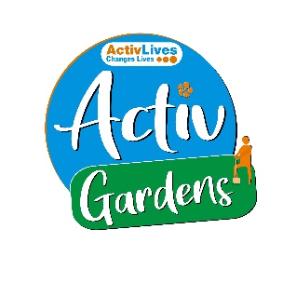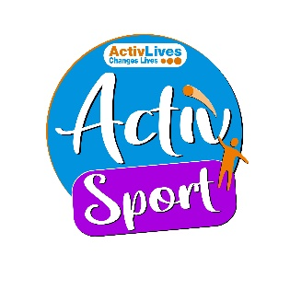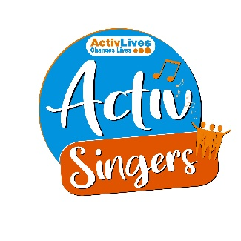
ActivHubs was set up to provide a fun and social way for people to keep fit and healthy, improve strength, balance andco-ordination, reduce stress and while doing all of that, make some new friends in the process!
ActivGardens are all about growing! Growing plants. Growing fresh healthy food. Growing yourself… your fitness, your health, your skills, your friends, your community. Get active with ActivGardens in Ipswich and Sudbury!
ActivSport - A community based sports and physical activity programme for adults. Particularly targeted at people who are not already taking part in regular sport or physical activity. New participants are always welcome!
ActivSingers meet in Ipswich and Woodbridge every couple of weeks to enjoy all of the benefits from the joy of singing. Everyone is welcome to join in with no previous experience of singing required.



The Suffolk Information Partnership manages a secure, online referral process to support vulnerable customers and clients and help them access services that they may not be able to on their own.
Please note that the referral form is only for use by organisations and is not for the public. If you wish to refer yourself or a family member to a service offered by the partners in the Scheme please contact the most appropriate organisation listed on the Partners' page.
Opportunities to Volunteer in Suffolk
Volunteer Roles - Volunteer Suffolk



Warm & relaxing space in the heart of Lowestoft

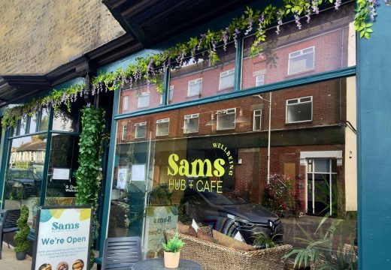

Sam’s Wellbeing Hub & Café is ready to welcome everyone, including your furry friends too (well-behaved & assistant dogs).
Nestled right in the heart of your community, we’ve created a warm, relaxing space that’s perfect for everyone to enjoy and escape to.
Whether you’re stopping by to explore our delicious food and drink menu or just looking for a cozy spot to unwind, we’re here Monday to Friday from 9:00 AM to 4:00 PM.

Seasonal events in December
Suffolk's New Christmas Destination! Bring your family, your friends, and your Christmas spirit!



Winter Village Ipswich


Visit Website
Golden Gallopers for Christmas 2025
Brighten up your Christmas with this beloved annual attraction! arc Shopping Centre, Bury St Edmunds

Christmas Events in Lowestoft

Lowestoft Town Council | Events

