

Labour Market Information & Wellbeing Events
February 2026

Ipswich Vacancies (and surrounding area)
422 jobs in Ipswich | Page 1 | Find a job

Swanton Care - Recruiter Swanton are looking for a Recruiter to work closely with hiring managers to understand their recruitment needs and service specific requirements. If you have the relevant experience and think you have what it takes, please speak to your work coach today, to apply.
Homecare direct Ltd – Personal Care AST Part time 20 hrs/week Help a vibrant woman live life to the fullest Join Homecare Direct and support a vibrant, creative woman who loves horses, arts and crafts, and countryside outings. You’ll help with daily tasks, personal care, and trips out making a real difference while enjoying companionship and variety. Full training provided, competitive pay, and ongoing support. A driving licence is essential.
One Stop – Customer Service Assistant One Stop are seeking a Customer Service Assistant in Rushmere St Andrew. Applicants must be reliable and customer focussed. If you're interested in the role and wish to apply, please ask your work coach today.
Joe Healthcare is recruiting Support Workers in the Ipswich area. These field-based roles offer flexible working patterns and full training, making them ideal for individuals looking to begin or advance a career in adult health and social care. The role involves providing personal care and supporting daily living tasks. Please speak to your work coach if you're interested in applying.
AC Waste and Removals – Drivers Mate We are seeking a reliable Delivery Drivers Mate. The successful candidate will be responsible for transporting goods in a timely and safe manner as we deliver and collect furniture / white goods. The company operate 7 days a week, you will be offered a 5- or 6- day rota. Weekend work will be involved. There will be Multi-drop Delivery's and collections Supporting the driver with the heavier items, Most are a two-person lift.
Tradeaze – Driver Tradeaze are the fastest growing same-day delivery company for construction and trades in the UK. We deliver tools and materials from builder's merchants and construction suppliers to customers across the UK. They are currently looking for Self Employed Drivers for courier work - £100 - £300 per day. If you would like to be considered, please speak with your work Coach.
SBFM Cleaner SBFM is recruiting for a Cleaner position based in the IP5 area of Ipswich. This role involves maintaining high hygiene standards by carrying out routine cleaning, emptying waste, replenishing supplies and following health and safety procedures. The position offers 24 hours per week with potential to increase to 35 hours per week and requires reliable travel to Ipswich, IP5. Please speak to your work coach if you're interested.
BCM Global have multiple jobs available in Ipswich town centre including Customer Service Officer positions and a Trainee Compliance Officer opportunity. For more info please contact your Work Coach.
Sizewell C Aspiring for a career in the nuclear sector? Explore numerous pathways to your desired profession, featuring current job openings, internships, apprenticeships and graduate schemes. Sizewell B, our operating power station on the Suffolk coast already provides long-term rewarding careers and we want Sizewell C to continue the legacy for years to come. Visit www.sizewellc.com/jobs/current-vacancies
Movement To Work – Ipswich Job Centre Placement Are you 18-29 and currently not in education, employment, or training? The DWP’s Movement to Work scheme allows 18–29-year-olds to gain valuable work experience within the Jobcentre itself. The placement usually lasts around 2 weeks but can be catered to fit the individual’s needs. You could be working alongside our Front of House team, assisting with various administration duties, supporting a DWP hosted Jobs Fair and so much more, expand your skills and improve your confidence. If you’re interested in the placement, please speak to your work coach regarding the placement.
Cidori – Construction Online Weekly CSCS SWAP The Construction Skills is a 2-week online course: - There will be a cohort starting every Monday morning. On completing and passing the course, candidates will achieve: • Level 1 Certificate – Introduction to Construction • Level 1 Certificate - Health and Safety in a Construction Environment • Level 1 Award – Personal Social Skills – waste management • Level 1 Award – Securing Employment Embedded IT skills Free CSCS Test (at an approved/external centre) plus five-year card. These qualifications all contain elements to prepare candidates to return to work, such as personal finances, mental health and wellbeing, CV writing, interview skills, and much more!
Preparing to work in Construction (CSCS) – Monday 23rd February This programme is designed to support individuals to gain qualifications required to secure employment in the construction industry. 9-day course. You must be 19 years or older to enrol, have suitable ID. Please ask your work coach for further details and to apply.

Ipswich Careers Fair
March 4, 2026
Portman Road
10am-2pm

To refer or for information on any vacancies or opportunities, please contact your work coach or contact ipswich.eainbox@dwp.gov.uk

Lowestoft Vacancies (and surrounding area)
56 jobs in Lowestoft | Page 1 | Find a job

Assistant Enforcement Officer - East Suffolk Council, Lowestoft, £31,537 - £38,220 P/Y, 37 hours P/W. Wide range of enforcement duties, from responding to complaints and carrying out site inspections to gathering evidence, preparing witness statements and, where necessary, participating in court proceedings. Full details and apply via Suffolk Jobs Direct
Attendance, Admissions and Welfare Office - Pakefield High School, £21,938 P/Y, 33 hours P/W, 8am – 3pm, 39 weeks P/Y. Well organised, flexible, adaptable and enjoys variety in your work. You will be an excellent communicator with the ability to motivate students and gain their respect. Full details and apply via Suffolk Jobs Direct
Sales Administrator – Hales, Lowestoft, Mon– Fri, 8:30 – 17:00, salary DOE. Highly organised, dependable, and able to manage multiple tasks at once. Competent with basic computer system. Full details and apply via Hales Group website
Call Referral Operator – NHS (East Coast Community Healthcare), Lowestoft, £24465 P/Y, full time. Receiving referrals via telephone, email and post, and scanning and processing these to strict deadlines. Communicate with a wide range of staff and patients. Full details and apply via Indeed
Home to School Driver – Atlas Private Hire, Lowestoft, Mon–Fri regular hours to be discussed. Excellent driving skills, Good communication skills essential. A full driving license and a Private Hire License essential. Funding can be applied for, via work coach, to obtain the Private Hire Drivers License. Speak to work coach for full details and to apply
Care and Support Assistant - Sanctuary Supported Living, Lowestoft (Clover Court), £12.60 P/H, 36 hours, 33 hours and 18 hours P/W available. Prior experience delivering personal care is desirable. A kind, caring nature. Full details and apply via Sanctuary Supported Living website
Care Assistant – Hales Care, Lowestoft, £12.21 P/H, Paid travel time & generous mileage allowance. Previous experience as a paid carer or caring for a loved one, maybe worked in retail or hospitality or other client facing role, or are simply looking to start a new career. Full UK driving licence and access to a vehicle preferred, not essential. Speak to work coach for details and to apply
Bar Team Member - Gunton Hall Coastal Village, Lowestoft, NMW, part time. Full details and apply via Warner Hotel website
Evening and weekend front of house staff - Jesters diner, Lowestoft, £7.55-£12.50 P/H, 8 – 12 P/W. Previous experience preferred but not essential. Full details and apply via Indeed
Kitchen Assistant - Lilac Lodge & Lavender Cottage, Lowestoft, £12.60 P/H, Previous experience in a similar role is desirable but not essential. Full details and apply via Kingsley Healthcare website
Midday Supervisor - Warren School, Lowestoft, Starting £12.60 P/H, 11.45am – 1.30pm. Basic level literacy and numeracy. Support with the supervision of pupils throughout the midday break ensuring that a good atmosphere is maintained. Full details and apply via Suffolk Jobs Direct
Learning Support Assistant - Horizon School, £25,185 – 25,989 pro rata, 35 hours P/W, 39 weeks P/W (term time only). Expert communication skills, superior listening skills, a deep knowledge and passion for your subject matter. Full details and apply via Suffolk Jobs Direct
Care Home Activities Coordinator - Kirkley Manor Nursing Home, Lowestoft, £12.60 P/H. Previous experience as a Lifestyle Coordinator, Activities Coordinator or a similar role in a care, community, leisure, hospitality or event management environment. Full details and apply via Kingsley Healthcare
Hospitality Manager - Kirkley Manor Nursing Home, Lowestoft, £30,000 P/Y DOE. Previous experience with a hospitality background-preferably some hotel experience. This is not a desk job! Natural warmth and a passion for looking after people. Full details and apply via Kingsley Healthcare website
Nights Team Member – Gunton Hall Coastal Village, £12.71P/H part time. Great customer service on reception, within the hotel. No experience necessary. Full details and apply via Warner Hotel website
Food Production Operative – GI Group, Lowestoft, approx. Multiple vacancies, £12.21P/H (overtime at time and a half over 40 hours), average 30-40 hours P/W (some may exceed). Mix of shifts, additional overtime. Full details and apply via GI Group website
Stores Operative (Insite Stores Operative) – Rubix, Lowestoft, full time. Ideally have some background in manufacturing, MRO, PPE or a trade counter environment, however full training will be provided. Full details and apply via Indeed
Warehouse Operative - Nutriwolds Raw, Kessingland, 30–40+ hours P/W, Mon-Fri (fixed shift options: 6:30am–2:30pm, 7am–3pm, or 8am–4:30pm). Forklift licence preferred (or willingness to obtain). Full details and apply via Indeed
HANDBALL OPERATIVE - The Best Connection Group, Lowestoft, full time, £12.21P/H. General warehouse duties. No experience needed- but please note the role involves lifting, and the shift demands vary from week to week. Full details and apply via Find A Job
Housekeeping Team Member - Gunton Hall Coastal Village, NMW, full time. Full details and apply via Warner Hotel website
Cleaner - TC Facilities Management, Lowestoft (NR33 7NR), £12.21 P/H, 7:30am starts 5 days P/W (inc. weekends). Full training will be given on all duties and machinery if required. Full details via Find A Job
Store Assistant – Aldi, Lowestoft (Tower Road), £13.02 - £13.95 P/H. Full details and apply via Aldi
Sales Colleague – Currys, Lowestoft, £12.21 8-15 hours P/W (with flexibility to work additional hours). Approachable and friendly. Keen to learn about the latest technology. Full details Indeed
Customer Sales Advisor – Halfords, Lowestoft, 12 hours P/W, £10.00 - £12.21 P/H. Experience of delivering great customer service, ideally in a retail sales environment. Ideally, some experience of working towards and achieving sales targets. Full details and apply via Indeed
Plant nursery assistants - QD Stores, Carlton Colville, 12 week contracts from 2nd or 23rd March, 8.30am to 12pm or 12pm to 3.30pm (includes alternate weekends). An interest in plants, gardening, or horticulture (experience preferred but not essential). Full details and apply via Find A Job

Lowestoft Jobcentre
50PLUS Offer
Supporting individuals aged 50 and over.
The event will provide a space for signposting and networking, where attendees can engage directly with local services and provisions that offer:
- Employment and training opportunities
- Health and wellbeing support
- Financial guidance
- Volunteering and community engagement
- Digital skills and confidence building
- Online safety and scams
Event Details
Wednesday, 25th February.
10:00am
Lowestoft Jobcentre, Rishton House, Clapham Road, Lowestoft.

Bury St Edmunds Vacancies (and surrounding area)
214 jobs in Bury St. Edmunds | Page 1 | Find a job

West Suffolk Council Jobs & Skills Fairs

- Newmarket: Wednesday, March 18 (10am-12pm) at Newmarket Racing Centre.
- Haverhill: Wednesday, April 22 (10am-12pm) at Haverhill Arts Centre.
- Bury St Edmunds: Wednesday, May 13 (10am-12:30pm) at The Apex.
- Mildenhall: Wednesday, June 24 (10am-12pm) at Mildenhall Hub.
- Haverhill: Thursday, October 1 (10am-12pm) at Haverhill Arts Centre.
- Bury St Edmunds: Wednesday, October 7 (10am-12:30pm) at The Apex.
- Newmarket: Thursday, October 29 (10am-12pm) at Newmarket Racing Centre.
- Mildenhall: Wednesday, November 4 (10am-12pm) at Mildenhall Hub.



Opportunities to Volunteer in Suffolk
https://volunteersuffolk.org.uk/

Suffolk Bright Futures




ICANBEA
icanbea... (Careers & Ideas in Norfolk & Suffolk) | icanbea...
ICANBEA is a social media styled careers website, designed to help you choose your future career from the massive spectrum of opportunities we have in Norfolk, Suffolk and beyond.

Wellbeing Support



GREEN LIGHT TRUST
Connects people with nature and each other to help build confidence, improve wellbeing and create a sense of belonging. We give people the green light to be themselves. Learn about our inspiring work to connect children, young people and adults to nature to improve their health and wellbeing.
Green Light Trust - Natural health and wellbeing support

Click here for Autumn/Winter 25/26 timetable
Recovery College | Norfolk and Suffolk NHS
Our courses provide a safe, supportive, and compassionate approach to mental health recovery. We empower, educate, and offer tools to help individuals navigate their journey while learning from others with similar experiences. They are delivered with lived and learned experience of mental health and wellbeing.
Our sessions cover a range of topics, promoting:
- Self-awareness and acceptance
- Understanding recovery principles
- Learning new skills and strategies
- Leading a meaningful life, with or without symptoms



wellbeingsuffolk.co.uk

The Wellbeing Service is the NHS Talking Therapies provider in Suffolk. Wellbeing offer a whole range of free services to support people with their wellbeing and to overcome difficulties such as stress, anxiety, depression and low mood.
All services are free and available to anyone aged 16 and over living in Suffolk.



Get Everyday Activ in Suffolk | Motivating, supporting and inspiring healthier lifestyles
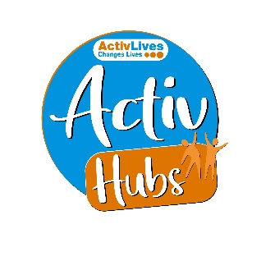
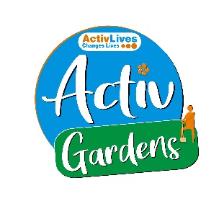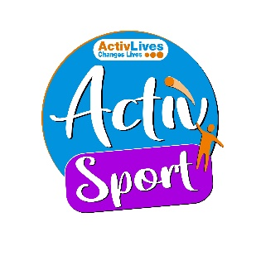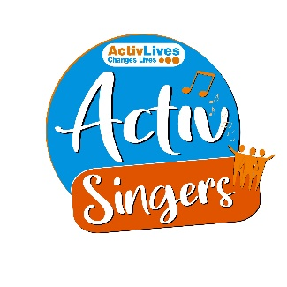
ActivHubs was set up to provide a fun and social way for people to keep fit and healthy, improve strength, balance andco-ordination, reduce stress and while doing all of that, make some new friends in the process!
ActivGardens are all about growing! Growing plants. Growing fresh healthy food. Growing yourself… your fitness, your health, your skills, your friends, your community. Get active with ActivGardens in Ipswich and Sudbury!
ActivSport - A community based sports and physical activity programme for adults. Particularly targeted at people who are not already taking part in regular sport or physical activity. New participants are always welcome!
ActivSingers meet in Ipswich and Woodbridge every couple of weeks to enjoy all of the benefits from the joy of singing. Everyone is welcome to join in with no previous experience of singing required.



The Suffolk Information Partnership manages a secure, online referral process to support vulnerable customers and clients and help them access services that they may not be able to on their own.
Please note that the referral form is only for use by organisations and is not for the public. If you wish to refer yourself or a family member to a service offered by the partners in the Scheme please contact the most appropriate organisation listed on the Partners' page.

Warm & relaxing space in the heart of Lowestoft

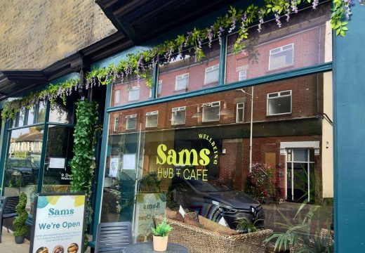

Sam’s Wellbeing Hub & Café is ready to welcome everyone, including your furry friends too (well-behaved & assistant dogs).
Nestled right in the heart of your community, we’ve created a warm, relaxing space that’s perfect for everyone to enjoy and escape to.
Whether you’re stopping by to explore our delicious food and drink menu or just looking for a cozy spot to unwind, we’re here Monday to Friday from 9:00 AM to 4:00 PM.

