

Labour Market Information & Wellbeing Events
April 2026

Ipswich Vacancies (and surrounding area)

Straight-Line Group Services Ltd
Exciting opportunities are now open in Ipswich for skilled drainage gangs and individual operatives. Straight-Line Group is offering immediate starts, competitive rates, and a one-month contract for experienced teams, including 360 operators, dumper drivers, roller operatives, and pipe layers. A great chance for reliable workers to step into well-paid, fast-paced site work. Contact your Work Coach for more information.
Specialist Passenger Solutions - Trainee and Qualified PCV Bus/Coach Driver
Specialist Passenger Solutions in Ipswich are looking for professional and customer focused individual Bus Drivers. Whether you already hold a PCV licence or are looking to start a new career, this is your opportunity to take the next step. Please speak to your work coach.
Specialist Passenger Solutions – Parking Attendant
Parking Attendant wanted for full time patrol and enforcement duties. Role includes checking permits, ensuring parking compliance, completing reports, and engaging positively with residents. Must be flexible with hours and confident using IT. A full UK driving licence (max three points) is essential. Speak to your work coach if interested.
Cranswick – Production Operatives (Day or night
Cranswick are looking for a Production Operative. A bus has been put on for successful applicants to get into and home from work – on two shifts – Day and Night.
For more information, please speak to your work coach.
Tru7 – Construction
Tru7 have the following vacancies in the Ipswich area and surrounds:
• GPS Machine Installation Engineer • Quantity Surveyor • Self Employed Plant Operator
• Estimator • Class 2 Mixer Drivers • Plumbing Mechanical Labourer.
Speak with your Work coach for more details.
Suffolk independent living
Suffolk Independent Living are hiring a carer for twin children. £16 per Hours in Holbrook, for 35 hours per week. If you would like more information on this role, please contact your Work Coach.
Morson Talent - Document Controller
Morson Talent in Leiston are recruiting for a Document Controller to work in Sizewell C from the Office and from home! The pay is very good £15 - £20 an hour! Hours to be discussed once application submitted. GCSE English and Maths needed as well as good admin and computer skills. Speak with your Work coach for more details!
Sizewell C
Aspiring for a career in the nuclear sector? Explore numerous pathways to your desired profession, featuring current job openings, internships, apprenticeships and graduate schemes. Sizewell B, our operating power station on the Suffolk coast already provides long-term rewarding careers and we want Sizewell C to continue the legacy for years to come. Visit www.sizewellc.com/jobs/current-vacancies
To refer or for information on any vacancies or opportunities, please contact your work coach or contact ipswich.eainbox@dwp.gov.uk

Ipswich Jobcentre - Newsletter Padlet
Welcome to the Ipswich Jobcentre Newsletter Padlet. Here you'll find a wide range of job seeking support, local events, courses and opportunities available in Ipswich and the surrounding areas. If you can't find what you're looking for try searching for keywords in the search bar. If you have any questions, please ask your Jobcentre work coach or get in touch via email at ipswich.eainbox@dwp.gov.uk



Lowestoft Vacancies (and surrounding area)

Support Worker – United Response; £12.40ph; F/T; This position is all about building relationships with the people you will be supporting while helping them with their day-to-day routine in line with their personal support plans. Apply via Indeed
Telephone Operator – Five One Taxis; £12.21 - £12.71ph; F/T or P/T; We are seeking a professional and courteous Telephone Operator to join our organisation. The successful candidate will be responsible for managing incoming and outgoing calls, providing excellent customer service, and ensuring effective communication across departments. Apply via Indeed
Bar Staff – Kessingland Parkdean; £12.21ph; At Parkdean Resorts, we’re searching for enthusiastic Bar Staff to join our buzzing on-park venues. If you love working with people, thrive in lively environments, and take pride in creating brilliant guest experiences, this could be the perfect role for you. Apply via Indeed
HR Advisor – East Coast College; £31,983 - £39,249pa; Permanent; F/T; The People team here at East Coast College are looking for a confident and knowledgeable HR Advisor to join them. Your success in this role will rely heavily on your ability to work closely with and guide all stakeholders within Team ECC. Apply via eastcoastcollege.talosats-careers.com
Residential Children’s Support Worker – JMR Healthcare Ltd; £15.50 - £16ph; P/T; JMR Healthcare Ltd are looking for experienced Support Workers who have experience in working with challenging behaviours to join our Residential teams in Suffolk! Apply via Indeed
Casual Funeral Service Operative – Dignity; £12.87ph; We’re looking for compassionate individuals to join our team on a casual basis, supporting families during funeral services and behind the scenes. This flexible opportunity is ideal for those who want to make a difference in their community while working around other commitments. Apply via Indeed
Labourer – East Suffolk Council; £26,403 - £28,142pa; Permanent; F/T; You will be required to undertake or assist in, a wide range of building maintenance duties performed to, or in association with, the council’s retained housing stock. The role may consist of working as part of a team or lone working in many varied tasks all consistent with providing a repair and maintenance service for council tenants to their homes. Apply via suffolkjobsdirect.org

Probation Services Officer – HM Prison & Probation Service; £26,475 - £31,650pa; Permanent; F/T; The job holder will undertake the full range of work with people on probation before and after sentence. This will include assessment, sentence implementation, offender management and producing reports. The job holder will provide case management support to a full range of people on probation. Apply via civilservicejobs
Production Specialist – Taylor Whitmore Ltd; £12.71ph; Permanent; F/T; This role involves supporting various stages of the production process within a manufacturing environment. Duties will include working as part of a team, following processes, and maintaining quality standards. Apply via Indeed
Employment Advisor – Seetec; £26,500 - £29,545pa; You'll manage a caseload of participants, managing their journey to employment, be their coach and mentor and be the principle highly trusted contact to build strong positive relationships, guide, motivate, challenge, encourage and help customers obtain sustainable employment. Apply via cv-library
Receptionist, Administrative​/Clerical - Norfolk & Suffolk Foundation NHS Trust; £24,465pa; The ideal candidate will have strong communication skills, the ability to answer telephone calls and prioritise tasks effectively, as well as demonstrate the ability to complete a variety of administrative tasks. We use a variety of different systems, so being confident in IT and with the ability to pick new things up quickly would be advantageous. Apply via learn4good.com
Travel Money Advisor – Travelex Ltd; £40,000 - £60,000pa; P/T; ou will assist customers with travel money needs, process transactions accurately, and work towards team sales targets. Ideal candidates are great communicators with a passion for helping others and a positive attitude. Apply via learn4good.com
Barista Maestro – Costa Coffee; £13.75 - £14.75ph; Lead smooth, efficient shifts; Train and support new Baristas; Energise and motivate your team; Maintain high standards across service and coffee excellence. Apply via glassdoor
Housekeeping Team Member – Travelodge; £11 - £13ph; P/T; A well-known hotel chain in Lowestoft is hiring a Housekeeping Team Member for a part-time fixed-term position. This role involves cleaning bedrooms, bathrooms, and public areas to high standards. No previous experience is necessary as training will be provided. Apply via talents.studysmarter.co.uk
Cleaner – Wede Recruitment; £13.75 - £14ph; P/T; We are currently seeking a reliable and hardworking Cleaner for an immediate start at Sunrise Academy in Lowestoft. This is a great opportunity for someone who takes pride in maintaining high standards of cleanliness and enjoys working in a school environment. Apply via cv-library
Commis Chef – Waterfront Restaurant, Kessingland; F/T or P/T; Commis Chef required to assist Head Chef in a small family-run restaurant in Kessingland. Experience not essential, but must have an enthusiastic attitude and a willingness to learn. Role will include supporting Head Chef with preparation of meals, maintaining standards of hygiene in the kitchen, and other duties as required. Apply via Indeed
Trainee Sales Negotiator – Spicerhaart; Permanent; £32,000pa; F/T; Howards Lowestoft is looking for a Trainee Sales Negotiator to join our high-performing, friendly team. You’ll receive fully funded training through the Spicerhaart Training Academy, giving you the skills, confidence, and industry knowledge needed to succeed from day one. Apply via indeed
Care Support Worker – Fuchsia Homecare; £27,248 - £29,328pa; F/T; We are seeking compassionate and dedicated Care Support Workers to join our team in the Lowestoft area. The role involves providing high-quality care and support to individuals living at home. Apply via bebee.com

Bury St Edmunds Vacancies (and surrounding area)
For vacancies in Bury St Edmunds, please visit:
Search and apply for jobs | Find a job

For all job vacancies in the Suffolk, please scan the below QR code


Jobs, Skills Fairs & Events

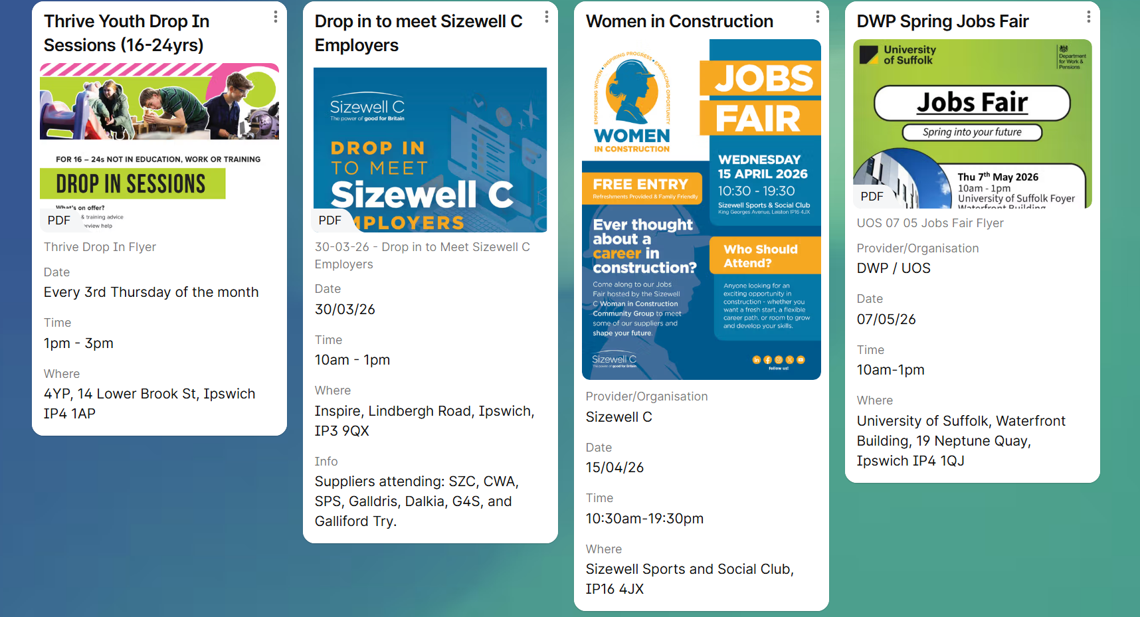

- Haverhill: Wednesday, April 22 (10am-12pm) at Haverhill Arts Centre.
- Bury St Edmunds: Wednesday, May 13 (10am-12:30pm) at The Apex.
- Mildenhall: Wednesday, June 24 (10am-12pm) at Mildenhall Hub.



Connect to Work Suffolk is here to help you find good work quickly – with free, personalised job support in the heart of your local community.

Connect to Work Suffolk - Seetec

Interview Tips and Using AI in Job Applications




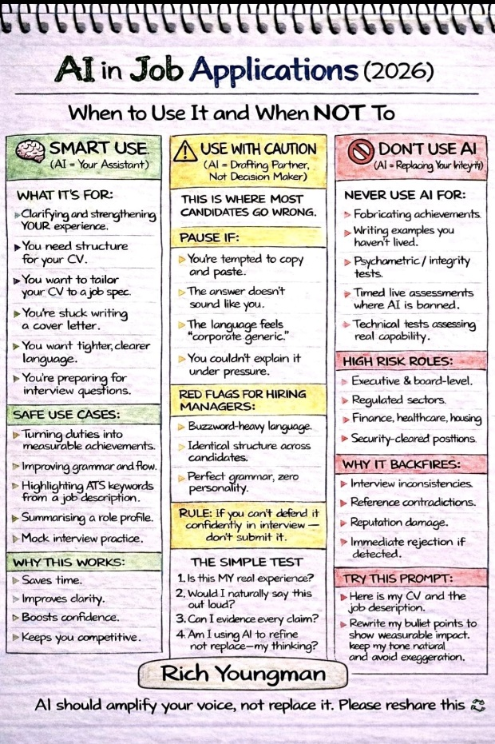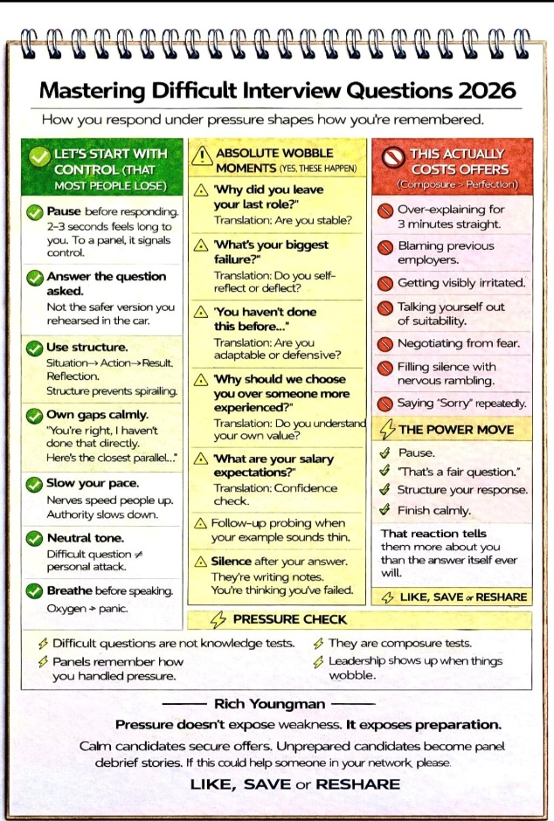



Opportunities to Volunteer in Suffolk
https://volunteersuffolk.org.uk/

Suffolk Bright Futures



Health & Wellbeing Support


Connects people with nature and each other to help build confidence, improve wellbeing and create a sense of belonging. We give people the green light to be themselves. Learn about our inspiring work to connect children, young people and adults to nature to improve their health and wellbeing.
Green Light Trust - Natural health and wellbeing support


Click here for Autumn/Winter 25/26 timetable
Recovery College | Norfolk and Suffolk NHS
Our courses provide a safe, supportive, and compassionate approach to mental health recovery. We empower, educate, and offer tools to help individuals navigate their journey while learning from others with similar experiences. They are delivered with lived and learned experience of mental health and wellbeing.
Our sessions cover a range of topics, promoting:
- Self-awareness and acceptance
- Understanding recovery principles
- Learning new skills and strategies
- Leading a meaningful life, with or without symptoms



wellbeingsuffolk.co.uk

The Wellbeing Service is the NHS Talking Therapies provider in Suffolk. Wellbeing offer a whole range of free services to support people with their wellbeing and to overcome difficulties such as stress, anxiety, depression and low mood.
All services are free and available to anyone aged 16 and over living in Suffolk.



Green Light Trust - Natural health and wellbeing support

The Green Light Trust are a health and wellbeing charity that works with nature to transform lives. Our expert-led programmes support children, young people and adults to thrive, supporting mental health, building skills, and improving the natural environment.



Get Everyday Activ in Suffolk | Motivating, supporting and inspiring healthier lifestyles

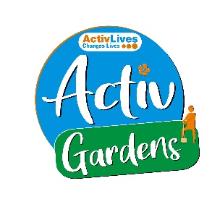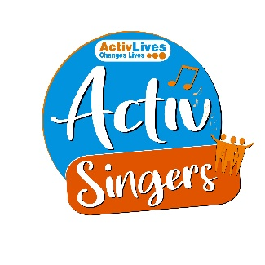
ActivHubs was set up to provide a fun and social way for people to keep fit and healthy, improve strength, balance andco-ordination, reduce stress and while doing all of that, make some new friends in the process!
ActivGardens are all about growing! Growing plants. Growing fresh healthy food. Growing yourself… your fitness, your health, your skills, your friends, your community.
ActivSport - A community based sports and physical activity programme for adults. Particularly targeted at people who are not already taking part in regular sport or physical activity. New participants are always welcome!
ActivSingers meet in Ipswich and Woodbridge every couple of weeks to enjoy all of the benefits from the joy of singing. Everyone is welcome to join in with no previous experience of singing required.



The Suffolk Information Partnership manages a secure, online referral process to support vulnerable customers and clients and help them access services that they may not be able to on their own.
Please note that the referral form is only for use by organisations and is not for the public. If you wish to refer yourself or a family member to a service offered by the partners in the Scheme please contact the most appropriate organisation listed on the Partners' page.

Warm & relaxing space in the heart of Lowestoft



Sam’s Wellbeing Hub & Café is ready to welcome everyone, including your furry friends too (well-behaved & assistant dogs).
Nestled right in the heart of your community, we’ve created a warm, relaxing space that’s perfect for everyone to enjoy and escape to.
Whether you’re stopping by to explore our delicious food and drink menu or just looking for a cozy spot to unwind, we’re here Monday to Friday from 9:00 AM to 4:00 PM.

Easter Activities



Family-Friendly Easter Fun
- Ickworth Estate (National Trust): Traditional Easter egg hunts and adventures in the gardens.
- Easton Farm Park: Spring Babies Carnival, featuring newborn lambs and goats.
- Jimmy's Farm & Wildlife Park: Egg trails, craft stations, and animal experiences.
- Pleasurewood Hills Family Theme Park: Woody's Eggcellent Adventure with themed games.
- Oasis Camel Park: Special Easter adventures with exotic animals.
- Southwold Maize Maze: Bunny hunt activities.
- The Food Museum (Stowmarket): Easter treat baking and tasting sessions.

Outdoor & Free Activities
- Thetford Forest: Perfect for spring walks and cycling.
- Aldeburgh Beach: A classic seaside stroll.
- Christchurch Park (Ipswich): Scenic parkland walking.
- Orford Ness National Nature Reserve: Enjoy the unique coastal scenery.

