

Labour Market Information & Wellbeing Events
March 2026

Ipswich Vacancies (and surrounding area)
422 jobs in Ipswich | Page 1 | Find a job

Ministry of Justice – Trainee Probation Officer
These roles offer strong long-term career prospects, structured training, and the chance to make a real difference in your community. For more information please contact your Work Coach.
CF Social – Cover Supervisor and Pastoral Support
CF Social are hiring a Cover Supervisor and Pastoral Support to work in Ipswich. If you would like more information on this role, please contact your Work Coach.
Suffolk Mind - Montrose
Suffolk Mind are looking for a compassionate and reliable Care Worker to help individuals with long-term mental health needs in their Montrose home in Ipswich. If you are interested speak to your work coach for details of how to apply.
Ingot Ventilation
Ingot Ventilation are looking for cleaning Technicians. Potential future promotion opportunities to Team Leader. Based around the Ipswich area. Previous duct cleaning is not essential as training is given. Drivers only, and a van is provided!. Speak to your Work coach if interested.
Tru7 – Construction
Tru7 have the following vacancies in the Ipswich area and surrounds:
• GPS Machine Installation Engineer
• Quantity Surveyor
• Self Employed Plant Operator
• Estimator
• Class 2 Mixer Drivers
• Plumbing Mechanical Labourer
Speak with your Work coach for more details!
Sizewell C
Aspiring for a career in the nuclear sector? Explore numerous pathways to your desired profession, featuring current job openings, internships, apprenticeships and graduate schemes. Sizewell B, our operating power station on the Suffolk coast already provides long-term rewarding careers and we want Sizewell C to continue the legacy for years to come. Visit www.sizewellc.com/jobs/current-vacancies for more details.
Specialist Passenger Solutions - Fleet Vehicle Cleaner
Join our Vehicle Presentation Team as a Fleet Vehicle Cleaner. Based in Ransomes Euro park - Ipswich you'll need to be able to reliably travel to and from without relying on public transport as shifts are from 3pm – 12am 5 days out of 7 each week. If you’re ready to make a difference and deliver exceptional standards, apply today and become an essential part of the team.
BCM Global
BCM Global have multiple jobs available in Ipswich town centre for Customer Service Officer positions. For more information, please contact your Work Coach.
Specialist Passenger Solutions - Trainee and Qualified PCV Bus/Coach Driver
Specialist Passenger Solutions in Ipswich are looking for professional and customer-focused individual Bus Drivers. Whether you already hold a PCV licence or are looking to start a new career, this is your opportunity to take the next step. If you are interested, please speak to your
work coach for details on how to apply.


Ipswich Careers Fair
March 4, 2026
Portman Road
10am-2pm



To refer or for information on any vacancies or opportunities, please contact your work coach or contact ipswich.eainbox@dwp.gov.uk

Lowestoft Vacancies (and surrounding area)
56 jobs in Lowestoft | Page 1 | Find a job

Fabricator - Phoenix Windows, Lowestoft, £12.71P/H, Mon – Thur 7:30am -5pm, Fri 7:30am – 2pm. Valid Driver's License and reliable transportation required, must be over 21 for insurance purposes. Fabrication experience highly desirable, not essential. If no direct experience, will need transferable skills. Speak to work coach for full details & apply
Maintenance Operative - Broadland Sands Holiday Park, Corton, £12.21 P/H, 40 hours P/W. Proven experience in general maintenance, including basic plumbing, carpentry, and electrical repairs. Previous experience in a similar role is preferred. Practical skills in DIY, repairs, and maintenance tasks. Experience using hand tools and equipment related to maintenance and gardening. Full details and apply via Park Holidays website
Relief Passenger Assistant – Rainbow Transport, Daily rate (depending on school run allocated), Mon - Fri, AM and PM school run, relief role initially with no guaranteed hours (permanent hours once driver available). Assist the driver wherever possible in a manner that ensures the safety and comfort of passengers. Speak to work coach for full details & apply
Home to School Driver – Atlas Private Hire, Lowestoft, Mon–Fri regular hours to be discussed. Excellent driving skills, Good communication skills essential. A full driving license and a Private Hire License essential. Funding can be applied for, via work coach, to obtain the Private Hire Drivers Licence. Speak to work coach for full details and to apply
Production Operator - Nomad Foods, Lowestoft, 12 or 8 hour shift pattern, £36,928 or £34,359 (dependant on hours). Previous experience of operating, size changing, sanitising and maintaining food manufacturing equipment. Speak to work coach for full details & apply
Customer Service Advisor - Essex and Suffolk Water, Lowestoft, Up to £29,000 DOE, 37 hours P/W. positive, and empathetic, have great communication & listening skills, be able to work as a part of a team, and have basic computer skills. Apply via Essex and Suffolk Water website
Admin Support Officer - East Suffolk Council, Lowestoft, £26,403 - £28,142 P/Y pro rata, 22.2 hours P/W. Experience required. Full details and apply via Indeed
Care Home Administrator - Lilac Lodge & Lavender Cottage, Lowestoft, £13P/H, days. Responsible for all administrative tasks. Deal with customer requests, queries and complaints. Previous experience of working in a similar environment is preferred, but not essential. Full details and apply via Kingsley Healthcare website
Care Home Activities Coordinator - Kirkley Manor Nursing Home, Lowestoft, £12.60P/H DOE. Knowledge of and experience in theatre, art, music, hospitality, and event hosting. Ability to lead group activities and manage volunteers. Full details and apply via Kingsley Healthcare website
Cleaner – Mitie, Lowestoft (Halifax), 11 hours P/W, £12.60 P/H. Ability to communicate and read basic English, previous cleaning experience is desirable but not essential and have a flexible approach to the role. Full details and apply via Find a Job
Cleaner - Northfield St Nicholas Primary Academy, 3 hours P/D, 5 days P/W, TTO plus 5 days (39 weeks per year). Undertaking various cleaning duties throughout the school to ensure our children’s learning environment is always clean. Apply via teaching-vacancies.service.gov.uk
Cleaner - Norse Group East Point Academy, £12.21ph Mon-Fri, 41 weeks 3:30 – 6. Indeed
Sales Advisor - Lifestyle and Mobility, Lowestoft, Must be 21+, £12.21 P/h (+commission), 28 hours P/W (Sat 8:30pm - 4pm, Fri, Thur, Wed) Overtime available at other times. Working with customers, till work, telephones. Technical set up, repairs, cleaning, etc as required. Driving long distances for deliveries, inc. London. Speak to work coach for full details & apply
Retail Sales Assistant – Travelex Lowestoft, 16 hours P/W, £13.00 P/H + monthly bonus. A great communicator who has a passion for great customer service. Apply via Indeed
Customer Sales Advisor – Halfords, Lowestoft, 12 hours P/W, Age 21+ £12.21 P/H & Under 21 £10.00 P/H. Experience of delivering great customer service, ideally in a retail sales environment. Ideally, some experience of working towards and achieving sales targets. Apply via Indeed
Sales Advisor (Flooring, Bed & Furniture Specialist) - Karpet & Furniture Kingdom, Lowestoft, Full-Time (Weekends Required), Base Salary + Commission. Proven sales experience, ideally within the flooring or furniture sector (product training will be provided). apply via Indeed
Assistant Retail Manager - Broadland Sands Holiday Park, Corton, £27,801 P/Y, 44 hours P/W. Experience in Complex Management, preferably within the retail or hospitality sector. Knowledge of the caravan or holiday park industry is highly desirable. Subject to DBS check. Full details and apply via Park Holidays website
Retail Sales Advisor –Brewers Decorator Centre, Lowestoft, 12 hours P/W (Fri 9am - 1pm and Sat 8am – 5pm), £8083 P/Y. Experience with our products isn't necessary. Bring great customer service and team working skills. Full details and apply via Indeed
Store Assistant – Aldi, Tower Road, £13.02 - £13.95 P/H. A really fast-paced environment, we all pitch in as part of a close-knit team. Full details and apply via Aldi website
Care Assistant – Hales Care, Lowestoft, £12.21 P/H, Alternating weekends or every weekend, various shift patterns (between 06:30 - 22:00). Full UK driving licence and access to a vehicle preferred, Can take on cyclists. Speak to work coach for full details and to apply
Catering Assistant - Northfield St Nicholas Primary Academy, 10 hours P/W, TTO (38 weeks). Basic preparation of food, Simple cooking duties under the supervision of the kitchen manager. Serving of meals to customers. Others general kitchen and dining room duties. Full details and apply via teaching-vacancies.service.gov.uk
Teaching Assistant - Roman Hill Primary School, Lowestoft, £16,030.00 - £16,541.00 P/Y (Actual), 27.5 hours P/W, 39 weeks P/Y (TTO + one week). Have experience of, or an interest in supporting pupils with special educational needs. Full details and apply via teaching-vacancies.service.gov.uk

Bury St Edmunds Vacancies (and surrounding area)
214 jobs in Bury St. Edmunds | Page 1 | Find a job

West Suffolk Council Jobs & Skills Fairs

- Newmarket: Wednesday, March 18 (10am-12pm) at Newmarket Racing Centre.
- Haverhill: Wednesday, April 22 (10am-12pm) at Haverhill Arts Centre.
- Bury St Edmunds: Wednesday, May 13 (10am-12:30pm) at The Apex.
- Mildenhall: Wednesday, June 24 (10am-12pm) at Mildenhall Hub.



Connect to Work Suffolk is here to help you find good work quickly – with free, personalised job support in the heart of your local community.

Connect to Work Suffolk - Seetec

Interview Tips and Using AI in Job Applications

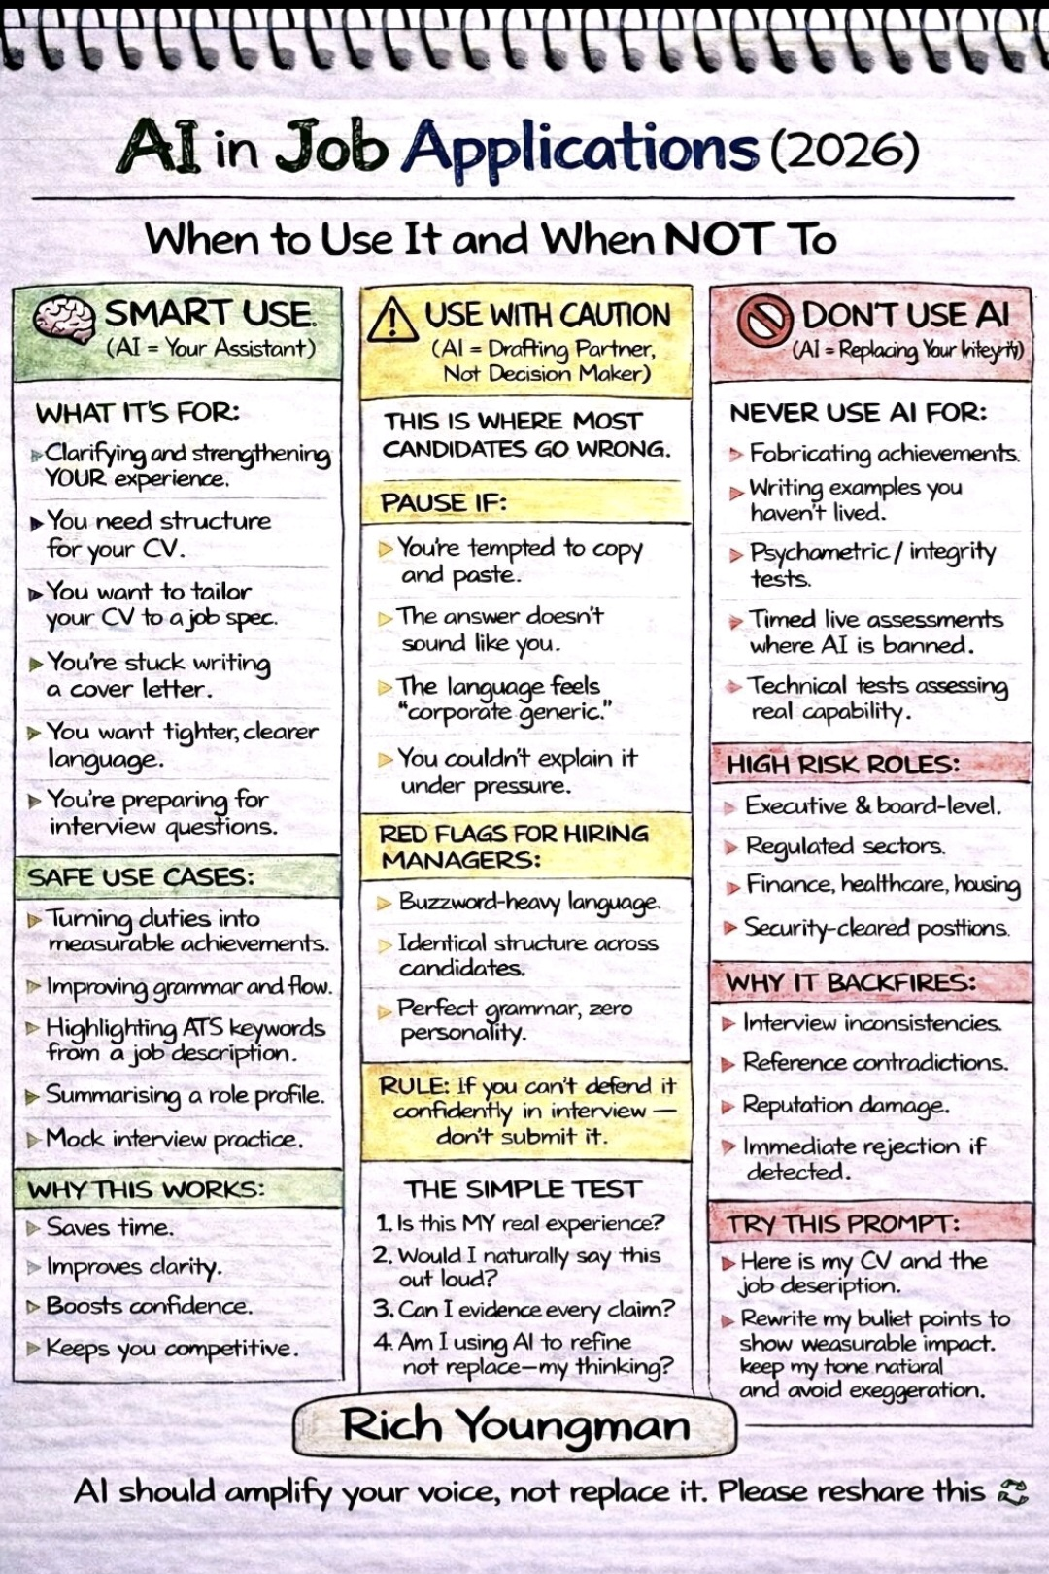
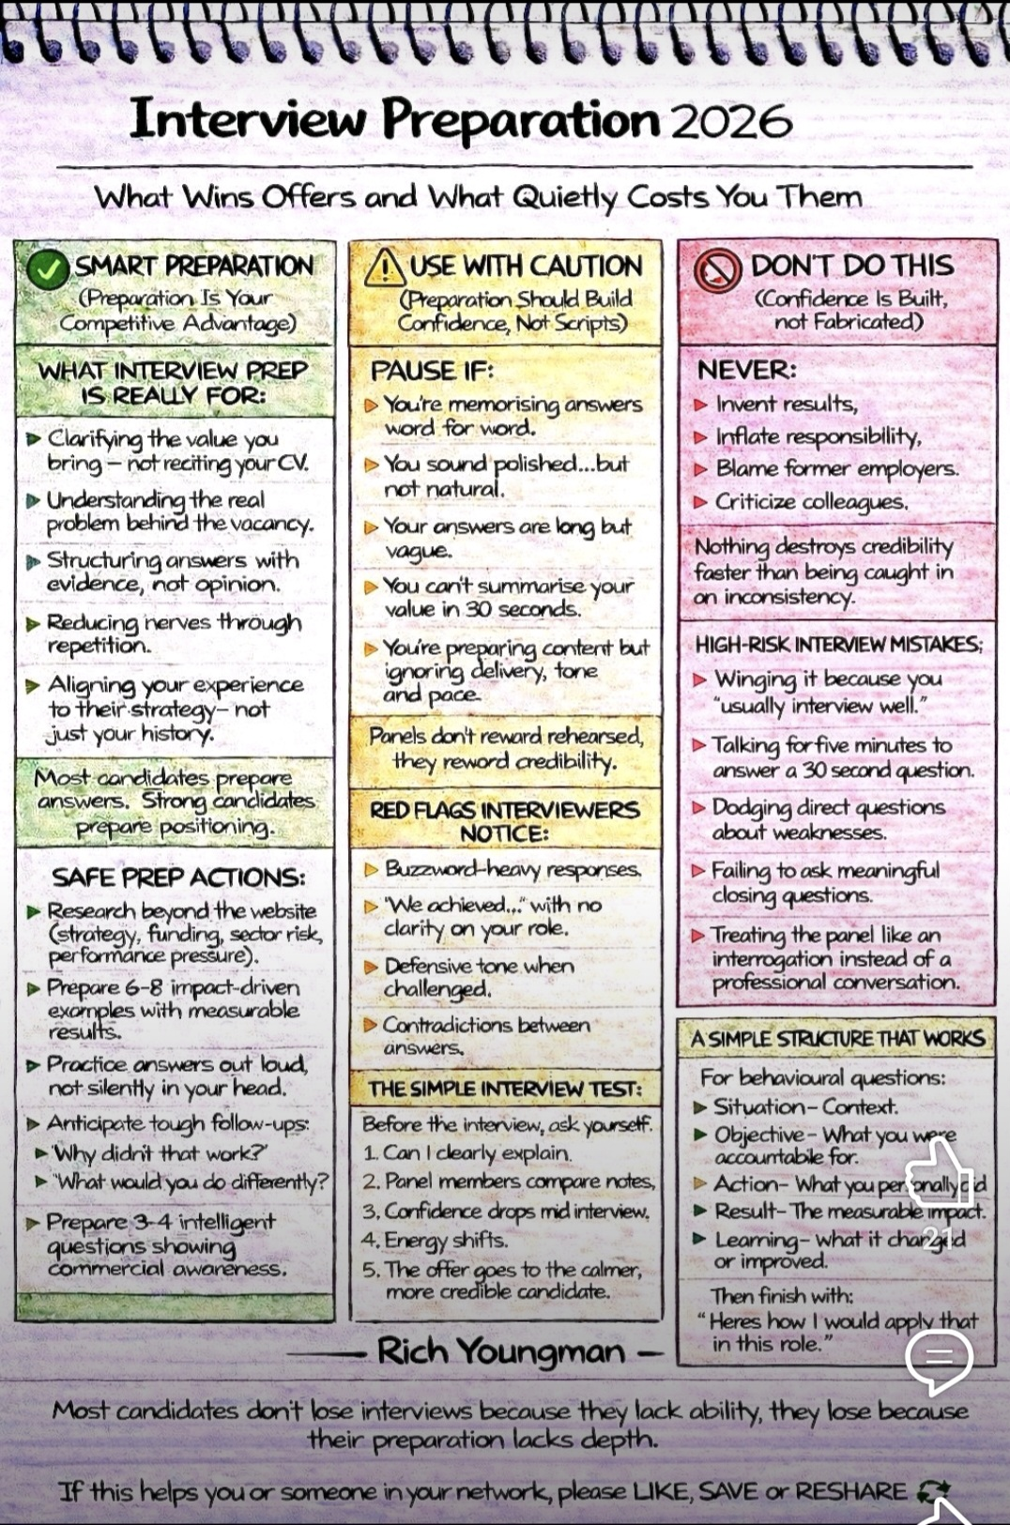



Opportunities to Volunteer in Suffolk
https://volunteersuffolk.org.uk/

Suffolk Bright Futures




ICANBEA
icanbea... (Careers & Ideas in Norfolk & Suffolk) | icanbea...
ICANBEA is a social media styled careers website, designed to help you choose your future career from the massive spectrum of opportunities we have in Norfolk, Suffolk and beyond.

Wellbeing Support

Connects people with nature and each other to help build confidence, improve wellbeing and create a sense of belonging. We give people the green light to be themselves. Learn about our inspiring work to connect children, young people and adults to nature to improve their health and wellbeing.
Green Light Trust - Natural health and wellbeing support
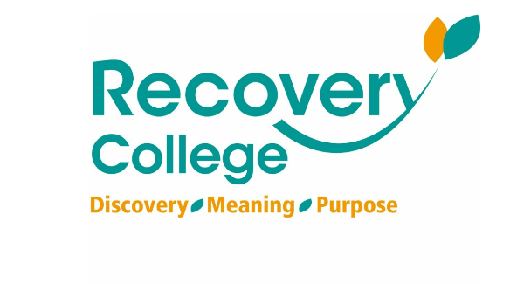
Click here for Autumn/Winter 25/26 timetable
Recovery College | Norfolk and Suffolk NHS
Our courses provide a safe, supportive, and compassionate approach to mental health recovery. We empower, educate, and offer tools to help individuals navigate their journey while learning from others with similar experiences. They are delivered with lived and learned experience of mental health and wellbeing.
Our sessions cover a range of topics, promoting:
- Self-awareness and acceptance
- Understanding recovery principles
- Learning new skills and strategies
- Leading a meaningful life, with or without symptoms



wellbeingsuffolk.co.uk

The Wellbeing Service is the NHS Talking Therapies provider in Suffolk. Wellbeing offer a whole range of free services to support people with their wellbeing and to overcome difficulties such as stress, anxiety, depression and low mood.
All services are free and available to anyone aged 16 and over living in Suffolk.



Get Everyday Activ in Suffolk | Motivating, supporting and inspiring healthier lifestyles
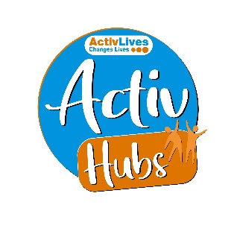
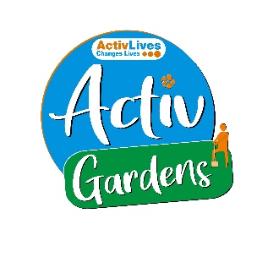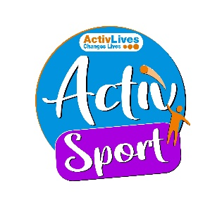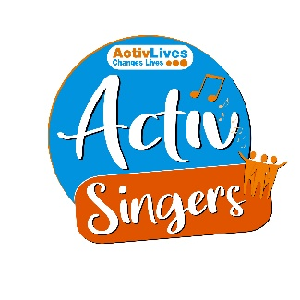
ActivHubs was set up to provide a fun and social way for people to keep fit and healthy, improve strength, balance andco-ordination, reduce stress and while doing all of that, make some new friends in the process!
ActivGardens are all about growing! Growing plants. Growing fresh healthy food. Growing yourself… your fitness, your health, your skills, your friends, your community. Get active with ActivGardens in Ipswich and Sudbury!
ActivSport - A community based sports and physical activity programme for adults. Particularly targeted at people who are not already taking part in regular sport or physical activity. New participants are always welcome!
ActivSingers meet in Ipswich and Woodbridge every couple of weeks to enjoy all of the benefits from the joy of singing. Everyone is welcome to join in with no previous experience of singing required.



The Suffolk Information Partnership manages a secure, online referral process to support vulnerable customers and clients and help them access services that they may not be able to on their own.
Please note that the referral form is only for use by organisations and is not for the public. If you wish to refer yourself or a family member to a service offered by the partners in the Scheme please contact the most appropriate organisation listed on the Partners' page.

Warm & relaxing space in the heart of Lowestoft

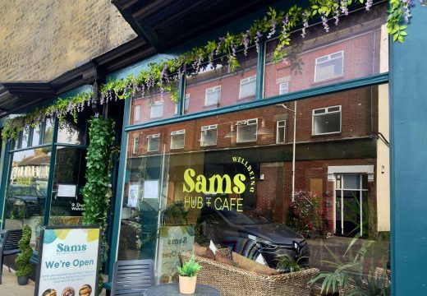

Sam’s Wellbeing Hub & Café is ready to welcome everyone, including your furry friends too (well-behaved & assistant dogs).
Nestled right in the heart of your community, we’ve created a warm, relaxing space that’s perfect for everyone to enjoy and escape to.
Whether you’re stopping by to explore our delicious food and drink menu or just looking for a cozy spot to unwind, we’re here Monday to Friday from 9:00 AM to 4:00 PM.

