

Labour Market Information & Wellbeing Events
June 2026

Ipswich Vacancies (and surrounding area)

New Look – Sales Advisor New Look are currently interviewing for a keen Sales Advisor in Ipswich. Bubbly personality and good Customer Service. If you are interested speak with your Work Coach.
My Local Bobby – Street Patrol Community Safety Officer
My Local Bobby are looking for a Street Patrol Community Safety Officer to join them on a flexible contract. SIA license required with a preference for experience. If you are able to build strong relations with the public, liaise with the police when required and are able to provide the flexibility needed get in touch with your work coach for more details.
Loyal Express Cabs Loyal Express Cabs are seeking taxi drivers to join their team. You must have a taxi license through Ipswich Borough Council to be considered for this role. If you are interested, please speak to your work coach regarding next steps.
Forklift Driver – The Range The Range is seeking a Forklift Driver (FLT Operator) to join their team in Stowmarket on a full-time basis. Working either 06:00– 18:00 or 18:00–06:00 on a 4 on, 4 off shift pattern, with interviews being held at Ipswich Jobcentre. Please speak to your work coach if you're interested in applying and would like an interview.
Pro-Fitness Martlesham This Apprentice Personal Trainer opportunity offers a great chance to gain practical experience in a professional gym setting while working towards a Level 3 qualification. You will develop essential skills in communication, teamwork, and customer service. It is ideal for motivated individuals passionate about fitness who are ready to learn, grow, and build a successful career in the health and fitness industry. Contact your Work Coach.
Range Recruitment Ltd – Mobile Cleaner Range Recruitment Ltd is seeking a Mobile Cleaner to join a small team in Ipswich, working full time Monday to Friday 08:00– 16:00 with an immediate start. Candidates require a full driving licence and have access to their own vehicle, with previous cleaning experience desirable. Please speak to your work coach if you're interested in applying.
TLP – Forklift and Warehouse TLP are interviewing for Fork Lift drivers/Warehouse in Claydon. If you have a Forklift licence and are interested in the job please speak with your Work Coach.
Sizewell C Aspiring for a career in the nuclear sector? Explore numerous pathways to your desired profession, featuring current job openings, internships, apprenticeships and graduate schemes. Sizewell B, our operating power station on the Suffolk coast already provides long-term rewarding careers and we want Sizewell C to continue the legacy for years to come. Visit www.sizewellc.com/jobs/current-vacancies

Ipswich Jobcentre - Newsletter Padlet
Welcome to the Ipswich Jobcentre Newsletter Padlet. Here you'll find a wide range of job seeking support, local events, courses and opportunities available in Ipswich and the surrounding areas. If you can't find what you're looking for try searching for keywords in the search bar. If you have any questions, please ask your Jobcentre work coach or get in touch via email at ipswich.eainbox@dwp.gov.uk

Scan the below QR code for the Ipswich JCP Padlet



Lowestoft Vacancies (and surrounding area)

Beach Office Assistant - East Suffolk Council, Lowestoft, 32 hours P/W, £25,583 - £25,989 P/Y. Flexible to respond to requirements of seasonal services, excellent communication skills, care, attention to detail and accuracy. Office experience & awareness of Health, Safety and welfare, maintenance and repair. Full details and apply via Suffolk Jobs Direct
HHSRS Coordinator - East Suffolk Council, Lowestoft, 37 hours P/W, £28,958 - £31,022 P/Y. Experience working in an admin role & have sound understanding of domestic property maintenance; along with experience in assessing and prioritising repair requests & understanding of data quality control. Full details and apply via Suffolk Jobs Direct
Administrator - Suffolk County Council, Lowestoft, 37 hours P/W, £25,185 P/Y. Organising meetings, managing finances, or helping colleagues and customers with queries. You’ll play a key part in keeping services running efficiently. Full details and apply via Suffolk Jobs Direct
Teaching Assistant - Pakefield High School, Lowestoft, £20,149 actual P/Y, 33.5 hours P/W, 39 weeks P/Y(TTO +1 week). GCSEs A*-C in English and Maths or equivalent or a willingness to upskill for these. Experience working with young people or people from other vulnerable groups and helping them to develop and progress. Full details and apply via Suffolk Jobs Direct
Student Liaison Officer - Sunrise Academy, Lowestoft, 37 hours P/W, 39 weeks P/Y, £21,377 - £22,059 P/Y. Ideally have experience in police force/ armed forces/ other careers requiring high levels of personal decision making/ negotiation skills. Educated to Level 3, enthusiastic, flexible, patient, and able to use your initiative. Full details and apply via Find A Job
Care Coordinator (Home care) - Kingsley Homecare, Lowestoft area, £30,000 P/Y, driving licence required. 2 years' experience in a care setting with vulnerable individuals. Willingness to undertake necessary NVQ or additional training. Full details and apply via Kingsley Healthcare website
Meet and Greet Receptionist - Kirkley Manor Nursing Home, Lowestoft, £13.45 P/H (DOE), weekends. Previous experience of working in a similar environment is preferred, but not essential. Full details and apply via Kingsley Healthcare website
Receptionist Team Member - Gunton Hall Coastal Village, NMW, full time. No experience necessary. Full details and apply via Warner Hotel website
Bar Team Member - Corton Coastal Village, NMW, full time. Apply via Warner Hotel website
Kitchen Porter - Gunton Hall Coastal Village, NMW, part time. Assisting in basic food preparation, washing up, cleaning, and clearing all kitchen areas. Unloading and putting away deliveries. Full details and apply via Warner Hotel website
Housekeeping Team Member - Warner Hotels, Lowestoft, NMW. Working together with a large diverse and multi-skilled team, you will ensure all our guests enjoy the highest quality stay in a perfectly kept room. Full details and apply via Warner Hotel website
Station cleaner – inploi (Carlisle Support Services), Lowestoft, £13.45 P/H, full time, must be 18+. DBS required. Full details and apply via Find A Job
Cleaner – Mitie, Lowestoft, £12.71 P/H, part time. Communicate and read basic English, previous cleaning experience is desirable, not essential. Full details and apply via Find A Job
Cleaner - Orwell Housing Association, Lowestoft, £12.77 P/H, 15 hours P/W. Clean, welcoming spaces, maintain strong infection-control standards to ensure a safe, spotless environment for everyone. Full details and apply via Find A Job
Cleaner - Thorn Baker Recruitment (The Range), Lowestoft, £12.71 P/H, Fri 7am-10am, Sat 8am-10am, Sun 7am-9am. If you have worked as a cleaner, janitor, warehouse cleaner, housekeeper please apply for this role and we will be in contact within the next 48 hours. Apply via Find A Job
Commis Chef - Corton Coastal Village, £8.50 - £13.21P/H, full time. Enthusiastic candidates who want to develop a career in the kitchen. Full details and apply via Warner Hotel website
Sandwich Artist – Subway, Lowestoft, £10.00 - £12.71 P/H, full time. Experience in food preparation, retail sales and/or customer service is desirable but not essential because you will receive full training. Full details and apply via Subway website
Colleague – Tesco, Lowestoft Leisure Way Superstore, min. 12 or 16 hours P/W, from £13.28 P/H, must be 18+. Full details and apply via Tesco website
Customer Services Assistant - Central Coop, NR33 0DS, £12.75 P/H, weekend availability. You don’t need prior experience, you just need to show pride in your appearance and actions, be willing to learn, and have a desire to do and be your best. A warm and friendly character, you will love talking and listening to our customers. Full details and apply via Indeed
Team Member – Next, Lowestoft, £8.28 - £12.71 P/H, 12.25hrs P/W (Sun 10:30-14:30; Tue 15:15-19:00; Wed 10:30-15:00). Full details and apply via Indeed
Service Colleague (Express) – Asda, Lowestoft Road (GY), 30 hours P/W. Apply via Asda website
Customer Assistant – Morrisons, Pakefield, 30 hours P/W. Helpful and friendly approach. Enjoys staying active and being hands-on. Full details and apply via Morrisons website
Security/Admin Operative - The Best Connection Group Limited, Lowestoft, £12.71P/H, 6am-6pm and 6pm-6am (usually 2 days, 2 nights, 4 off pattern), typically 3-4 shifts per week/ 36-48 hours P/W. Computer literacy is a must. Full details and apply via Find A Job
Care Home Activities Coordinator - Kirkley Manor Nursing Home, Lowestoft, £13.45 P/H (DOE), Weekdays with Alternative Weekends. Knowledge of and experience in theatre, art, music, hospitality, and event hosting. Full details and apply via Kingsley Healthcare website
Assembly Operative – Hales, Lowestoft, Mon–Thur 7:30–4:15, Fri 7:30–12:30, £12.96 P/H. Good level of dexterity and attention to detail. No previous manufacturing experience required, full training provided. Full details and apply via Hales Group website
Retail Travel Advisor – TUI, Lowestoft, part time. You’ll receive training on a variety of systems empowering you to enhance your knowledge whilst bringing memorable holidays to life for our customers. Full details and apply via Find A Job
Warehouse Operative/Driver - North Star Shipping, Lowestoft, 40 hours P/W. Valid counterbalance forklift licence (minimum 2.5 ton), Full, clean UK driving licence, previous experience in a warehouse, stores, or logistics environment. Full details and apply via Indeed

Scan the below QR code for more vacancies in Lowestoft



Bury St Edmunds Vacancies (and surrounding area)

Scan the below QR code for vacancies in Bury St Edmunds


Jobs, Skills Fairs & Events



- Mildenhall: Wednesday, June 24 (10am-12pm) at Mildenhall Hub.



Connect to Work Suffolk is here to help you find good work quickly – with free, personalised job support in the heart of your local community.

Connect to Work Suffolk - Seetec

Interview Tips and Using AI in Job Applications

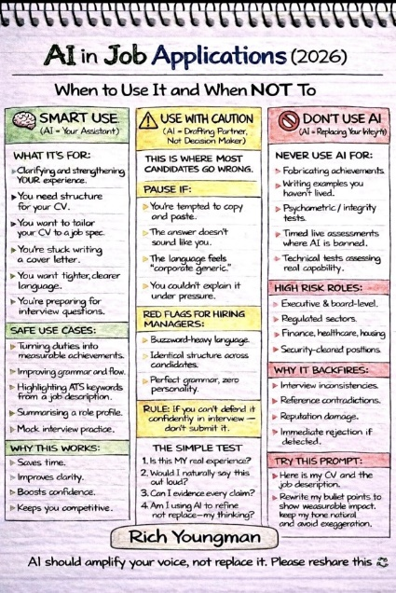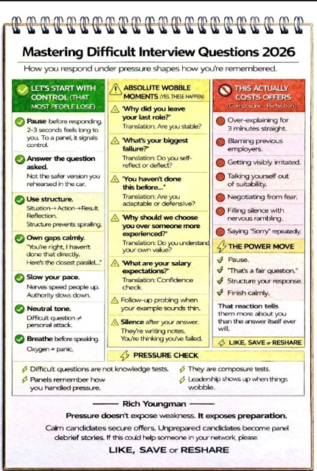



Opportunities to Volunteer in Suffolk
https://volunteersuffolk.org.uk/



Health & Wellbeing Support


Click here for Autumn/Winter 25/26 timetable
Recovery College | Norfolk and Suffolk NHS
Our courses provide a safe, supportive, and compassionate approach to mental health recovery. We empower, educate, and offer tools to help individuals navigate their journey while learning from others with similar experiences. They are delivered with lived and learned experience of mental health and wellbeing.
Our sessions cover a range of topics, promoting:
- Self-awareness and acceptance
- Understanding recovery principles
- Learning new skills and strategies
- Leading a meaningful life, with or without symptoms



wellbeingsuffolk.co.uk

The Wellbeing Service is the NHS Talking Therapies provider in Suffolk. Wellbeing offer a whole range of free services to support people with their wellbeing and to overcome difficulties such as stress, anxiety, depression and low mood.
All services are free and available to anyone aged 16 and over living in Suffolk.



Green Light Trust - Natural health and wellbeing support

The Green Light Trust are a health and wellbeing charity that works with nature to transform lives. Our expert-led programmes support children, young people and adults to thrive, supporting mental health, building skills, and improving the natural environment.



Get Everyday Activ in Suffolk | Motivating, supporting and inspiring healthier lifestyles

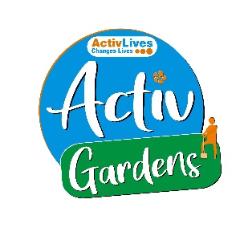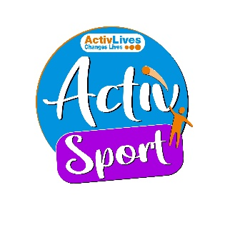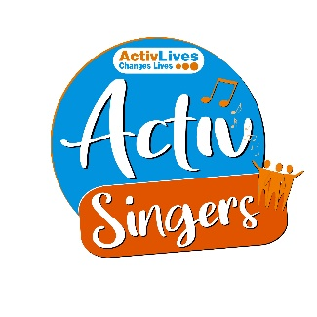
ActivHubs was set up to provide a fun and social way for people to keep fit and healthy, improve strength, balance andco-ordination, reduce stress and while doing all of that, make some new friends in the process!
ActivGardens are all about growing! Growing plants. Growing fresh healthy food. Growing yourself… your fitness, your health, your skills, your friends, your community.
ActivSport - A community based sports and physical activity programme for adults. Particularly targeted at people who are not already taking part in regular sport or physical activity. New participants are always welcome!
ActivSingers meet in Ipswich and Woodbridge every couple of weeks to enjoy all of the benefits from the joy of singing. Everyone is welcome to join in with no previous experience of singing required.



The Suffolk Information Partnership manages a secure, online referral process to support vulnerable customers and clients and help them access services that they may not be able to on their own.
Please note that the referral form is only for use by organisations and is not for the public. If you wish to refer yourself or a family member to a service offered by the partners in the Scheme please contact the most appropriate organisation listed on the Partners' page.

Warm & relaxing space in the heart of Lowestoft

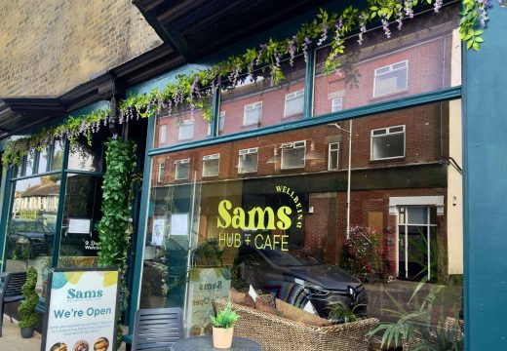

Sam’s Wellbeing Hub & Café is ready to welcome everyone, including your furry friends too (well-behaved & assistant dogs).
Nestled right in the heart of your community, we’ve created a warm, relaxing space that’s perfect for everyone to enjoy and escape to.
Whether you’re stopping by to explore our delicious food and drink menu or just looking for a cozy spot to unwind, we’re here Monday to Friday from 9:00 AM to 4:00 PM.

Events and Activities June 2026

Music & Arts Festivals
- First Light Festival (June 20–21): Head to Lowestoft's South Beach for this vibrant 24-hour arts and music festival celebrating the summer solstice.
- East Anglian Storytelling Festival (June 19–21): Taking place at The Food Museum in Stowmarket, featuring live storytelling, music, and ceilidhs.
- Golden Hour IX (June 12): An intimate live music and artist showcase at New Street Market in Woodbridge. [1, 2, 3, 4, 5]
Heritage & Family Days
- Stories of Guinness Festival (June 13): Explore the history of the Guinness family at the rarely accessible Elveden Hall, featuring historical talks and opera.
- Heveningham Hall Country Fair & Concours (June 27–28): A massive country fair in Halesworth featuring displays of historic cars, vintage aircraft, and the famous 'Horsepower Hill' drag race. [1, 2]
Food, Markets & Theatre
- Taste of East Anglia (June 13): A massive artisan food and drink festival featuring top local chefs at Kentwell Hall in Long Melford.
- Much Ado About Nothing (June 22–July 3): Enjoy a 1970s-themed production of the Shakespeare classic by Harwich Redoubt Fort.
- An Evening with Jane Green (June 12): Book discussion and audience Q&A with the New York Times bestselling author at Woodbridge Library. [1, 2, 3]

