

Labour Market Information & Wellbeing Events
May 2026

Ipswich Vacancies (and surrounding area)

SBFM is recruiting a Mobile Cleaner to work across multiple sites in Ipswich. The role includes maintaining high cleaning standards, sanitising surfaces, resolving issues, covering absences, completing stock checks and supporting managers. A company vehicle and phone are provided. Monday–Friday, 5am–1pm, some weekends, £27,500. Full driving licence required.
Suffolk Refugee Support are looking for an Employment and Training Coordinator. If you have proven experience of effective line management and knowledge of recruitment processes this could be the role for you.
Remedy Tutors are expanding across Suffolk and seeking experienced, compassionate tutors to provide personalised one-to-one support in Maths, English, or Science. Flexible hours, competitive pay (£30–£35/hr), and the chance to make a real difference for young people who need it most.
Cranswick are looking for a Production Operative. A bus has been put on for successful applicants to get into and home from work – on two shifts – Day and Night.
BCM Global are looking for a Customer Service Officer in their Ipswich town centre office . Previous customer service experience required. You will need excellent communication skills, both verbal and written. An ability to organise your work efficiently to meet deadlines will also be required. For more information, please contact your Work Coach.
Level 2 or 3 Child Care Practitioner Action Staffing are hiring a Full Time Nursery Practitioner for a new Nursery in IP1 Ipswich. If you have Level 2 or 3 Childcare Qualification.
Morson Edge – Meter Readers Enjoy being outdoors, staying active, and working independently? Morson are offering a great opportunity with full training provided, reliable hours, and supportive team culture. No experience needed—just good people skills and a willingness to get out and about. Interested? Please speak to your work Coach.
Sizewell C Aspiring for a career in the nuclear sector? Explore numerous pathways to your desired profession, featuring current job openings, internships, apprenticeships and graduate schemes. Sizewell B, our operating power station on the Suffolk coast already provides long-term rewarding careers and we want Sizewell C to continue the legacy for years to come. Visit www.sizewellc.com/jobs/current-vacancies

To refer or for information on any vacancies or opportunities, please contact your work coach or contact ipswich.eainbox@dwp.gov.uk

Scan the below QR code for more vacancies in Ipswich



Ipswich Jobcentre - Newsletter Padlet
Welcome to the Ipswich Jobcentre Newsletter Padlet. Here you'll find a wide range of job seeking support, local events, courses and opportunities available in Ipswich and the surrounding areas. If you can't find what you're looking for try searching for keywords in the search bar. If you have any questions, please ask your Jobcentre work coach or get in touch via email at ipswich.eainbox@dwp.gov.uk



Lowestoft Vacancies (and surrounding area)

Relief Passenger Assistant - Rainbow Transport, Lowestoft, daily rate, relief hours initially. Assist, monitor and supervise passengers whilst in transit/ embarking & disembarking vehicle, being responsible for their welfare. DBS check required. Speak to work coach.
Refuse Loader - East Suffolk Services, Lowestoft, 40 hours P/W (over 4 days Mon-Fri), £28,543 - £30,423 P/Y. Reliable, enjoy working as part of a team, have a keen awareness of health and safety and don’t mind physical work in all weather conditions. Full details via Suffolk Jobs Direct
Warehouse Operative – Hales, Lowestoft, Mon-Thur 7:30am – 4pm Fri 7:30am–3pm (+ overtime), £29406 P/Y. Valid counterbalance forklift licence (2.5 ton), full clean UK driving licence, Previous experience in a warehouse, stores, or logistics environment. Full details via Hales Group website
Cold store operatives - The Best Connection Group Limited, Lowestoft, £12.71P/H, 6am-6pm & 6pm-6am (Combination of day and night shifts, Typically 3-5 shifts per week), Mon-Fri. Previous warehouse or similar experience desirable. Full details via Find A Job
Learning Support Assistants - Ashley School Academy Trust, Lowestoft, £17,695 - £18,260 P/Y, 30.5 hours P/W, 39 weeks P/Y. Very good literacy and numeracy skills. Experience of working with school-aged children with Moderate and Complex needs. Experience of working within early years/foundation education. Full details and apply via Suffolk Jobs Direct
Spa Therapist - Gunton Hall Coastal Village, Lowestoft, up to £12.71 P/H, part time. Level 2 or equivalent industry qualifications required. Full details and apply via Warner Hotel website
Care Assistant/Carer – Amari Care, Lowestoft, Competitive pay/ best in Lowestoft, full or part time. Drivers preferred, will consider cyclists. Fully paid training & shadowing. EXPERIENCED AND NEW CARERS. Speak to work coach for full details and to apply
Support Worker (Learning Disability Services) - Cypress House Learning Disability Home, Lowestoft, £13.45 P/H, nights, full or part time. Previous experience as a carer is preferred, but not essential. Full details and apply via Kingsley Healthcare website
Support Worker - Orwell Housing Association, Phoenix House Lowestoft, £12.71P/H, 30 hours P/W. Supported housing for young people. Play a central role in ensuring each customer has a personalised, outcomes‑focused support plan that reflects their goals, aspirations, and individual needs. Full details and apply via Find A Job
Sandwich Artist – Subway, North Quay, NMW. Previous experience in food preparation, retail sales and/or customer service is desirable but not essential. Full details and apply via Indeed
Team Member – NEXT, NORTH QUAY 8.5 hours P/W, Sun 12pm-4pm, Sat 2:30pm-7pm. A great communicator who’s always looking for ways you can help. Full details and apply via Indeed

Sales Assistant – Ryman, Lowestoft, 7 hours P/W (Sat). Passion for the Ryman Brand and our associated companies. Passion for exceeding customer expectations. Full details via Indeed
Customer Services Advisor – Halfords, Lowestoft, £11.05 - £12.91P/H, 12 hours P/W. Experience of delivering great customer service, ideally in a retail sales environment. A proactive approach to helping customers and understanding their needs. Full details and apply via Indeed
Customer Assistant – Morrisons, Pakefield, 16 hours P/W, Mon-Fri, fully flexible between 7am-9pm. Helpful and friendly approach. Full details via Morrisons website
Customer Assistant – Morrisons, Pakefield, 30 hours P/W, Mon-Fri, fully flexible between 7am-9pm. Helpful and friendly approach. Full details via Morrisons website
FRONT OF HOUSE ASSISTANT – Bannatyne, Lowestoft, £12.71 P/H, 16 hours P/W (inc. weekends and holidays, can be 5.30am starts to 10.30pm finishes). Proven experience in a receptionist or customer service role, preferably in the hospitality industry, & proficient in using booking systems and basic computer skills desirable. Full details and apply via Indeed
Administrator – Hales Group, Lowestoft, Mon-Fri, 9am–5pm, £13 P/H. Previous administrative experience in an office or data-focused environment. Strong attention to detail and accuracy in data handling. Full details and apply via Hales Group website
Cleaner - Morson International, Lowestoft, as-and-when-required position, typically 3–4 shifts P/W between 5pm-8pm, across 7 days P/W. Maintaining a clean, safe, and hygienic environment for patients, staff, and visitors. Full details and apply via Find A Job
Housekeeping Team Member - Broadland Sands Holiday Park, Corton, £12.71P/H, 12 hours P/W. Previous experience in a housekeeping or cleaning role is preferred but not essential. Full details and apply via Park Holidays website
Lifeguard - Broadland Sands Holiday Park, Corton, £12.71P/H, 12 hours P/W. A current lifeguard certification from a recognised organisation is required (e.g., NPLQ). Full details and apply via Park Holidays website
Midday Supervisor - Roman Hill Primary School, Lowestoft, £5591P/Y, 10 hours P/W, 38 weeks P/Y (TTO). Have patience, empathy and the ability to think on your feet. Demonstrate ability to exert authority and give directions in a confident manner Full details and apply https://teaching-vacancies.ser vice.gov.uk
Learning Support Assistant - Phoenix St Peter Academy, Lowestoft, £24796 - £25185 P/Y, 34 hours P/W, Mon - Fri, 38 weeks plus 5 INSET days. Very good Numeracy and Literacy skills - at least GCSE C grade or equivalent, Minimum NVQ2 or equivalent qualification. Full details and apply https://teaching-vacancies.service.gov.uk
SEN Learning Support Assistant - Phoenix St Peter Academy, Lowestoft, £24796 - £25185, 32.5 hours P/W, Mon – Fri, Term-Time Only. At least one years experience of working with children with SEND in the primary age range Level 2 qualification in play work/childcare. Full details and apply https://teaching-vacancies.ser vice.gov.uk
On Call Firefighter – SCC, Lowestoft. Full UK driving license/ access to personal transport essential. Live/ work within 5 mins of station. Full details and apply via Suffolk Jobs Direct

Scan the below QR code for more vacancies in Lowestoft



Bury St Edmunds Vacancies (and surrounding area)

Scan the below QR code for vacancies in Bury St Edmunds


Jobs, Skills Fairs & Events

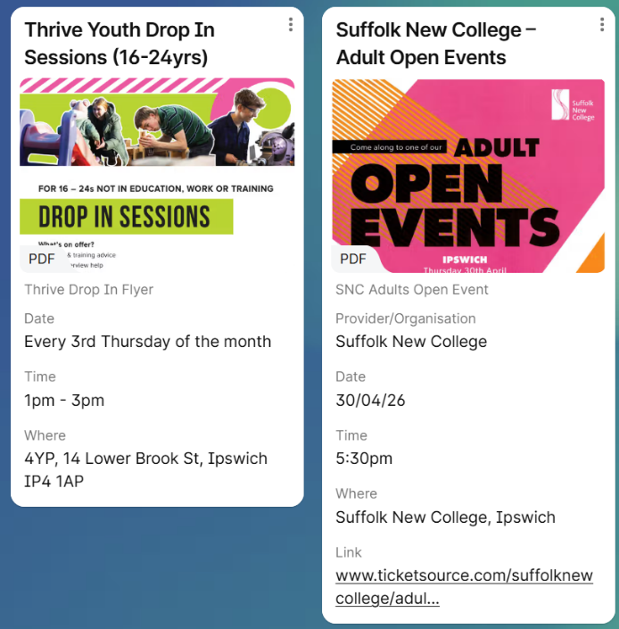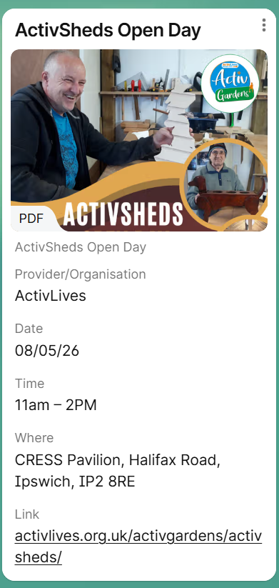

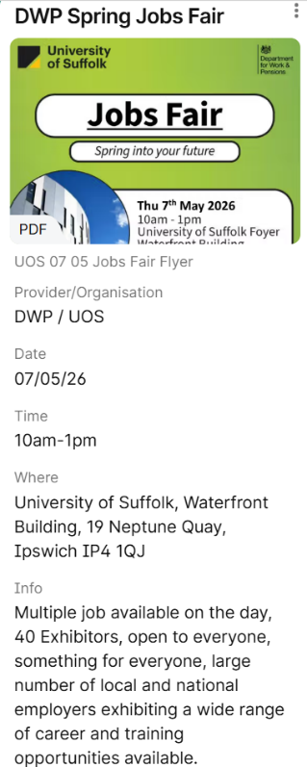

- Haverhill: Wednesday, April 22 (10am-12pm) at Haverhill Arts Centre.
- Bury St Edmunds: Wednesday, May 13 (10am-12:30pm) at The Apex.
- Mildenhall: Wednesday, June 24 (10am-12pm) at Mildenhall Hub.



Connect to Work Suffolk is here to help you find good work quickly – with free, personalised job support in the heart of your local community.

Connect to Work Suffolk - Seetec

Interview Tips and Using AI in Job Applications

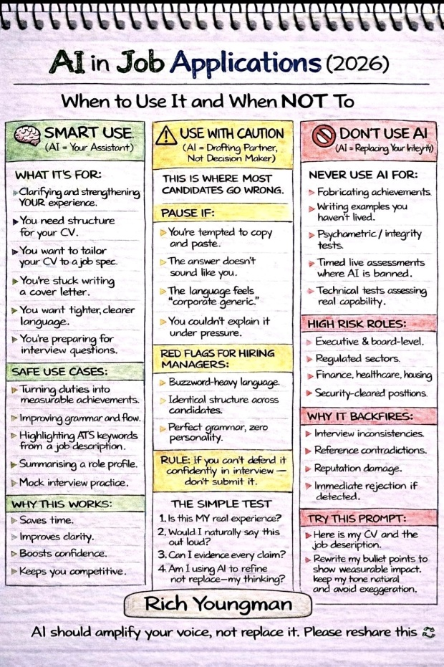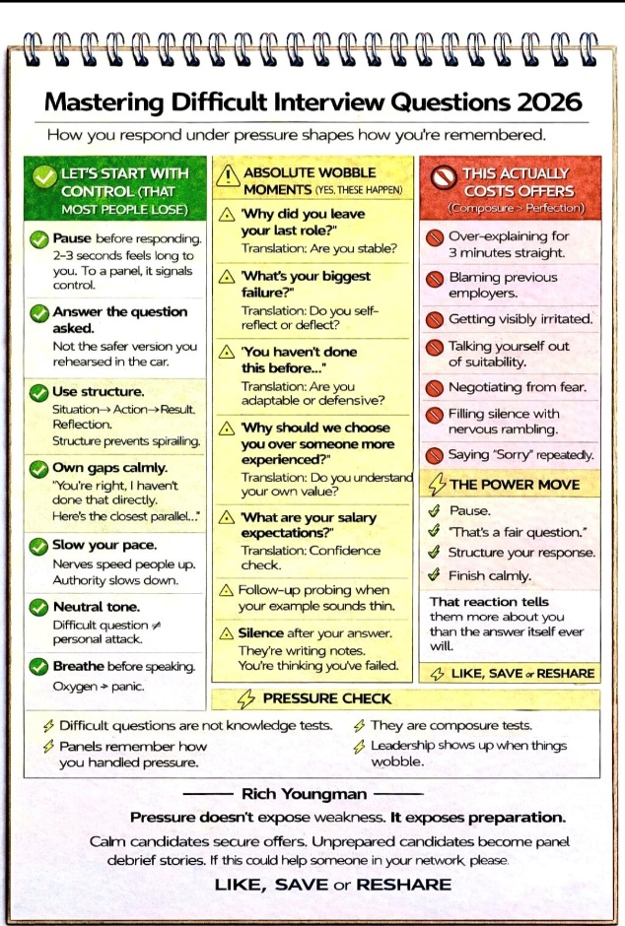



Opportunities to Volunteer in Suffolk
https://volunteersuffolk.org.uk/

Health & Wellbeing Support

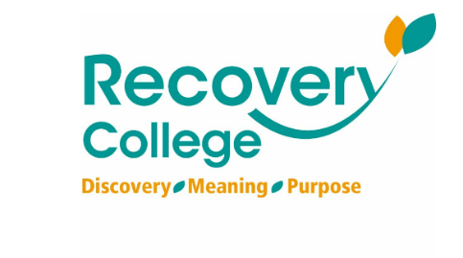
Click here for Autumn/Winter 25/26 timetable
Recovery College | Norfolk and Suffolk NHS
Our courses provide a safe, supportive, and compassionate approach to mental health recovery. We empower, educate, and offer tools to help individuals navigate their journey while learning from others with similar experiences. They are delivered with lived and learned experience of mental health and wellbeing.
Our sessions cover a range of topics, promoting:
- Self-awareness and acceptance
- Understanding recovery principles
- Learning new skills and strategies
- Leading a meaningful life, with or without symptoms



wellbeingsuffolk.co.uk

The Wellbeing Service is the NHS Talking Therapies provider in Suffolk. Wellbeing offer a whole range of free services to support people with their wellbeing and to overcome difficulties such as stress, anxiety, depression and low mood.
All services are free and available to anyone aged 16 and over living in Suffolk.



Green Light Trust - Natural health and wellbeing support

The Green Light Trust are a health and wellbeing charity that works with nature to transform lives. Our expert-led programmes support children, young people and adults to thrive, supporting mental health, building skills, and improving the natural environment.



Get Everyday Activ in Suffolk | Motivating, supporting and inspiring healthier lifestyles
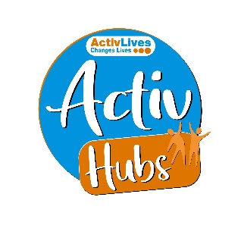
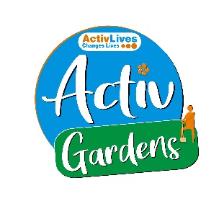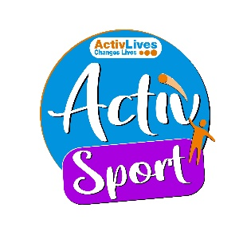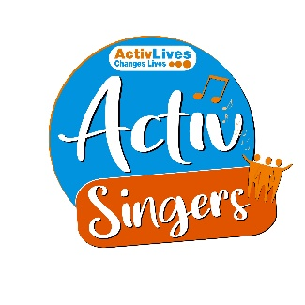
ActivHubs was set up to provide a fun and social way for people to keep fit and healthy, improve strength, balance andco-ordination, reduce stress and while doing all of that, make some new friends in the process!
ActivGardens are all about growing! Growing plants. Growing fresh healthy food. Growing yourself… your fitness, your health, your skills, your friends, your community.
ActivSport - A community based sports and physical activity programme for adults. Particularly targeted at people who are not already taking part in regular sport or physical activity. New participants are always welcome!
ActivSingers meet in Ipswich and Woodbridge every couple of weeks to enjoy all of the benefits from the joy of singing. Everyone is welcome to join in with no previous experience of singing required.



The Suffolk Information Partnership manages a secure, online referral process to support vulnerable customers and clients and help them access services that they may not be able to on their own.
Please note that the referral form is only for use by organisations and is not for the public. If you wish to refer yourself or a family member to a service offered by the partners in the Scheme please contact the most appropriate organisation listed on the Partners' page.

Warm & relaxing space in the heart of Lowestoft

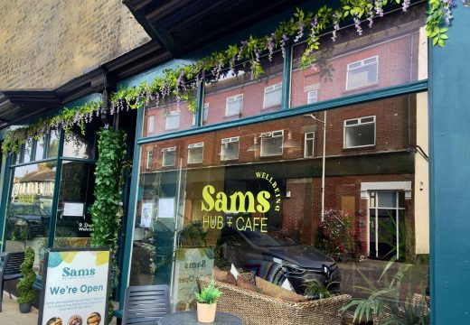

Sam’s Wellbeing Hub & Café is ready to welcome everyone, including your furry friends too (well-behaved & assistant dogs).
Nestled right in the heart of your community, we’ve created a warm, relaxing space that’s perfect for everyone to enjoy and escape to.
Whether you’re stopping by to explore our delicious food and drink menu or just looking for a cozy spot to unwind, we’re here Monday to Friday from 9:00 AM to 4:00 PM.

Key Events and Activities coming up in Suffolk


The Suffolk Show (27-28 May 2026): A two-day event at Trinity Park, Ipswich, featuring livestock, show jumping, and local produce The Suffolk Show
Red Rooster Festival (30 May – 1 June): Held at Euston Hall, offering live music in a scenic setting Statement from Red Rooster Festival
Suffolk Walking Festival A month-long event with over 100 walks showcasing Suffolk's countryside and history Suffolk Walking Festival - Celebrate Suffolk Every May
Bluebell Sundays (Late April – early May): Haughley Park opens its private woodlands for walks among the bluebells Bluebell Sundays - Google Search
Hadleigh Show (18 May 2024 - Check for 2026): A traditional agricultural show Welcome to Hadleigh Show | Hadleigh Show
Big Day Out (9 May 2026): A free, family-friendly event at Suffolk Rural Campus Big Day Out - Suffolk New College
Suffolk River Trips Boat trips departing from Orford Quay, including trips to see Havergate Island Suffolk River Trips - boat trips down the river Alde, river Ore and river Deben
Music in the Gardens Garden exploration and live music at Helmingham Hall Music In the Gardens - Jax & Co

