

Labour Market Information & Wellbeing Events
July 2026

Ipswich Vacancies (and surrounding area)

Universal Credit Job Centre - Work Coach The DWP are currently recruiting for Universal Credit work coaches (Ipswich, Sudbury, Colchester and more). Offering a rewarding career where you’ll support people into employment and financial independence. This varied, customer focused role provides excellent training, career progression and the chance to make a real difference to people’s lives every day in a supportive team environment. Apply before 7th July - https://shorturl.at/ZIPHB
Track Marshall/ Race Director - Anglia Indoor Karting
Anglia Indoor Karting are recruiting 2 Track Marshall/Race Directors to join their team in Ipswich. This is an excellent opportunity for someone looking to gain experience in a customer service role. If you would like more information on this role, please contact your Work Coach.
Learning Support Assistant – TCHC
TCHC are hiring a Learning Support Assistant to work in their Ipswich branch. You must hold or be willing to work towards a Level 2 Learner Support Certificate, with Level 2 qualifications in Maths and English. Preferably experience in supporting 16 -19 aged learners in education and those with learning difficulties and/or disabilities, with a good understanding of inclusive learning. Please contact your work coach to apply.
Done with Dirt - Cleaning Operative
Done with Dirt are seeking a part-time cleaner to work in and around the Ipswich area both in Domestic and Commercial environments. The ideal candidate must be reliable, detail-oriented, and committed to providing a clean and safe environment for all. Candidates must hold a Full UK driving licence and access to a vehicle is also required. Please speak to your work coach if you're interested in applying,
Shop Manager – Oxfam
Join Oxfam as a Shop Manager and lead a motivated team to drive sales, support community impact, and deliver outstanding customer experiences. This is a rewarding opportunity for a commercially aware leader who thrives on delivering results, embracing change, and making a difference while championing equality, diversity, and sustainability in a dynamic retail environment. Contact your Work Coach for more information.
Sales Colleague – Peacocks (Woodbridge)
Peacocks are seeking 2 x motivated and enthusiastic Sales Associates to join their dynamic team. The ideal candidate will possess excellent communication skills and a passion for providing exceptional customer service. As a Sales Associate, you will play a crucial role in driving sales and ensuring a positive shopping experience for our customers. Please speak to your work coach if you’re interested in applying.
Care Support Worker - Ocala Recruitment (Woodbridge)
You'll be providing care and support to a range of care services. As an agency carer, you'll be working with in other care providers, providing sickness and holiday cover for their permanent staff. Due to the expectation that you'll hit the ground running on shift, we require all successful applicants to have a minimum of 6 months professional experience in care. Please speak to you work coach to apply.

Deputy Cleaning Manager - Jenzo Group
Jenzo Group are recruiting a Deputy Manager for the Cleaning team in Ipswich. This is an excellent opportunity for someone looking to gain experience in a management role and develop their skills in a dynamic and fast-paced environment. If you would like more information on this role, please contact your Work Coach
Sizewell C Aspiring for a career in the nuclear sector? Explore numerous pathways to your desired profession, featuring current job openings, internships, apprenticeships and graduate schemes. Sizewell B, our operating power station on the Suffolk coast already provides long-term rewarding careers and we want Sizewell C to continue the legacy for years to come. Visit www.sizewellc.com/jobs/current-vacancies

Ipswich Jobcentre - Newsletter Padlet
Welcome to the Ipswich Jobcentre Newsletter Padlet. Here you'll find a wide range of job seeking support, local events, courses and opportunities available in Ipswich and the surrounding areas. If you can't find what you're looking for try searching for keywords in the search bar. If you have any questions, please ask your Jobcentre work coach or get in touch via email at ipswich.eainbox@dwp.gov.uk

Scan the below QR code for the Ipswich JCP Padlet



Lowestoft Vacancies (and surrounding area)

General catering assistant – Hotel Victoria, Lowestoft, part time (extra hours available when business requires). Full training provided. Full details advertised on company Facebook, send CV to gm@hotelvictoria.co.uk or call to arrange an interview 01502 574433
Kitchen Assistant - Lilac Lodge & Lavender Cottage, Lowestoft, £13.45 P/H. Previous experience in a similar role is desirable but not essential. A good understanding of food hygiene and safety practices. Full details and apply via Kingsley Healthcare website
Food and Beverage Team Member - Corton Coastal Village, NMW, full time. Full details and apply via Warner Hotel website
Waiting Staff – Harvester, Lowestoft, full time/ part time, NMW. Full details and via Harri website
Kitchen Assistant - Harvester - Potters Kiln, Lowestoft, full time. Set up the kitchen ready for the day. Help keep the kitchen clean during a busy shift. Full details and apply via Indeed
Kitchen Porter - Hotel Hatfield, Lowestoft, part time. Previous experience in a busy kitchen desirable but not essential. Full details and apply via Indeed
Sandwich Artist – Subway, North Quay full time & Tower Road x2 part time roles. Previous experience in food preparation, retail sales and/or customer service is desirable but not essential. Full details and apply via Subway website
Café All Rounder - Deans Beans, Lowestoft, £12.71 P/H, Fri/ Sun/ every other Sat. Similar experience would be great but as long as you have the right attitude it’s not essential. Full details and apply via Indeed
Housekeeping Team Member - Warner Hotels, Corton, part time, NMW. Full details and apply via Warner Hotel website
AFTERNOON/EVENING CLEANER LOWESTOFT - Minster Cleaning, £12.71 P/H, 1.5 hours Tuesday & Thursday (3 total hours). Full training will be given. Full details and apply via Indeed
Caretaker - Dell Primary School, Lowestoft, £25,989 - £26,403 P/Y pro rata, 18.75 hours P/W, year-round. Good numeracy and literacy skills. Experience in DIY/ Trades or general maintenance person skills and the ability to provide maintenance of equipment and premises. Full details and apply via Suffolk Jobs Direct
Maintenance Operative - Broadland Sands Holiday Park, Corton, £12.71 P/H, 40 hours P/W. Proven experience in general maintenance, including basic plumbing, carpentry, and electrical repairs. Full details and apply via Park Holidays website
Labourer - East Suffolk Council, Lowestoft, £26,403 - £28,142 P/Y, 37 hours P/W. Building site experience and knowledge of basic building maintenance procedures. Ability to work as part of a team, & alone and unsupervised. Full details and apply via Suffolk Jobs Direct
Residential Youth Support Practitioner - Suffolk County Council, Lowestoft, £32,887 per annum (pro rata for part time), + payment for rostered sleep in duties. Willingness to undertake training as required to update knowledge and skills. Full, current driving licence and access to personal transport/ meet mobility requirements through other reasonable means. Be able to work fixed shifts to provide 24/7 coverage. Full details and apply via Suffolk Jobs Direct
Park Warden - Broadland Sands Holiday Park, Corton, £12.71 P/H, 25 hours P/W. Proven experience in a security or warden role, with prior management experience preferred. Full details and apply via Park Holidays website
Support Worker - Suffolk County Council, Lowestoft/ Beccles/ & Bungay , 8 x 22.5 hours P/W. You will require a valid driving licence and access to a car, but apart from that no experience is required. Full details and apply via Suffolk Jobs Direct
Youth and Community Practitioner – Inspire, Lowestoft, £24,762 - £27,502 P/Y, 37.5 hours P/W. Knowledge of safeguarding and PREVENT. GCSE English (or equivalent). Full UK driving licence and access to a vehicle. Willingness to work flexibly, including residentials. Full details and apply via Suffolk Jobs Direct
Learning Support Assistant - Horizon School, Lowestoft, £25,185 - £25,989 P/Y pro rata, 35 hours P/W, 39 weeks P/Y. The work will involve responding independently to unexpected problems and situations. Full details and apply via Suffolk Jobs Direct
Business Support Project Officer (Safe Suffolk Renters) - East Suffolk Council, Lowestoft, £31,537 - £34,434, 37 hours P/W. Excellent IT skills, demonstrate excellent organisational and communication. Knowledge of office systems, use of graphic design software would be helpful. No need for prior housing experience. Full details and apply via Suffolk Jobs Direct
Receptionist - Hotel Victoria, Lowestoft, £12.71 P/H, part time (Early shift 7am-2pm / Late Shift 2pm-9pm, will include weekends). Previous experience in an administrative or receptionist role is preferred although full training will be given. Full details and apply via Indeed
Customer Representative - Alexander Mann Solutions, Lowestoft, £13.87 P/H, full time. You’ll be given plenty of training on our products, services, and processes; you just need to be comfortable using digital tools and apps. Full details and apply via Indeed
Inclusion Facilitator - Suffolk County Council, Community Based, £28,598 P/Y, 37 hours P/W (flexible options available). Experience of working with children, young people or families, with an understanding of their needs (e.g. education, care, youth work, health or similar settings). Full details and apply via Suffolk Jobs Direct
Midday Supervisory Assistant - Warren School, Lowestoft, £12.60 P/H, 11.45am - 1.30pm, Mon – Fri. Basic level of literacy and numeracy. Maintain acceptable standards of behaviour, conduct, and safety. Full details and apply via Suffolk Jobs Direct
Colleague - Tesco, Leisure Way, 16 hours P/W (min 12 hours P/W if preferred). Full details and apply via Tesco website

Leisure Team Member - Corton Coastal Village, £8.50 - £13.21 P/H, part time. National Pool Lifeguard qualification (RLSS) is essential. Full details and apply via Warner Hotel website
Flexible Workers - Nomad Foods, Lowestoft. Inspection and hand packing of products, basic machine operation, material handling/preparation, sanitation duties (including basic line set up) and maintaining housekeeping. Full details and apply via Indeed
Home to School Driver – Rainbow Transport, Mon-Fri regular hours, excellent day rates. Private Hire Licence required, or must be willing to apply (FSF funding can be applied for, to cover cost). Speak to Work Coach for full details and to apply

Scan the below QR code for more vacancies in Lowestoft



Bury St Edmunds Vacancies (and surrounding area)

Scan the below QR code for vacancies in Bury St Edmunds



Jobs, Skills Fairs & Events





Connect to Work Suffolk is here to help you find good work quickly – with free, personalised job support in the heart of your local community.

Connect to Work Suffolk - Seetec

Interview Tips – STAR method

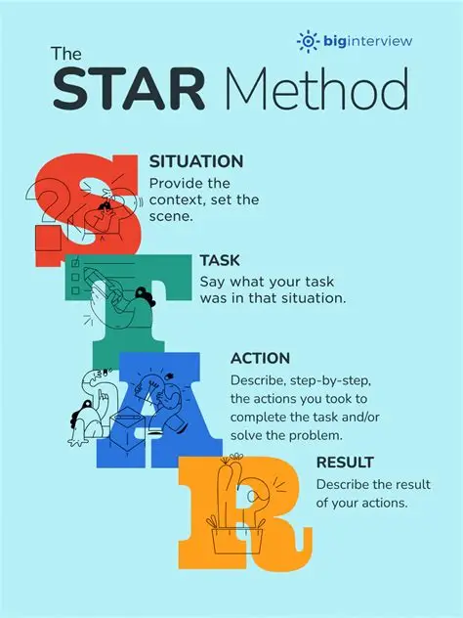



Opportunities to Volunteer in Suffolk
https://volunteersuffolk.org.uk/



The Food Museum are keen to sign up more Events Volunteers. This is occasional volunteering around major events happening throughout the year and so can suit many people, even those with busy lives and can be a lot of fun!

Next Event is the Beer Festival running 2nd July till the 5th July.

29th Festival of Beer and Brewing - Food Museum

If you are interested in volunteering for events, please contact volunteering@foodmuseum.org.uk or apply directly using the link below. You will need to go through the normal volunteering onboarding system which includes sign up with a Volunteering Agreement, provision of character references, understanding and consideration of our policies and procedures and an induction process. Once signed up you will be good to go for future events.

Website Volunteer Registration Form Survey

Opportunity to highlight the Green Therapy Courses as spaces still available for the Summer Course:
13 Jul 2026 - 31 Aug 2026, 10.00 till 13.00 (8 weeks)
The courses run as either Monday attendance or Wednesday attendance.
The courses are FREE and designed to engage people who feel they could benefit in some way from time spent outside, interacting with growing programmes and with nature.
The groups have a maximum of 10 places.

Green Therapy Courses - Food Museum
The Food Museum
01449 618228

Health & Wellbeing Support


Click here for Autumn/Winter 25/26 timetable
Recovery College | Norfolk and Suffolk NHS
Our courses provide a safe, supportive, and compassionate approach to mental health recovery. We empower, educate, and offer tools to help individuals navigate their journey while learning from others with similar experiences. They are delivered with lived and learned experience of mental health and wellbeing.
Our sessions cover a range of topics, promoting:
- Self-awareness and acceptance
- Understanding recovery principles
- Learning new skills and strategies
- Leading a meaningful life, with or without symptoms



wellbeingsuffolk.co.uk

The Wellbeing Service is the NHS Talking Therapies provider in Suffolk. Wellbeing offer a whole range of free services to support people with their wellbeing and to overcome difficulties such as stress, anxiety, depression and low mood.
All services are free and available to anyone aged 16 and over living in Suffolk.



Green Light Trust - Natural health and wellbeing support

The Green Light Trust are a health and wellbeing charity that works with nature to transform lives. Our expert-led programmes support children, young people and adults to thrive, supporting mental health, building skills, and improving the natural environment.



Get Everyday Activ in Suffolk | Motivating, supporting and inspiring healthier lifestyles
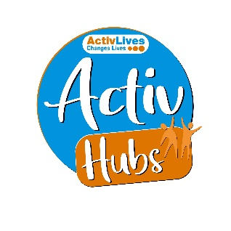
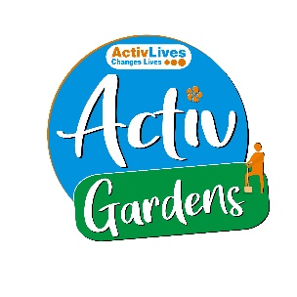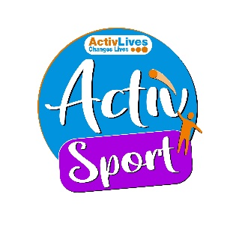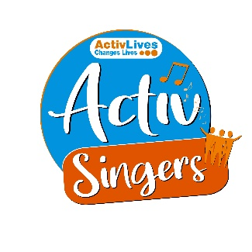
ActivHubs was set up to provide a fun and social way for people to keep fit and healthy, improve strength, balance andco-ordination, reduce stress and while doing all of that, make some new friends in the process!
ActivGardens are all about growing! Growing plants. Growing fresh healthy food. Growing yourself… your fitness, your health, your skills, your friends, your community.
ActivSport - A community based sports and physical activity programme for adults. Particularly targeted at people who are not already taking part in regular sport or physical activity. New participants are always welcome!
ActivSingers meet in Ipswich and Woodbridge every couple of weeks to enjoy all of the benefits from the joy of singing. Everyone is welcome to join in with no previous experience of singing required.



The Suffolk Information Partnership manages a secure, online referral process to support vulnerable customers and clients and help them access services that they may not be able to on their own.
Please note that the referral form is only for use by organisations and is not for the public. If you wish to refer yourself or a family member to a service offered by the partners in the Scheme please contact the most appropriate organisation listed on the Partners' page.

Warm & relaxing space in the heart of Lowestoft

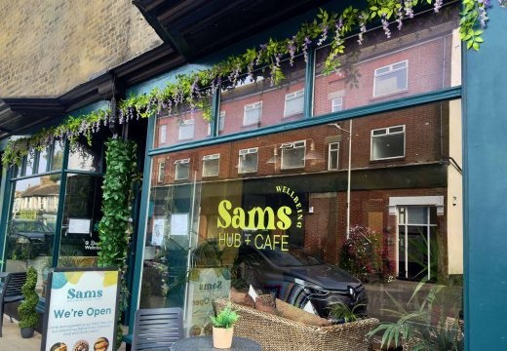

Sam’s Wellbeing Hub & Café is ready to welcome everyone, including your furry friends too (well-behaved & assistant dogs).
Nestled right in the heart of your community, we’ve created a warm, relaxing space that’s perfect for everyone to enjoy and escape to.
Whether you’re stopping by to explore our delicious food and drink menu or just looking for a cozy spot to unwind, we’re here Monday to Friday from 9:00 AM to 4:00 PM.

Events and Activities July 2026



Major Festivals & Multi-Day Events
- Latitude Festival: Taking place 23rd–26th July at Henham Park (near Southwold). Celebrating its 20th year, the festival features major headliners, comedy, arts, and wellness Latitude Festival.
- The Suffolk Military Show: Held at Trinity Park in Ipswich on the 25th and 26th July. This family-friendly weekend covers 1,000 years of history, featuring massive battle reenactments, military vehicles, and a Battle of Britain Memorial Flight flypast The Suffolk Military Show. [1]
Live Music & Outdoor Performances
- Ipswich Music Day: Taking place on 5th July around Christchurch Mansion. It's one of the largest free one-day music festivals in the UK, drawing tens of thousands of people for multiple stages of live music Ipswich Music Day.
- Theatre in the Forest: From 22nd July through mid-August, the Red Rose Chain brings William Shakespeare’s Twelfth Night to the stunning outdoor amphitheatre at Sutton Hoo Theatre in the Forest 2026: Twelfth Night.
Film & Arts
- Outdoor Cinema at Helmingham Hall: On 5th July, you can catch open-air screenings on the beautiful grounds of Helmingham Hall, including showings of Pride & Prejudice and an Andrea Bocelli concert film Pride and Prejudice Outdoor Cinema. [1]
- Witness for the Prosecution: The Sudbury Dramatic Society will be running a thrilling theatrical production of the Agatha Christie classic courtroom drama at the Sudbury Arts Centre (15th–18th July) WITNESS FOR THE PROSECUTION by AGATHA CHRISTIE. [1]

