

Labour Market Information & Wellbeing Events
October 2026

Ipswich Vacancies (and surrounding area)

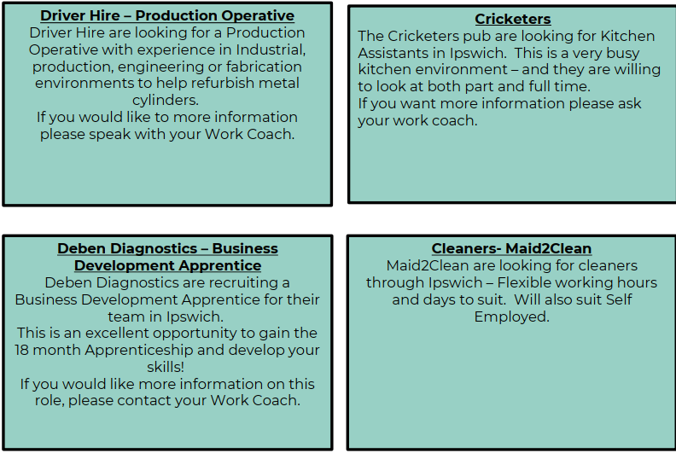
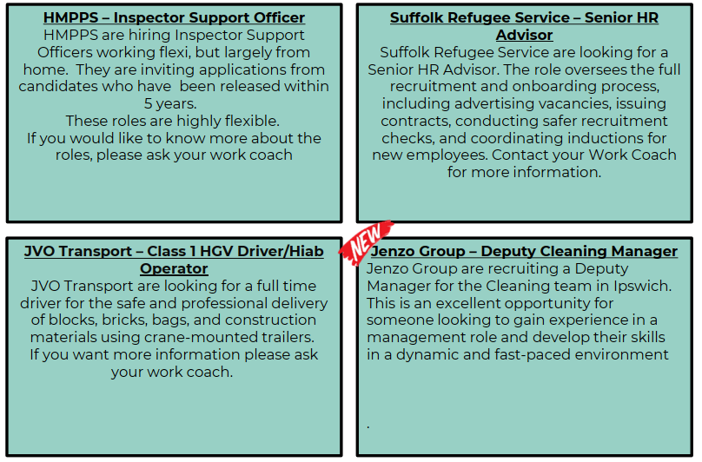



Ipswich Jobcentre - Newsletter Padlet
Welcome to the Ipswich Jobcentre Newsletter Padlet. Here you'll find a wide range of job seeking support, local events, courses and opportunities available in Ipswich and the surrounding areas. If you can't find what you're looking for try searching for keywords in the search bar. If you have any questions, please ask your Jobcentre work coach or get in touch via email at ipswich.eainbox@dwp.gov.uk

Scan the below QR code for the Ipswich JCP Padlet



Lowestoft Vacancies (and surrounding area)

Environmental Services Support Officer – East Suffolk Council; F/T; £27,274 - £32,046 pa; Your duties will include receiving and processing incoming work arriving by email, telephone, and face to face interactions, with both internal and external customers. You will also be responsible for creating and maintaining computer records using Uniform and other IT systems. Apply via Suffolk Jobs Direct

Key Holder – Poundstretcher; P/T; As a Key Holder, you’ll have the autonomy and freedom to help shape the success of your store. You’ll be working directly with the Store and Deputy Managers, learning the ropes, and taking on responsibilities that will keep the store buzzing. Apply via poundstretcher.current-vacancies.com

Cleaning Operative – Churchill Services; P/T; Temporary; Churchill Services are seeking 4 diligent and reliable Cleaners to join the team for their new contract at East Coast College. The ideal candidate will play a vital role in maintaining cleanliness and hygiene in an Education environment, ensuring that all areas are presentable and welcoming. Please speak to your Work Coach for further information (MJO ID: 5cf5b483-0309-4d24-ae1e-73effb3a0172)

Housekeeping Team Member – Broadland Sands Holiday Park; P/T; £12.71 ph; Join our dedicated housekeeping team at Park Holidays UK, where your attention to detail and commitment to cleanliness will help create unforgettable guest experiences every day. In this role, you will be responsible for maintaining the cleanliness and organisation of holiday homes and communal areas, as well as assisting with laundry duties. Apply via careers.suncommunities.com

Support Worker – Ashurst Care Home; £12.80 ph; P/T; Assist with daily routines, including personal care, activities, and recreational outings; Maintain accurate records of activities, incidents, and developmental milestones in compliance with organizational policies. Apply via Indeed

Supported Housing Officer – Anglia Care Trust; F/T; £24,810 pa; The role is designed to support early intervention, stabilisation and timely move-on, preventing repeat rough sleeping and ensuring rough sleeper beds remain accessible for those most in need. This role covers Lowestoft and East Suffolk so a full driving license and access to a vehicle are essential. Apply via angliacaretrust.org.uk

Owner Experience Specialist – Awaze; F/T; You’ll thrive in this role if you’re someone who enjoys solving problems and building meaningful relationships. You’re confident communicating with a wide range of stakeholders and comfortable balancing simple day-to-day queries with more complex commercial conversations. Apply via careers.awaze.com

Assembly Operative – Hales Recruitment; Temporary; £12.96 ph; Hales Group are delighted to be recruiting Assembly Operatives for a respected and well-established manufacturer based in Lowestoft. Known for producing premium handcrafted products, our client combines traditional skills with outstanding attention to detail, creating items that are recognised for their quality and craftsmanship. Apply via halesjobs.co.uk
Midday Supervisor Assistant (MDSA) Casual Hours – Woods Loke Primary School; £12.85 ph; Permanent; Woods Loke Primary School has openings for enthusiastic and reliable midday supervisors to work alongside a wonderful team. This role is crucial in helping make lunchtimes at our school an enjoyable and positive experience for all. Please speak to your Work Coach for further information (MJO ID: f76a0f33-bb28-48f0-a839-60ea98017d4a)

Cleaner – Morson Edge; P/T; £12.71 ph; Cleaning and sanitising wards, corridors, and communal areas; Ensuring all cleaning tasks are completed to a high standard; Following infection control and health & safety guidelines; Safe use of cleaning equipment and materials; Reporting any maintenance or safety issues as required. Apply via jobs.service.gov.uk

Barista – Starbucks (Belvedere Road Drive-thru); P/T; £12.71 ph; As a Starbucks Barista, you will deliver an exceptional customer experience, serving high-quality beverages and food in a friendly and efficient manner. You will contribute to a welcoming and safe environment while supporting the team and the store’s operational goals. Apply via harri.com

Commis Chef – Corton Coastal Village; P/T; Up to £13.21 ph; Working alongside our experienced chefs, you'll assist with food preparation, maintain high standards of food safety and hygiene, and support the smooth running of the kitchen operation. As a Commis Chef, you'll have the opportunity to develop your culinary skills. Apply via jobs.warnerhotels.co.uk

Bar Staff – The Brewery Tap; P/T; Permanent; Duties to include: Serving drinks, Stock replenishment, Customer enquiries, Cleaning spillages and bar, Experience preferred but not essential, Must be able to work evenings and weekends, Dealing with money. Please speak to your Work Coach for further information (MJO ID: bdc05f3c-a984-45a1-84b3-aa1c32b49b88)

Payroll and Pension Administrator – East Coast College; P/T; Permanent; £25,168 - £25,490 pa; Experience processing payroll and pension activities, including enrolments, ensuring accuracy and compliance. Ability to maintain accurate records, verify claims and payroll information, identify discrepancies, produce reports, and work to strict deadlines with a high level of accuracy. Apply via eastcoastcollege.talosats-careers.com

Flexible Workers - Nomad Foods (Birds Eye); F/T; Attention to detail, Flexible approach, Reliability, Proactive approach, Team Commitment. Inspection and hand packing of products, basic machine operation, material handling/preparation, sanitation duties (including basic line set up) and maintaining housekeeping. Apply via careers-nomadfoods.icims.com

Market Street Fishmonger – Lowestoft North Quay; P/T; Reporting into the Market Street Manager, you’ll bring a proactive approach to the fish counter. You'll scale, skin, fillet, and pin bone fish to company and customer specs, helping both in-store and online shoppers get delicious seafood ready for their meals. Apply via morrisons.jobs

Tesco Colleague - Lowestoft Express; £13.28 ph; P/T; Knowing your customers and serving them with passion and pride; giving great natural service. Passionate and knowledgeable about the products and services within my store. Must be 18+. Apply via careers.tesco.com

Scan the below QR code for more vacancies in Lowestoft



Bury St Edmunds Vacancies (and surrounding area)

Scan the below QR code for vacancies in Bury St Edmunds





Connect to Work Suffolk is here to help you find good work quickly – with free, personalised job support in the heart of your local community.

Connect to Work Suffolk - Seetec

Interview Tips
https://nationalcareers.service.gov.uk/careers-advice/interview-advice





Opportunities to Volunteer in Suffolk
https://volunteersuffolk.org.uk/

Health & Wellbeing Support

Click here for Autumn/Winter 25/26 timetable
Recovery College | Norfolk and Suffolk NHS
Our courses provide a safe, supportive, and compassionate approach to mental health recovery. We empower, educate, and offer tools to help individuals navigate their journey while learning from others with similar experiences. They are delivered with lived and learned experience of mental health and wellbeing.
Our sessions cover a range of topics, promoting:
- Self-awareness and acceptance
- Understanding recovery principles
- Learning new skills and strategies
- Leading a meaningful life, with or without symptoms



wellbeingsuffolk.co.uk

The Wellbeing Service is the NHS Talking Therapies provider in Suffolk. Wellbeing offer a whole range of free services to support people with their wellbeing and to overcome difficulties such as stress, anxiety, depression and low mood.
All services are free and available to anyone aged 16 and over living in Suffolk.



NEW - Suffolk Mind – REST Hub, Ipswich - Mental wellbeing support when you need it.
The REST Hub is a welcoming, non-clinical space where adults can access free mental wellbeing support from Suffolk Mind.
Whether you’re feeling overwhelmed, struggling with your mental health, finding it difficult to cope with everyday life, or simply don’t know where to turn, an experienced team are here to help.
They offer focused, person-centred support to help you understand what’s happening for you, identify your next steps and work towards improved wellbeing.
There are three ways to access support:
- Drop in during opening hours.
- Refer yourself using an online referral form to book an appointment (from 1st Sept).
- Be referred by a healthcare professional or another organisation, such as NHS 111 or your GP.

REST Hub, Ipswich - Suffolk Mind



Green Light Trust - Natural health and wellbeing support

The Green Light Trust are a health and wellbeing charity that works with nature to transform lives. Our expert-led programmes support children, young people and adults to thrive, supporting mental health, building skills, and improving the natural environment.



Get Everyday Activ in Suffolk | Motivating, supporting and inspiring healthier lifestyles

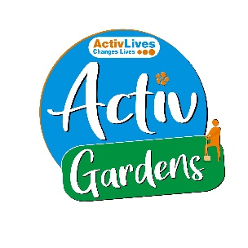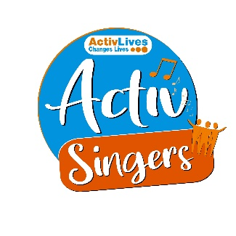
ActivHubs was set up to provide a fun and social way for people to keep fit and healthy, improve strength, balance andco-ordination, reduce stress and while doing all of that, make some new friends in the process!
ActivGardens are all about growing! Growing plants. Growing fresh healthy food. Growing yourself… your fitness, your health, your skills, your friends, your community.
ActivSport - A community based sports and physical activity programme for adults. Particularly targeted at people who are not already taking part in regular sport or physical activity. New participants are always welcome!
ActivSingers meet in Ipswich and Woodbridge every couple of weeks to enjoy all of the benefits from the joy of singing. Everyone is welcome to join in with no previous experience of singing required.



The Suffolk Information Partnership manages a secure, online referral process to support vulnerable customers and clients and help them access services that they may not be able to on their own.
Please note that the referral form is only for use by organisations and is not for the public. If you wish to refer yourself or a family member to a service offered by the partners in the Scheme please contact the most appropriate organisation listed on the Partners' page.

Warm & relaxing space in the heart of Lowestoft



Sam’s Wellbeing Hub & Café is ready to welcome everyone, including your furry friends too (well-behaved & assistant dogs).
Nestled right in the heart of your community, we’ve created a warm, relaxing space that’s perfect for everyone to enjoy and escape to.
Whether you’re stopping by to explore our delicious food and drink menu or just looking for a cozy spot to unwind, we’re here Monday to Friday from 9:00 AM to 4:00 PM.

Events and Activities Sept/Oct 2026



- There is a survey being run now aimed at unpaid carers of all ages to help Suffolk County Council better understand the experiences and needs of unpaid carers in Suffolk. Her is the link to the survey – Help shape the next Suffolk All Age Carers Strategy (2027–2030) – Fill in form
- Autumn programmes from the New Wolsey Theatre - Tell Your Story and Creative Club are back! As a social prescribing project, participants need to meet certain NHS criteria to join the programme. To see if you’re eligible, sign up or for more information, check the website or contact cdavis@wolseytheatre.co.uk.
https://www.wolseytheatre.co.uk/projects/tell-your-story/
You can find more information on the group and how to sign up on our website or email creativeclub@wolseytheatre.co.uk
Anyone aged 18+ is welcome to join.
https://www.wolseytheatre.co.uk/projects/creative-club/
- Haverhill Jobs and Skills Fair - 1st October, The Arts Centre, Haverhill, 10-12pm.
- NEW Gambling Harms project - FREE anxiety and counselling support from Suffolk Mind. Find out more at: https://www.suffolkmind.org.uk/services/gambling-harms/.
Contact: 0300 111 6000 / info@suffolkmind.org.uk.
- Please see the latest Fraud Alert, available here as a PDF, from the new Suffolk Against Fraud network.
To get in touch directly with the SAF team, email: saf@suffolk.gov.uk.
To report fraud or suspected scams to Report Fraud: www.reportfraud.police.uk.
To report fraud or suspected scams to Citizens Advice: www.citizensadvice.org.uk/consumer/scams/reporting-a-scam/
- Felixstowe Jobs & Careers Fair – Friday 2nd Oct 2026, 9.30am – 1pm, Salvation Army Community Hall, Cobbold Road, Felixstowe.
- Renew Wellbeing Café - Do you or does someone you know struggle with mental health? Would you appreciate a quiet shared space where it’s ok not to be ok? You are very welcome to the Renew Wellbeing Café. Thursdays, 12noon - 2pm, 2nd and 4th Thursday of the month
Taste Community Café, 426A Woodbridge Road, Ipswich, IP4 4EL.
- "Want to cut your food bills and cook delicious meals at home? @BagsofTaste offers a FREE, friendly cooking course to help you save money and eat well! Find out more and sign up here: https://bagsoftaste.org/students/
- Norfolk and Suffolk NHS Foundation Trust (NSFT) is holding its Annual General Meeting at The Mix, in Stowmarket, on Tuesday 6 October 2026. The meeting itself will be held at 11.30am, however, NSFT will be showcasing its work from 10am until 3pm.
- VASP Mental Health and Wellbeing Event on Wednesday 7th October from 10-12pm at Turning Point, Bury St Edmunds.
To attend, please use the link below to book your ticket:
VASP Mental Health and Wellbeing event Tickets, Wednesday, October 7 • 10 AM - 12 PM | Eventbrite
- Christies Care welcomes all to join our monthly community group, connecting local communities with activities, entertainment and guest speakers.
  - 10.30am - 12.30pm,Second Friday of every month,Ixworth Village Hall IP31 2HH
- VOLUNTEER
Red Rose Community Farm are holding a coffee morning, at 10am on Thursday 15th October, for anyone interested in getting involved.
- Choral Evensong at St Edmundsbury Cathedral on Sunday 25 October 2026 at 3.30pm (please be seated by 3.25pm).
RSVP by email to info@burydropin.org no later than Sunday 18 October so we can prepare well for this special occasion.
- Newmarket Youth Hub at the Pavilion every Monday, apart from Bank Holidays.
Monday’s 13.30pm-15.00pm- 1:1 drop-in/scheduled sessions, aimed at 16-25 but will be open to all aged 7-25.
Monday’s 15.30pm-17.00pm- drop-in group sessions designed for young people aged 7–12 and operate as a safe, structured youth club environment.
THE SEVERALS SPORTS PAVILION,
Fordham Road
Severals
Newmarket
CB8 7BS

