

Labour Market Information & Wellbeing Events
September 2026

Ipswich Vacancies (and surrounding area)

Driver Hire – Production Operative - Driver Hire are looking for a Production Operative with experience in Industrial, production, engineering or fabrication
environments to help refurbish metal cylinders. If you would like to more information please speak with your Work Coach.
Farlingaye High School – Part time cleaning roles - Farlingaye High School in Woodbridge are
recruiting Cleaning Operatives. Previous experience is preferred but not essential. You should have good customer service skills, attention to detail, and be able to work independently or within a team. Flexible working hours may apply. Contact your Work Coach for more information.
Deben Diagnostics – Business Development Apprentice
Deben Diagnostics are recruiting a Business Development Apprentice for their
team in Ipswich. This is an excellent opportunity to gain the 18 month Apprenticeship and develop your skills! If you would like more information on this role, please contact your Work Coach.
Cleaners- Maid2Clean
Maid2Clean are looking for cleaners through Ipswich – Flexible working hours
and days to suit. Will also suit Self Employed.

Core Recruiter – Labourers
Core recruiter are looking for Labourers in the Ipswich area to work Monday-Friday 09:30am-4:30pm. CSCS card required. For more information please contact your Work Coach.
Trainee and Qualified PCV Bus/Coach Driver - Specialist Passenger Solutions
Specialist Passenger Solutions in Ipswich are looking for professional and customer-
focused individuals to join their team supporting the Sizewell C Project as Bus
Drivers. Whether you already hold a PCV licence or are looking to start a new career,
this is your opportunity to take the next step. If you are interested, please speak to your work coach for details on how to apply.
Operations Coordinator - Jenzo
Jenzo Group are recruiting an Operations Coordinator for the team in Ipswich. This is an excellent opportunity for someone looking to gain experience in a management role and develop their skills in a dynamic and fast-paced environment.
Prison Officer - HMMPS
HMPPS is recruiting Prison Officers to help maintain a safe and secure environment
while supporting people in custody. This role suits individuals with strong communication skills, resilience and a positive attitude. Full training is provided, with flexible part-time hours available after training. Applicants must meet eligibility, fitness and eyesight requirements. Please
speak to your work coach if you're interested in applying.

Ipswich Jobcentre - Newsletter Padlet
Welcome to the Ipswich Jobcentre Newsletter Padlet. Here you'll find a wide range of job seeking support, local events, courses and opportunities available in Ipswich and the surrounding areas. If you can't find what you're looking for try searching for keywords in the search bar. If you have any questions, please ask your Jobcentre work coach or get in touch via email at ipswich.eainbox@dwp.gov.uk

Scan the below QR code for the Ipswich JCP Padlet



Lowestoft Vacancies (and surrounding area)

Young Person Support Worker – Sixteen Plus, Lowestoft, full time 35 hours P/W/ Relief Bank Support Workers/ part time 30 hours per month, £13 P/H. Relevant experience may come from support work, education, probation, care, community work, parenting or other roles involving responsibility for and support of others. Speak to your work coach for full details and to apply
Home to School Driver – Rainbow Transport, Lowestoft, Mon-Fri regular hours, excellent day rates offered. Excellent driving skills. Private Hire Licence, or willing to apply (FSF funding can be applied for, to cover full cost). Speak to work coach for full details and to apply
Housekeeping Team Member - Broadland Sands Holiday Park, Corton, £12.71 P/H, 12 hours P/W. Previous experience in a housekeeping or cleaning role is preferred but not essential. Full details and apply via Park Holidays website
Housekeeping Team Member - Gunton Hall Coastal Village, NMW, part time. Full details and apply via Warner Hotels website
Cleaner – Woods Loke Primary School, Lowestoft, Mon-Fri 3:15pm - 5:45pm + bank hours to cover sickness + additional hours in the school holidays, £12.85 P/H. Speak to work coach for full details and to apply
Cleaning Operative – Monthind Clean, Lowestoft, Mon-Fri 5pm-7pm, £13 P/H. Previous experience is not essential as training will be provided. Full details via Find A Job, call to apply for the role on 01206 215307 quoting ref. NNC13 or email admin@monthindclean.co.uk.
Midday Supervisor (MDSA) – Woods Loke Primary School, Lowestoft, £12.85P/H, casual 11:45 and 1:15 Monday - Friday (TTO) cover short and long term, covering illness, holidays with a view to taking on more regular hours as they become available. Speak to work coach for full details and to apply
Careers Advisor - Consortium Trust, Lowestoft, £14.29 - £15.76 P/H, 30 hours P/W, 39 week P/Y, 9am – 3.30pm Mon-Fri. Grade C/4+ level of Numeracy and Literacy, basic level of computer literacy, SEND experience (preferable). Full details and apply via Suffolk Jobs Direct
Year Leader - Pakefield High School, £24,999 actual P/Y, 37 hours P/W, 39 weeks P/Y. Non teaching. 5 GCSEs A*-C inc. Maths & English or equivalent NVQ L2. Full details and apply via Suffolk Jobs Direct
Regulatory Compliance Officer - East Suffolk Council, Lowestoft, £29,542 - £32,046 P/Y, 37 hours P/W. Review applications, collate evidence and carry out intelligence checks, you will be professionally curious, and have a knowledge of the East Suffolk area. Ability to travel across the district in your own vehicle. Full details and apply via Suffolk Jobs Direct
Volunteer Coordinator - St Elizabeth Hospice, from £26,975 P/Y, full time. People-focused role for someone who enjoys being out in the community, building relationships, developing partnerships. Full details and apply via Find A Job
Service Colleague (Express) – Asda, Hopton (Lowestoft Road), 10 hours P/W Mon 6am- 11:30am & Tue 6am- 11am, £13.10 P/H. Full details and apply via Asda website
Colleague – Tesco, Lowestoft, 4:30am start, 12 hours P/W, £13.28 P/H, must be 18+. Full details and apply via Tesco website
Sales Colleague – Currys, Lowestoft, 8-39 hours P/W, £12.71* P/H + average bonus P/H 89p (raising to £13.01 on successful completion of probation period). Keen to learn about the latest technology. Comfortable achieving personal sales, service and customer experience targets. Full details and apply via Indeed
Sales Assistant – Dunelm, Lowestoft, 16 hours P/W, NMW. You’ll support your colleagues across the store and work together to create a smooth, enjoyable experience for everyone. Full details and apply via Indeed
Customer Delivery Driver – Tesco, Lowestoft Leisure Way Superstore, £14.18 P/H, min. 16 hours P/W (roles from 12 hours are also available). Full details and apply via Tesco website
Restaurant Crew Member - Burger King, Lowestoft, NMW, part time or full time. Experience would be great if you have it - but don’t worry if not, because we’ll give you full training. Full details and apply via Harri website
Food and Beverage Assistant - The Wherry Hotel, Lowestoft, NMW, part time or full time. Experience is not essential, but an eagerness to do well is. Full details and apply via Harri website
Front of house assistant - The Copper smokehouse, Lowestoft, part time. Serving customers with food and drink, working as a team to ensure customers enjoy their visit. Setting up the restaurant, cleaning tables, bar work if old enough. Full details and apply via Find A Job
Barista – Starbucks, Lowestoft, part time (Flexibility to work varied shifts, inc. early mornings, evenings, weekends, holidays), NMW. Basic cash handling and transaction processing skills. Physical ability to stand for extended periods and lift/move stock when necessary. Full details and apply via Harri website
Spa Therapist - Gunton Hall Coastal Village, £8.50 - £13.21 P/H, part time. Level 2 or equivalent industry qualifications, Level 3 or equivalent industry qualifications massage essential. Full details and apply via Warner Hotels website
Facilities Officer – East Coast College, Lowestoft, £25,811.10 to £26,025 P/Y, 25 hours P/W. Practical and hands-on with maintenance experience. Full details and apply via East Coast College website
Maintenance Assistant - Parkdean Resorts, Kessingland, £27,414 P/Y. Hands-on experience with groundskeeping and general maintenance work, inc. garden maintenance, landscaping, and practical repair tasks. Full UK driving licence. Full details and apply via Indeed
Tyre Technician - Kirkley Run Tyres and Wheels, Lowestoft & GY, 40-48 hours P/W Mon-Sat 8am-6pm. Previous experience is essential, Driving License is ESSENTIAL. Full details & apply via Find A Job, to apply please email a cv to FAO Mark Steward or drop cv in to site
Trainee Tyre Fitter - Kirkley Run S/Stn, Lowestoft, £20,800 - £24,690 P/Y, full time. No prior experience is necessary, just a positive attitude and a willingness to learn. You will receive hands-on training to become proficient in tyre fitting, using hand tools and power tools, and supporting vehicle maintenance tasks. Full details and apply via Indeed
Roofing labourer - Norwich Conservatory Roofs, field based, full time. Experience in warm roof/conservatory roof installations is preferred. Full details and apply via Find A Job

Scan the below QR code for more vacancies in Lowestoft



Bury St Edmunds Vacancies (and surrounding area)

Scan the below QR code for vacancies in Bury St Edmunds





Connect to Work Suffolk is here to help you find good work quickly – with free, personalised job support in the heart of your local community.

Connect to Work Suffolk - Seetec

Interview Tips
https://nationalcareers.service.gov.uk/careers-advice/interview-advice





Opportunities to Volunteer in Suffolk
https://volunteersuffolk.org.uk/

Health & Wellbeing Support
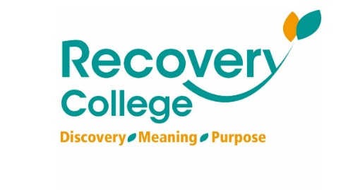
Click here for Autumn/Winter 25/26 timetable
Recovery College | Norfolk and Suffolk NHS
Our courses provide a safe, supportive, and compassionate approach to mental health recovery. We empower, educate, and offer tools to help individuals navigate their journey while learning from others with similar experiences. They are delivered with lived and learned experience of mental health and wellbeing.
Our sessions cover a range of topics, promoting:
- Self-awareness and acceptance
- Understanding recovery principles
- Learning new skills and strategies
- Leading a meaningful life, with or without symptoms



wellbeingsuffolk.co.uk

The Wellbeing Service is the NHS Talking Therapies provider in Suffolk. Wellbeing offer a whole range of free services to support people with their wellbeing and to overcome difficulties such as stress, anxiety, depression and low mood.
All services are free and available to anyone aged 16 and over living in Suffolk.



Green Light Trust - Natural health and wellbeing support

The Green Light Trust are a health and wellbeing charity that works with nature to transform lives. Our expert-led programmes support children, young people and adults to thrive, supporting mental health, building skills, and improving the natural environment.



Get Everyday Activ in Suffolk | Motivating, supporting and inspiring healthier lifestyles
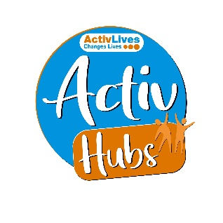
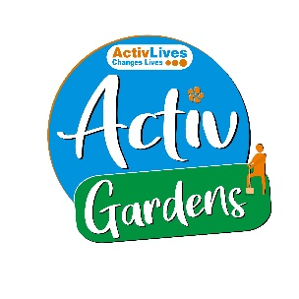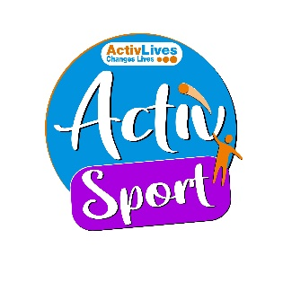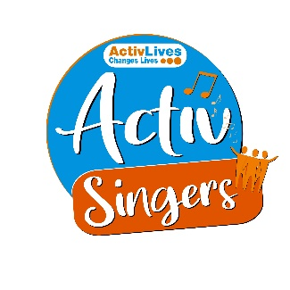
ActivHubs was set up to provide a fun and social way for people to keep fit and healthy, improve strength, balance andco-ordination, reduce stress and while doing all of that, make some new friends in the process!
ActivGardens are all about growing! Growing plants. Growing fresh healthy food. Growing yourself… your fitness, your health, your skills, your friends, your community.
ActivSport - A community based sports and physical activity programme for adults. Particularly targeted at people who are not already taking part in regular sport or physical activity. New participants are always welcome!
ActivSingers meet in Ipswich and Woodbridge every couple of weeks to enjoy all of the benefits from the joy of singing. Everyone is welcome to join in with no previous experience of singing required.



The Suffolk Information Partnership manages a secure, online referral process to support vulnerable customers and clients and help them access services that they may not be able to on their own.
Please note that the referral form is only for use by organisations and is not for the public. If you wish to refer yourself or a family member to a service offered by the partners in the Scheme please contact the most appropriate organisation listed on the Partners' page.

Warm & relaxing space in the heart of Lowestoft

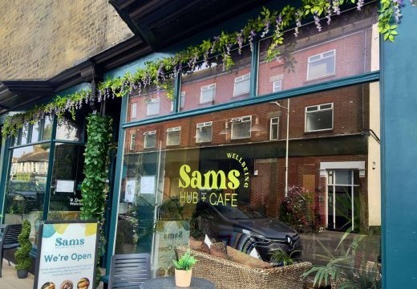

Sam’s Wellbeing Hub & Café is ready to welcome everyone, including your furry friends too (well-behaved & assistant dogs).
Nestled right in the heart of your community, we’ve created a warm, relaxing space that’s perfect for everyone to enjoy and escape to.
Whether you’re stopping by to explore our delicious food and drink menu or just looking for a cozy spot to unwind, we’re here Monday to Friday from 9:00 AM to 4:00 PM.

Events and Activities Sept/Oct 2026



- There is a survey being run now aimed at unpaid carers of all ages to help Suffolk County Council better understand the experiences and needs of unpaid carers in Suffolk. Her is the link to the survey – Help shape the next Suffolk All Age Carers Strategy (2027–2030) – Fill in form
- FREE programme supporting parents of children and young people with neurodevelopmental conditions. Starts 8th September, 10am - 12pm, St Francis Church Hall, 192 Hawthorn Drive, Ipswich IP2 0QQ.
To find out more or to book, contact: 07842 000475 / chloe.hirst@themazegroup.co.uk or visit www.themazegroup.co.uk.
- Emmaus Suffolk's FREE Felixstowe Wellbeing Hub Open Day & Celebration event - Wednesday 9th September, 10am - 2pm, Great Eastern Square, Felixstowe (near the train station)
- Autumn programmes from the New Wolsey Theatre - Tell Your Story and Creative Club are back! As a social prescribing project, participants need to meet certain NHS criteria to join the programme. To see if you’re eligible, sign up or for more information, check our website or contact cdavis@wolseytheatre.co.uk.
https://www.wolseytheatre.co.uk/projects/tell-your-story/
You can find more information on the group and how to sign up on our website or email creativeclub@wolseytheatre.co.uk
Anyone aged 18+ is welcome to join.
https://www.wolseytheatre.co.uk/projects/creative-club/
- World Suicide Prevention Day 2026: Small Steps That Can Help Us Stay Well. All information and signposting to further support can be found in our Suffolk Well Minds Booklet
- Ace Anglia's Talk Tech 2026: Making Technology Work for Everyone - 11th September, Kesgrave Conference Centre. The event is for people with learning disabilities, autistic people, family carers, and health and social care staff. It is a chance for everyone to come together to learn about new technology, share ideas, and find out what is happening across the East of England.
- Wednesdays with Wellbeing at The Mix - 16th September. Email: Suffolk.CummunityTeam@nsft.nhs.uk.
- Public Health Suffolk's FREE Ageing Well Webinar Series - Falls Prevention - 24th September. Thursday 24 September 2026, 11:00am – 12:00pm.
For further details and joining instructions Ageing Well Webinar Series - Falls Prevention
- The Resilient Carer FREE Workshop – Dove Cottage, Debenham, 29th September - Suffolk Family Carers.
Contact: hello@suffolkfamilycarers.org / 01473 835477.
- Haverhill Jobs and Skills Fair - 1st October, The Arts Centre, Haverhill, 10-12pm.
- NEW Gambling Harms project - FREE anxiety and counselling support from Suffolk Mind. Find out more at: https://www.suffolkmind.org.uk/services/gambling-harms/.
Contact: 0300 111 6000 / info@suffolkmind.org.uk.
- Please see the latest Fraud Alert, available here as a PDF, from the new Suffolk Against Fraud network.
To get in touch directly with the SAF team, email: saf@suffolk.gov.uk.
To report fraud or suspected scams to Report Fraud: www.reportfraud.police.uk.
To report fraud or suspected scams to Citizens Advice: www.citizensadvice.org.uk/consumer/scams/reporting-a-scam/
- Felixstowe Jobs & Careers Fair – Friday 2nd Oct 2026, 9.30am – 1pm, Salvation Army Community Hall, Cobbold Road, Felixstowe.
- FREE Stand Tall programme in Newmarket - Newmarket Leisure Centre, Exning Road, Newmarket, CB8 0EA. For 16-25 year-olds, who are not in education or employment (NEET) designed in partnership with Suffolk Mind to support Mental Health and wellbeing. If you would like more information, please see the webpage for more information- Stand Tall | Abbeycroft Leisure.
If you would like to book a space please email both lucy.sagrott@acleisure.com and charlie.potter@acleisure.com by the 24th September.
- Renew Wellbeing Café - Do you or does someone you know struggle with mental health? Would you appreciate a quiet shared space where it’s ok not to be ok? You are very welcome to the Renew Wellbeing Café. Thursdays, 12noon - 2pm, 2nd and 4th Thursday of the month
Taste Community Café, 426A Woodbridge Road, Ipswich, IP4 4EL.

