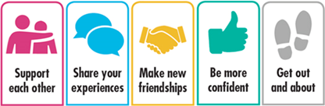

Labour Market Information & Wellbeing Events
November 2026

Ipswich Vacancies (and surrounding area)

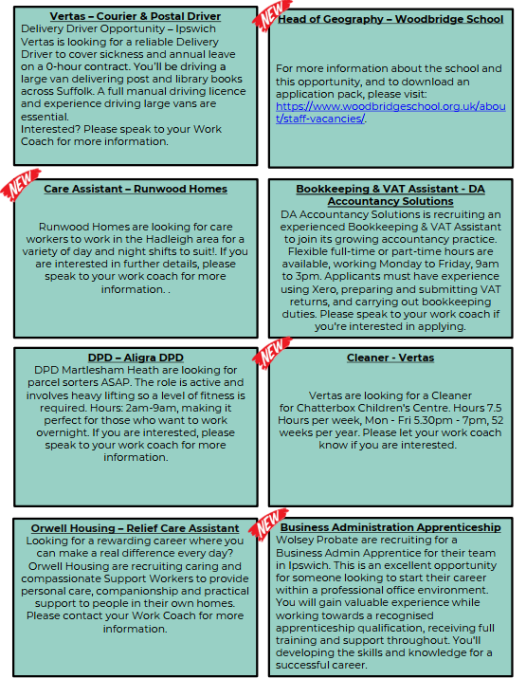

Ipswich Jobcentre - Newsletter Padlet
Welcome to the Ipswich Jobcentre Newsletter Padlet. Here you'll find a wide range of job seeking support, local events, courses and opportunities available in Ipswich and the surrounding areas. If you can't find what you're looking for try searching for keywords in the search bar. If you have any questions, please ask your Jobcentre work coach or get in touch via email at ipswich.eainbox@dwp.gov.uk

Scan the below QR code for the Ipswich JCP Padlet



Lowestoft Vacancies (and surrounding area)

Customer Advisor (Call Centre) - Essex and Suffolk Water, Lowestoft, full time, £25,878. Experience in a similar role is beneficial, it’s not essential. We offer fully paid training. Full details and apply via Essex and Suffolk Water website
Office & Accounts Administrator – Phoenix Windows, 25 - 30 hours P/W, £12.71 P/H DOE. Previous experience in an administration, accounts, or bookkeeping role. Experience using Sage accounting software. Speak to work coach for full details and to apply
Call Referral Operator - East Coast Community Healthcare, 37.5 hours P/W, £25,272 P/Y, requirement to work rotational weekends/ evenings. Educated to GCSE C or above, or equivalent, in English, Maths and IT, or displaying substantial experience in a similar role. Full details and apply via NHS Jobs website
Clinical Team Administrator - Norfolk & Suffolk Foundation NHS Trust, part time, £25,760-£27,476 P/Y pro rata. Understanding/ experience in full range of secretarial procedures/ systems gained through practice at intermediate level. Full details and apply via NHS Jobs website
Community Hub Support Worker – Leading Lives, Lowestoft, 27 hours P/W, £13 P/H. No experience is needed; full training is provided. What we value is heart, creativity, and the confidence to try new things. Speak to work coach for full details and to apply
Short Break Unit Support Worker – Leading Lives, John Turner House, Focus on morning/ evening/ weekend shift patterns, £13 P/H (Enhanced Sundays & Bank Holidays). Prior experience of working with people in a care setting, including provision of intimate care, supporting complex needs, risk assessment. Speak to work coach for full details and to apply
Facility Assistant – Suffolk FA, casual, evening & weekend work, NMW. Key facility management knowledge including business planning, facility operation and marketing. Clean, full driving licence. Speak to work coach for further details and how to apply
Community Activator – Suffolk FA, casual, evening & weekend work, NMW. Plan, organise, and deliver engaging, safe, and inclusive activities. Min. Level 1 in relevant Coaching Course. Clean, full driving licence Speak to work coach for further details and how to apply
Flexible Workers – Nomad Foods, Birds Eye Lowestoft, Production duties that include hand packing, inspection, basic machine operation, material handling /preparation, basic line set up and housekeeping duties. Full details and apply via Nomad Foods website
Home to School Driver – Rainbow Transport, Lowestoft, Mon-Fri regular hours, excellent day rates offered. Excellent driving skills. Private Hire Licence, or willing to apply (FSF funding can be applied for, to cover full cost). Speak to work coach for full details and to apply
Home Delivery Driver – Iceland, Lowestoft, £13.71 P/H, 16 & 2x 7.5 hours P/W contracts, evening work till 9pm. 11pm in December is required and weekends are a must. Have a full driving license (held for at least 3 years and have no more than 6 points). Full details and apply via Iceland website
Retail Assistant – Iceland, Lowestoft, £11.60 - £12.71 P/H, 2x 7.5 hours P/W contracts. Full details and apply via Iceland website
Customer Assistant (Market Street & Café) – Morrisons, North Quay, 12 hours P/W, competitive salary + benefits. Full details and apply via Morrisons website

Seasonal Store Fulfilment Assistant – Boots, Lowestoft, £13.02 - £15.10 P/H, full time. Moving between the stockroom and shop floor, helping customers, working on tills, replenishing shelves, and supporting deliveries. Full details and apply via Indeed
Christmas Customer Assistant (operations) - Marks & Spencer, Lowestoft, £13.41 P/H, all successful candidates may be asked to work up to full-time hours in the weeks commencing 13th and 20th December. Must be 18+. Being digitally confident is essential. Full details and apply via Indeed
Short-term Temporary Team Member – NEXT, Lowestoft, NMW, Thu 13:15 - 19:00 & Sat 10:00 - 16:00. Full details and apply via Next website
Team Member – Greggs, Lowestoft, £12.91 P/H(£11.03 if under 18). Full details and apply via Find A Job
Bingo Operative/Team Member - Real Fun Group, Lowestoft, 24 hours P/W, £12.71 P/H. Customer service experience (ideally in bingo or in the hospitality/entertainment industry). Full details and apply via Indeed
Learning Support Assistant - Horizon School, £26,017 – £26,847 P/Y pro rata, 35 hours P/W (39 weeks P/Y, TTO). Will involve responding independently to unexpected problems and situations. Full details and apply via Suffolk Jobs Direct
Learning Support Assistant - East Coast College, Lowestoft,24 hours P/W (TTO), £25,168.50 - £25,490 (FTE). Experience of working with a wide range of learning and/or physical needs. Full details and apply via East Coast College website
Teaching Assistant - Pakefield Primary School, 27.5 hours P/W, 38 weeks P/Y, £16,297.79 to £16,684.97 P/Y. Full details and apply via teaching-vacancies.service.gov.uk
Assembly Operative – Hales, Lowestoft, £12.96 P/H, Mon-Thur 7:30am-4:15pm & Fri 7:30am-12:30pm. Previous manufacturing experience is beneficial but not essential, as full training will be provided. Full details and apply via Hales website
Park Warden – Broadland Sands Holiday Park, Corton, £12.71 P/H, 30 hours P/W. Proven experience in a security or warden role, with prior management experience preferred. Full details and apply via Park Holidays website
Hygiene Technician – East Coast College, Lowestoft, part time, £25,168.50 - £25,490.00 FTE. Full details and apply via East Coast College website
Cleaner - Ormiston Denes Academy, Lowestoft, £10,076 P/Y, Mon-Fri, 3:15pm-6:15pm. No previous experience is needed - full training will be provided. Punctual, take pride in job, happy to work hard as part of a team. Full details and apply via teaching-vacancies.service.gov.uk
Cleaner - Royal Mail, Lowestoft, £12.71 P/H, Mon-Sat, 10am-1.30pm. Hands-on role that involves manual handling, but don’t worry, we’ll provide all the training and support you need to succeed. Full details and apply via Find A Job
Night Porter - The Hatfield Hotel, Lowestoft, £13 P/H, 2 -3 nights P/W (10pm-7am). Experience in a busy Hotel/Restaurant/Bar environment preferred and experience with Guestline would be an advantage. Full details and apply via Indeed

Scan the below QR code for more vacancies in Lowestoft



Bury St Edmunds Vacancies (and surrounding area)

Scan the below QR code for vacancies in Bury St Edmunds





Connect to Work Suffolk is here to help you find good work quickly – with free, personalised job support in the heart of your local community.

Connect to Work Suffolk - Seetec

Interview Tips
https://nationalcareers.service.gov.uk/careers-advice/interview-advice





Opportunities to Volunteer in Suffolk
https://volunteersuffolk.org.uk/

Health & Wellbeing Support
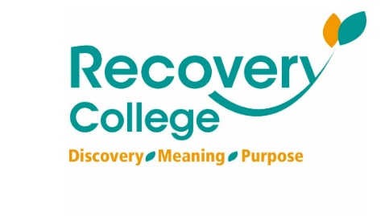
Click here for Autumn/Winter 25/26 timetable
Recovery College | Norfolk and Suffolk NHS
Our courses provide a safe, supportive, and compassionate approach to mental health recovery. We empower, educate, and offer tools to help individuals navigate their journey while learning from others with similar experiences. They are delivered with lived and learned experience of mental health and wellbeing.
Our sessions cover a range of topics, promoting:
- Self-awareness and acceptance
- Understanding recovery principles
- Learning new skills and strategies
- Leading a meaningful life, with or without symptoms



wellbeingsuffolk.co.uk

The Wellbeing Service is the NHS Talking Therapies provider in Suffolk. Wellbeing offer a whole range of free services to support people with their wellbeing and to overcome difficulties such as stress, anxiety, depression and low mood.
All services are free and available to anyone aged 16 and over living in Suffolk.



NEW - Suffolk Mind – REST Hub, Ipswich - Mental wellbeing support when you need it.
The REST Hub is a welcoming, non-clinical space where adults can access free mental wellbeing support from Suffolk Mind.
Whether you’re feeling overwhelmed, struggling with your mental health, finding it difficult to cope with everyday life, or simply don’t know where to turn, an experienced team are here to help.
They offer focused, person-centred support to help you understand what’s happening for you, identify your next steps and work towards improved wellbeing.
There are three ways to access support:
- Drop in during opening hours.
- Refer yourself using an online referral form to book an appointment (from 1st Sept).
- Be referred by a healthcare professional or another organisation, such as NHS 111 or your GP.

REST Hub, Ipswich - Suffolk Mind



Green Light Trust - Natural health and wellbeing support

The Green Light Trust are a health and wellbeing charity that works with nature to transform lives. Our expert-led programmes support children, young people and adults to thrive, supporting mental health, building skills, and improving the natural environment.



Get Everyday Activ in Suffolk | Motivating, supporting and inspiring healthier lifestyles
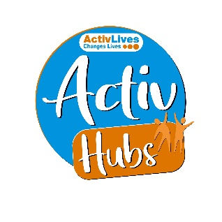
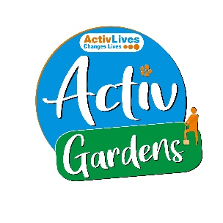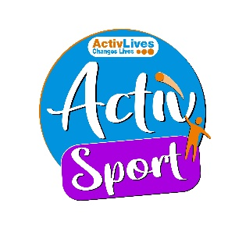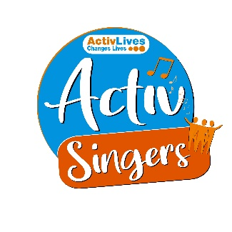
ActivHubs was set up to provide a fun and social way for people to keep fit and healthy, improve strength, balance andco-ordination, reduce stress and while doing all of that, make some new friends in the process!
ActivGardens are all about growing! Growing plants. Growing fresh healthy food. Growing yourself… your fitness, your health, your skills, your friends, your community.
ActivSport - A community based sports and physical activity programme for adults. Particularly targeted at people who are not already taking part in regular sport or physical activity. New participants are always welcome!
ActivSingers meet in Ipswich and Woodbridge every couple of weeks to enjoy all of the benefits from the joy of singing. Everyone is welcome to join in with no previous experience of singing required.



The Suffolk Information Partnership manages a secure, online referral process to support vulnerable customers and clients and help them access services that they may not be able to on their own.
Please note that the referral form is only for use by organisations and is not for the public. If you wish to refer yourself or a family member to a service offered by the partners in the Scheme please contact the most appropriate organisation listed on the Partners' page.

Warm & relaxing space in the heart of Lowestoft

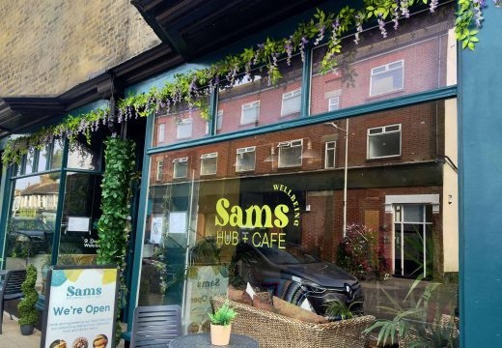

Sam’s Wellbeing Hub & Café is ready to welcome everyone, including your furry friends too (well-behaved & assistant dogs).
Nestled right in the heart of your community, we’ve created a warm, relaxing space that’s perfect for everyone to enjoy and escape to.
Whether you’re stopping by to explore our delicious food and drink menu or just looking for a cozy spot to unwind, we’re here Monday to Friday from 9:00 AM to 4:00 PM.

Events and Activities Nov/Dec 2026



- Autumn programmes from the New Wolsey Theatre - Tell Your Story and Creative Club are back! As a social prescribing project, participants need to meet certain NHS criteria to join the programme. To see if you’re eligible, sign up or for more information, check the website or contact cdavis@wolseytheatre.co.uk.
https://www.wolseytheatre.co.uk/projects/tell-your-story/
You can find more information on the group and how to sign up on our website or email creativeclub@wolseytheatre.co.uk
Anyone aged 18+ is welcome to join.
https://www.wolseytheatre.co.uk/projects/creative-club/
- NEW Gambling Harms project - FREE anxiety and counselling support from Suffolk Mind. Find out more at: https://www.suffolkmind.org.uk/services/gambling-harms/.
Contact: 0300 111 6000 / info@suffolkmind.org.uk.
- Renew Wellbeing Café - Do you or does someone you know struggle with mental health? Would you appreciate a quiet shared space where it’s ok not to be ok? You are very welcome to the Renew Wellbeing Café. Thursdays, 12noon - 2pm, 2nd and 4th Thursday of the month
Taste Community Café, 426A Woodbridge Road, Ipswich, IP4 4EL.
- "Want to cut your food bills and cook delicious meals at home? @BagsofTaste offers a FREE, friendly cooking course to help you save money and eat well! Find out more and sign up here: https://bagsoftaste.org/students/
- Christies Care welcomes all to join our monthly community group, connecting local communities with activities, entertainment and guest speakers.
  - 10.30am - 12.30pm,Second Friday of every month,Ixworth Village Hall IP31 2HH
- Newmarket Youth Hub at the Pavilion every Monday, apart from Bank Holidays.
Monday’s 13.30pm-15.00pm- 1:1 drop-in/scheduled sessions, aimed at 16-25 but will be open to all aged 7-25.
Monday’s 15.30pm-17.00pm- drop-in group sessions designed for young people aged 7–12 and operate as a safe, structured youth club environment.
THE SEVERALS SPORTS PAVILION,
Fordham Road
Severals
Newmarket
CB8 7BS
- Wild Winter Christmas Children's sessions at Green Light Trust (Castan Woods, Martlesham and Frithy Woods, nr Bury St Edmunds).
Tuesday 22nd and Wednesday 23rd December - 9.30am to 2.30pm.
For Children aged 7-11. A chance to make new friends, enjoy games, Christmas-themed nature crafts, woodland adventures and campfire fun. For children with a love of the outdoors. Cost - £37 per child, per day (£30 for additional siblings). Contact Green Light Trust for more information or to book: info@greenlighttrust.org
- Winter Wellbeing Wednesday event coming to Sudbury in November: Date: Wednesday 4 November, 11am-1pm. Venue: Sudbury Arts Centre (St Peter's), Market Hill, Sudbury, CO10 2EA.
- YMCA Community Coffee Morning on 6th November, 10am - 12.30pm, Ipswich YMCA Hub. To confirm your attendance prior to the event: danielle.parodi@ymcatrinity.org.uk.
- Suffolk People First Conference – for people with learning disabilities, autistic people, families, carers, supporters, professionals, and partners to come together for a morning of discussion and shared learning.
Friday 6 November
9.30am - 1.00pm
Booking link: https://www.eventbrite.co.uk/e/suffolk-people-first-tickets-1905422984439
Kesgrave Community and Conference Centre
Twelve Acre Approach
Kesgrave
Ipswich
IP5 1JF
- Ageing Well Webinar
Attendees will leave with simple actions that can be used to help stay well throughout the winter season.
📅 Wednesday 25th November 2026
🕚 11:00am – 12:00pm
Please click here to register: Ageing Well Winter Preparedness Webinar SIGN UP NOW

